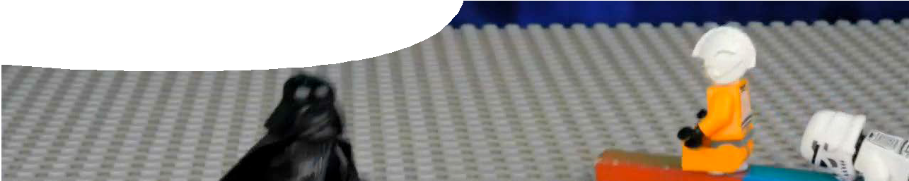
teachers guide
Forces 1:
Introduction to force

Components

 | NAME | DESCRIPTION | AUDIENCE
 | Introduction to force  teachers guide | This guide suggests teaching strategies to engage students’ interest in learning about forces and their effects on objects. | teachers
 | Use the force  video | A ‘Lego-mation’ movie shows different forces in action. | students
 | Thinking about forces  presentation | Questions about scenarios shown in the video promote class discussion about forces. | students
 | Newton explained  background sheet | This background sheet for teachers summarises Newton’s laws of motion and describes some common misconceptions held by students. | teachers

Purpose
This resource is intended to Engage students’ interest in learning about forces and their effects on objects.

Activity summary
Outcomes
Students understand that:
- forces may change the position or motion of an object;
- forces have strength (magnitude) and direction; and
- forces may act through contact with objects or at a distance.

ACTIVITY | POSSIBLE STRATEGY
Teacher introduces the topic of forces and what they can do to objects, through questions such as:  - What forces can you name? (gravity, magnetism, friction …)  - What can forces do to objects? (change their position, speed or shape …)  - Do forces always have these effects on objects? (No – some forces don’t seem to have any effect on some objects)  Teacher explains that students will investigate what forces can do to objects and why. | whole class
Teacher shows ‘Lego-mation’ video, Use the force.  Students are asked to think about forces that are acting in each scenario included in the video. | teacher and whole class
Teacher-led discussion and summary of forces depicted in the video and their effects on objects. The presentation, Thinking about forces, contains questions to prompt discussion. | whiteboard summary
Teacher asks students to call out what they want to know more about. Responses may include:  - How do forces affect the motion of objects?  - How do forces balance each other? | Teacher uses these responses to select appropriate exploratory activities.

Teacher notes
This resource helps develop students’ understanding of Newton’s laws of motion. A summary of these laws is included in the background sheet, Newton explained.
The ‘Lego-mation’ video, Use the force, is designed to engage students’ interest in forces and motion, and to elicit their prior knowledge and misconceptions about forces. It is recommended that students view the video all the way through, before examining it in detail to identify forces and their effects in some or all of the scenarios.
The presentation, Thinking about forces, contains a series of still shots taken from the video to encourage class discussion. Teachers should decide which, and how many, scenarios to discuss. The following information is provided to assist with the discussion.

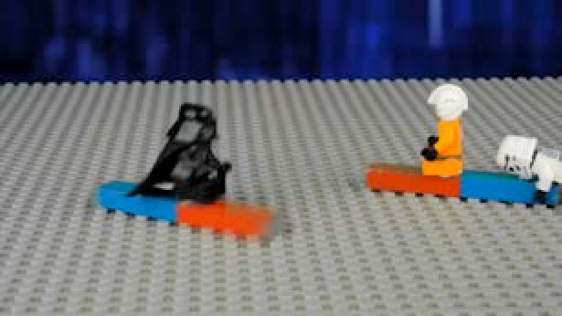  slide 2 | Scenario 1 Magnetic force 1  Description Luke’s magnet pushes Vader’s magnet away. Vader’s magnet slides and stops.  Question Why did Vader’s magnet move away from Luke’s?  Answer It moved away because Luke’s magnet repelled it. Magnetic force between like poles (N and N, or S and S) causes magnets to repel one another.  Notes Magnetism is a force that can act at a distance or through contact.  Friction only acts between objects in contact.  Question Why did Vader’s magnet stop moving?  Answer Friction between the magnet and table stopped his magnet from sliding further.  Notes Vader’s magnet stopped sliding when the friction force balanced the magnetic force.
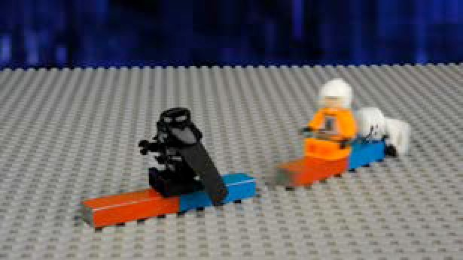  slide 3 | Scenario 2 Magnetic force 2  Description The stormtrooper pushes Luke’s magnet towards Vader’s. Vader’s magnet slides and sticks to Luke’s. Luke and Vader fall off.  Question What made the magnets slide towards each other?  Answer Magnetic force between opposite poles attracts the magnets to each other.  Notes When magnets are closer together, attraction is stronger. When magnetic force is greater than friction the magnets slide towards each other.
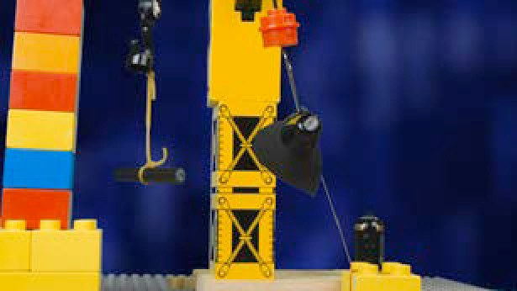  slide 4 | Scenario 3 Magnetic force 3  Description The stormtrooper hands Vader a paper clip, which is attached to the ground by a rope. Suddenly Vader is yanked upwards, suspended below a magnet hanging from a crane.  Question What is holding Vader and the paper clip up? Answer Magnetic force holds Vader and the paperclip up. Question What other forces are acting on Vader?  Answer Gravity and tension in the rope are acting on Vader, preventing him from reaching the magnet.  Notes Vader and the paper clip remain suspended below the magnet as long as the upward magnetic force balances the downward forces of gravity and tension.
slide 5 | Scenario 4 Electrostatic force  Description The stormtrooper and Luke hold a charged rod close to a pile of paper. Small pieces of paper jump up and stick to the rod.  Question What forces are acting on the pieces of paper?  Answer Electrostatic force makes the paper move toward the rod. Gravity is acting on the pieces, pulling them back down.  Notes When the rod is rubbed it gains (or loses) electrons and becomes electrostatically charged. The charged rod attracts the pieces of paper. The electrostatic force is stronger than gravity, so the pieces of paper move toward the rod. Eventually, charges on paper and rod leak away and the electrostatic force decreases until it is weaker than gravity. At this point the pieces of paper fall to the floor.

slide 6 | Scenario 5 Elastic force  Description Vader releases the paper clip and jumps onto a weight suspended by elastic. The elastic stretches; then contracts, flinging him off.  Questions What made the elastic stretch? What made it spring back?  Answer Gravity (Vader’s weight) made the elastic stretch. The more it stretches, the greater the tension in the elastic. Elastic force made the material return to its original length.
slide 7 | Scenario 6 Tension 1  Description Luke and Vader are engaged in a tug of war. The rope isn’t moving.  Questions What forces are acting in the tug of war? Why isn’t the rope moving?  Answer The forces are: tension in the rope; friction between Luke’s and Vader’s feet and the ground; gravity; and the ground’s supporting force.  Notes The rope isn’t moving because Luke and Vader are pulling in opposite directions with an equal amount of force. Forces are balanced.
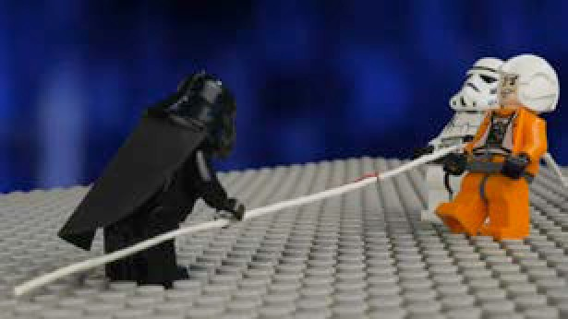  slide 8 | Scenario 7 Tension 2  Description The stormtrooper joins Luke at his end of the rope and together they pull Vader along.  Question What forces are acting when the rope starts moving?  Answer The forces are: tension in the rope; friction between Luke’s, Vader’s and the stormtrooper’s feet, and the ground; gravity; and the ground’s supporting force.  Notes Horizontal forces are no longer balanced. Luke and the stormtrooper exert more force than Vader, so they pull him along.
slide 9 | Scenario 8 Friction 1  Description Luke and Vader run and slide along the ground. Question What made Luke and Vader stop sliding?  Answer Friction between their bodies and the ground stopped them sliding.  Notes Friction opposes motion. Because it is strong, they soon stop sliding. The vertical forces (gravity and the ground’s supporting force) have no effect on their motion.
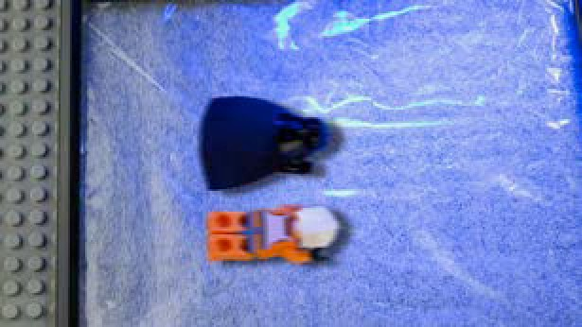  slide 10 | Scenario 9 Friction 2  Description Luke and Vader repeat their sliding competition, this time on ice.  Question What forces are acting on Luke and Vader when they’re sliding along the ice?  Answer When they’re sliding at constant speed the only forces acting on them are gravity (down) and the ice’s supporting force (up). Horizontal forces, air resistance and friction, are so small they can be ignored.  Notes: Vertical forces balance each other. If not, Luke and Vader would sink into the ice. There are no horizontal forces to make them go faster or slower, so they keep sliding at the same speed.
slide 11 | Scenario 10 Air resistance  Description The stormtrooper drops two pieces of paper at the same time: one flat; the other scrunched into a ball.  Questions What forces are acting on the pieces of paper as they fall? Why does the flat piece of paper fall slower?  Answer Forces acting on both pieces of paper as they fall are gravity (downwards) and air resistance (upwards).  Air resistance depends on surface area. The flat sheet has a bigger surface area, which means there’s more air resistance, so it falls slower.  Notes If the experiment was repeated in a vacuum, both pieces of paper would fall at the same rate because of absence of air resistance.

Technical requirements
The teachers guide requires Adobe Reader (version 5 or later), which is a free download from www.adobe. com. QuickTime version 7 or later is required to view the video. This is a free download from www.apple. com/quicktime. A high-quality MP4 version of the video with subtitles is also available on CD-ROM or download from the SPICE website.

Acknowledgements
Designed and developed by the Centre for Learning Technology, The University of Western Australia.
Production team: Graham Baker, Alwyn Evans, Jenny Gull, Kate Vyvyan, Dan Hutton, Paul Ricketts and Michael Wheatley with thanks to Bob Fitzpatrick and Wendy Sanderson.

SPICE resources and copyright
All SPICE resources are available from the Centre for Learning Technology at The University of Western Australia (“UWA”). Selected SPICE resources are available through the websites of Australian State and Territory Education Authorities.
Copyright of SPICE Resources belongs to The University of Western Australia unless otherwise indicated.
Teachers and students at Australian and New Zealand schools are granted permission to reproduce, edit, recompile and include in derivative works the resources subject to conditions detailed at spice.wa.edu.au/usage.
All questions involving copyright and use should be directed to SPICE at UWA.
Web: spice.wa.edu.au Email: spice@uwa.edu.au Phone: (08) 6488 3917
Centre for Learning Technology (M016) The University of Western Australia
35 Stirling Highway
Crawley WA 6009

Associated SPICE resources
Forces 1: Introduction to force may be used in conjunction with related SPICE resources to address the broader topic of forces and motion.

DESCRIPTION | LEARNING PURPOSE
Forces (overview)
This learning pathway shows how a number of SPICE resources can be used to teach concepts of balanced forces, unbalanced forces and motion.
Forces 1: Introduction to force  A video stimulates students’ interest in learning about forces and motion, and elicits prior knowledge and misconceptions. | Engage
Forces 2: Investigating forces  Practical activities provide opportunities for students to explore effects of forces on the motion of objects, including those falling in Earth’s gravity. | Explore
Forces 3: Balanced and unbalanced forces  An interactive learning object enables students to explain and predict effects of balanced and unbalanced forces on objects. | Explain
Forces 4: Forces in the human body  Students apply their understanding of forces and motion to new contexts, such as: forces in the human body or designing and testing the effectiveness of a safety capsule to protect passengers in motor vehicle collisions. | Elaborate

