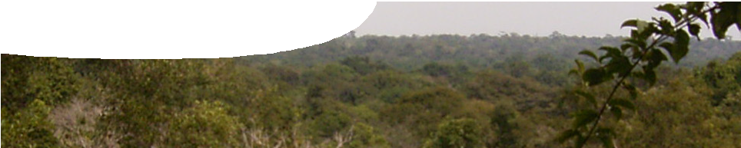
teachers guide
Amazon 1:
The Amazon rainforest

Components

 | NAME | DESCRIPTION | AUDIENCE
 | The Amazon rainforest  teacher guide | This guide suggests ways to use the video, Ecology of the Amazon rainforest. | teachers
 | Ecology of the Amazon rainforest  video | This video provides students with an overview of one of the world’s major biomes, the Amazon rainforest. It presents a visual journey of aspects of the rainforest with information on abiotic and biotic factors and components of the forest. | students
 | Factors affecting ecosystems  worksheet | This worksheet contains questions to be answered after viewing the videoclip. | students

Purpose
To use a video of interesting animals and plants from the Amazon rainforest to illustrate abiotic and biotic components of this ecosystem.

Activity summary
Outcomes
Students:
- describe some abiotic and biotic factors within an ecosystem, and
- appreciate a major ecosystem (biome) of the world.

ACTIVITY | POSSIBLE STRATEGY
Show the video, Ecology of the Amazon rainforest. | discuss aspects of an ecosystem, including abiotic and biotic factors
Students complete worksheet, Factors affecting ecosystems, as they view video. | provide worksheet
Discuss student answers. | class or small-group discussions

Technical requirements
The video, Ecology of the Amazon rainforest, may be viewed in any modern browser.
The teacher guide and worksheet require Adobe Reader (version 5 or later), which is a free download from www.adobe.com. The worksheet is also provided in Microsoft Word format.

Using the video
Show the video Ecology of the Amazon rainforest and discuss it with students to explore the abiotic and biotic components of the ecosystem.
Student discussion following the video can be teacher-led as a whole group discussion, or in small groups using strategies such as Think, Pair, Share. Suitable discussion questions include:
- Does the large rainfall amount affect the forest?
- Does the height of rainforest trees affect aspects of the non-living environment?
- Why is the biomass of the rainforest floor so large?
- Why is biodiversity and biomass so high in this ecosystem?

Associated SPICE resources

DESCRIPTION
Amazon 1: The Amazon rainforest
A video provides an overview of one of the world’s major biomes, the Amazon rainforest. It presents a visual journey of aspects of the rainforest with information on abiotic and biotic factors and components of the forest.
Amazon 2: Humans and the Amazon
A video provides an overview of some impacts of humans on the Amazon rainforest ecosystem.

Acknowledgements
Concept design: Jeff Mengler (Applecross Senior High School). Production by DUIT Multimedia (The University of Western Australia).
Photography: Jeff Mengler, Dr Natasha Pauli, Karl Atzmanstorfer, Scott Zehnder, Ken Southall, Neil George, Susanne Vaughan, Graeme Lindstedt, Susan Doncon, Bruce Pendlebury, Vangelis Thomaidis, Brian Hoskins, Fernando Weberich, Christiana Serpa, Bruno Camelier, Julia Freeman-Woolpert, Max Mitenkov, Andrzej Podiedzinski, Elke Rohn, Patrick Moore, Barun Patio, Nara Vieira da Silva Osga, NASA.

SPICE resources and copyright
All SPICE resources are available from the Centre for Learning Technology at The University of Western Australia (“UWA”). Selected SPICE resources are available through the websites of Australian State and Territory Education Authorities.
Copyright of SPICE Resources belongs to The University of Western Australia unless otherwise indicated.
Teachers and students at Australian and New Zealand schools are granted permission to reproduce, edit, recompile and include in derivative works the resources subject to conditions detailed at spice.wa.edu.au/usage.
All questions involving copyright and use should be directed to SPICE at UWA.
Web: spice.wa.edu.au Email: spice@uwa.edu.au Phone: (08) 6488 3917
Centre for Learning Technology (M016) The University of Western Australia
35 Stirling Highway
Crawley WA 6009

