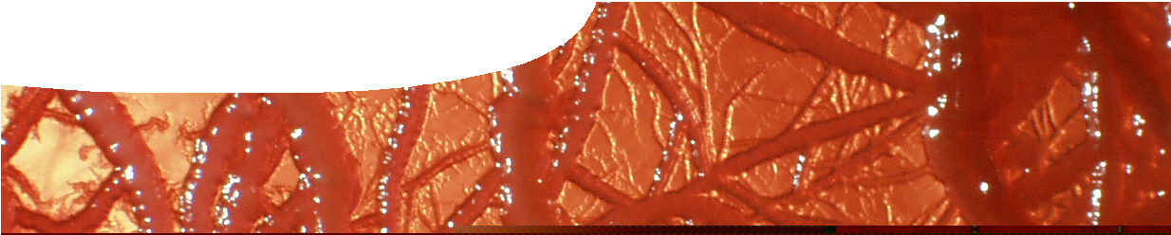
teachers guide
Soil life 3
Soil ecosystem

Components

 | NAME | DESCRIPTION | AUDIENCE
 | Soil ecosystem  teachers guide | This guide shows how to explain feeding relationships and energy flow in a soil ecosystem. | teachers
 | Soil life explorer  learning object | Students use a virtual microscope to construct food chains and food webs that involve soil organisms. | students
 | What’s for dinner?  worksheet | This worksheet accompanies the learning object, Soil life explorer. Students complete it to build an explanation of feeding relationships and energy flow in terrestrial and soil ecosystems. | students
 | Energy flow in the soil  video | This video examines energy transfer in ecosystems. | students

Purpose
To enable students to develop explanations of feeding relationships between soil organisms and how energy flows through the soil ecosystem.

Activity summary
Outcomes
Students:
- explain that organisms have different roles as producers and consumers,
- recognise that the soil ecosystem is different from above ground ecosystems,
- use feeding data to construct food chains and webs for soil fauna, and
- explain how energy flows through an ecosystem.

ACTIVITY | POSSIBLE STRATEGY
Students complete parts 1 to 3 of the worksheet, What’s for dinner? by using the learning object, Soil life explorer. Feeding relationships, food chains and food webs are examined. | individually or in pairs
Students watch the video, Energy flow in the soil, and complete part 4 of What’s for dinner? | individually or in pairs with teacher-led discussion

Technical requirements
The teachers guide and worksheet require Adobe Reader (version 5 or later), which is a free download from www.adobe.com. The worksheet is also provided in Microsoft Word format.
The learning object requires Adobe Flash Player version 8 or later (this is a free download from www. adobe.com). It can be placed on a web or file-server and run either locally or remotely in a web browser.
QuickTime version 7 or later is required to view the video. This is a free download from www.apple.com/ quicktime. A high quality MP4 version is available on CD-ROM or download from the SPICE website.
The video contains closed captions.

Acknowledgements
Science advisers: Honorary Associate Professor Adrianne Kinnear (School of Natural Sciences, Edith Cowan University) and Winthrop Professor Lynette Abbot (Faculty of Natural and Agricultural Sciences, The University of Western Australia)
Thanks to Muza Gondwe, PhD candidate, Faculty of Life and Physical Sciences, The University of Western Australia.
Designed and developed by the Centre for Learning Technology, The University of Western Australia.
Production team: Anton Ball, Helen Billiald, Kim Braimbridge, Jan Dook, Alwyn Evans, Bob Fitzpatrick, Dan Hutton, Bec McKinney, Paul Ricketts, Jodie Ween and Michael Wheatley. Thanks to Jenny Gull, Pauline Charman, Charmaine White and Wendy Sanderson.

Teachers notes
video, Energy flow in the soil
Root exudates are an important energy source for many soil micro-organisms. However, for the purpose of this resource, we have ignored this energy flow pathway and concentrated on the release of energy through decomposition of organic matter.
Question 7 in the worksheet, What’s for dinner? is designed to stimulate discussion about impacts of humans on ecosystems. Explanations of energy flow may have students questioning the impact on the environment of a vegetarian diet versus an
omnivorous diet, ideas about animal rearing practices, inequalities in resource distribution, land productivity and agricultural techniques. If only food chains are
considered then it is apparent that the more levels there are, the less energy is available to be transferred at each. However modern agricultural practices (including the use of water, fertilisers and pesticides) and associated energy consumption must be taken into consideration before a balanced judgement can be made in each case.

learning object, Soil life explorer
Additional notes on this learning object can be found in the teachers guide for Soil life 2: Exploring soil.
banner image: ‘Bacteria’ by Honorary Associate Professor Adrianne Kinnear, School of Natural Sciences, Edith Cowan University, used by permissionAssociated SPICE resources

Soil life 3: Soil ecosystem may be used in conjunction with related SPICE resources.

DESCRIPTION | LEARNING PURPOSE
Soil life (overview)
This learning pathway shows how a number of SPICE resources can be combined to assist with teaching the topic of ecology.
Soil life 1: Life in the soil  This resource engages student interest in the variety and importance of soil fauna. | Engage
Soil life 2: Exploring soil  Videos guide students through the process of sampling soil and extracting soil fauna, which they then identify. | Explore
Soil life 3: Soil ecosystem  Students use worksheets and an interactive learning object to construct food chains and food webs. An animated video explains the concept of energy flow through ecosystems. | Explain
Soil life 4: Soil investigation  Students investigate the importance of the sampling strategy by using an interactive learning object to see how observed sampling results vary with each organism. | Explore/Explain
Soil life 5: Soil scientists  Interviews with soil scientists illustrate the importance of different sampling strategies in their research. | Elaborate

SPICE resources and copyright
All SPICE resources are available from the Centre for Learning Technology at The University of Western Australia (“UWA”). Selected SPICE resources are available through the websites of Australian State and Territory Education Authorities.
Copyright of SPICE Resources belongs to The University of Western Australia unless otherwise indicated.
Teachers and students at Australian schools are granted permission to reproduce, edit, recompile and include in derivative works the resources subject to conditions detailed at spice.wa.edu.au/usage.

All questions involving copyright and use should be directed to SPICE at UWA.
Web: spice.wa.edu.au Email: spice@uwa.edu.au Phone: (08) 6488 3917
Centre for Learning Technology (M016) The University of Western Australia
35 Stirling Highway
Crawley WA 6009

