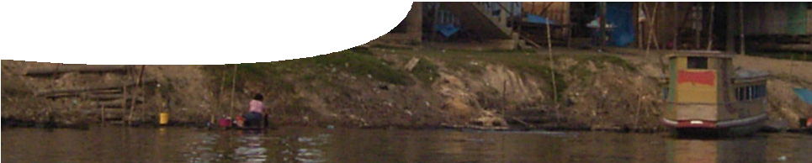
teacher guide
Amazon 2:
Humans and the Amazon

Components

 | NAME | DESCRIPTION | AUDIENCE
 | Humans and the Amazon  teacher guide | This guide suggests how to use the video, Human impact on the Amazon. | teachers
 | Human impact on the Amazon  video | This video provides students with an overview of some of the impacts of humans on the Amazon rainforest ecosystem. | students
 | Human impact: Amazon case study  worksheet | This worksheet contains questions to be answered after viewing the video. | students

Purpose
A video of human impacts on the Amazon rainforest stimulates discussion and ideas in students.

Activity summary
Outcomes
Students:
- describe some examples of impacts of population growth on ecosystems, and
- appreciate some causes and consequences of environmental issues such as deforestation, agricultural practices and urbanisation.

ACTIVITY | POSSIBLE STRATEGY
Discuss human impacts that occur as humans go from small decentralised populations to larger urban developments.  Discuss where this has occurred around the world. | teacher-led class discussion
Show the video, Human impact on the Amazon.
Students complete the worksheet, Human impact: Amazon case study, as they view the video.
Discuss student answers. | class or small-group discussions

Technical requirements
The video Human impact on the Amazon may be viewed in any modern browser.
The teacher guide and worksheet require Adobe Reader (version 5 or later), which is a free download from www.adobe.com. The worksheet is also provided in Microsoft Word format.

Using the video
Show the video, Human impact on the Amazon, and discuss it with students to explore impacts humans have on ecosystems.
Student discussion following the video may be teacher-led as a whole group discussion, or in small groups using strategies such as Think, Pair, Share. Suitable discussion questions include:
- Has this occurred elsewhere in the world?
- What parts of the ecosystem are affected?
- Do humans impact the biotic or abiotic environment?
- What is the ‘Gaia hypothesis’ and how do humans affect this?
- Discuss the investigation activity in the worksheet.

Associated SPICE resources

DESCRIPTION
Amazon 1: The Amazon rainforest
A video provides an overview of one of the world’s major biomes, the Amazon rainforest. It presents a visual journey of aspects of the rainforest with information on abiotic and biotic factors and components of the forest.
Amazon 2: Humans and the Amazon
A video provides an overview of some impacts of humans on the Amazon rainforest ecosystem.

Acknowledgements
Concept design: Jeff Mengler (Applecross Senior High School). Production by DUIT Multimedia (The University of Western Australia).
Photography: Jeff Mengler, Dr Natasha Pauli, Karl Atzmanstorfer, Scott Zehnder, Ken Southall, Neil George, Susanne Vaughan, Graeme Lindstedt, Susan Doncon, Bruce Pendlebury, Aleksandra Przenioslo, Hans Thoursie, Nagy Balázs, Carrieann Schneider, Edr Zambrano, Carlos Aguilar, Novitas, Dj Alemao, Dora Pete, Cécile Geng, Sabrina Olivetti, Kiril Havezov, Brain Hoskins, Danny de Bruyne, Pam Roth, Joshua Davis, Lionel Titu, NASA.

SPICE resources and copyright
All SPICE resources are available from the Centre for Learning Technology at The University of Western Australia (“UWA”). Selected SPICE resources are available through the websites of Australian State and Territory Education Authorities.
Copyright of SPICE Resources belongs to The University of Western Australia unless otherwise indicated.
Teachers and students at Australian and New Zealand schools are granted permission to reproduce, edit, recompile and include in derivative works the resources subject to conditions detailed at spice. wa.edu.au/usage.
All questions involving copyright and use should be directed to SPICE at UWA.
Web: spice.wa.edu.au Email: spice@uwa.edu.au Phone: (08) 6488 3917
Centre for Learning Technology (M016) The University of Western Australia
35 Stirling Highway
Crawley WA 6009

