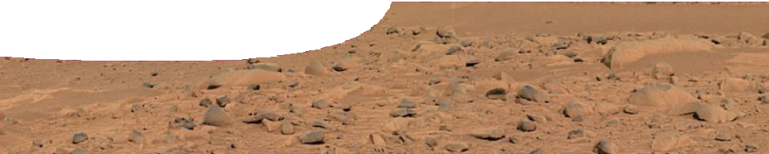
teacher guide
Life in the Solar System 2:
Exploring environments

Components

 | NAME | DESCRIPTION | AUDIENCE
 | Exploring environments  teacher guide | The guide provides information about how to use the learning object in this resource. | teachers
 | Eco-explorer  learning object | Students interact with the learning object to Explore  environmental conditions under which life might exist. | students
 | Exploring environments 1  worksheet | This detailed worksheet leads students through the activity below. | students
 | Exploring environments 2  worksheet | An open worksheet allows students to arrive at conclusions about planetary conditions. | students

Purpose
To Explore environmental circumstances under which life might exist.

Activity summary
Outcomes
Students:
- describe some similarities and differences between environments on Earth, and
- compare major environmental factors that support life on Earth, to conditions on Mars.

ACTIVITY | POSSIBLE STRATEGY
Students use the Eco-explorer learning object to explore images of Earth environments. Using output provided by Eco-explorer, students quantify similarities and differences while responding to questions posed on the worksheet. | individually or in pairs

Technical requirements
The learning object requires Adobe Flash Player version 8 or later (this is a free download from www. adobe.com). It can be placed on a web or file-server and run either locally or remotely in a web browser.
The guide and worksheets require Adobe Reader which is a free download from www.adobe.com. The worksheets are also provided in Microsoft Word format.
About the Eco-explorer learning object
Eco-explorer allows students to select from images of Earth environments and display information on atmospheric composition, pressure, temperature, moisture and gravity. It also provides a subjective measurement of the abundance of life. Environments include: Antarctica, cave, coastal, city, desert, mountain, rainforest and volcanic pool.
The abundance of life is affected by humidity, sunlight, and temperature. Lower readings for the abundance of life are in areas of low moisture and low light. The life reading for the volcanic pool
is very low because of high water temperature and presence of toxic gases. Only highly adapted organisms can survive in this environment.
An unlabelled image of the surface of Mars is included to provide a contrast in readings. It also challenges students to account for differences within the context of the existence of life on other planets.

Associated SPICE resources
Life in the Solar System 2: Exploring environments may be used in conjunction with related SPICE resources.

DESCRIPTION | LEARNING PURPOSE
Life in the Solar System
This learning pathway combines a number of SPICE resources to address the topic of the search for life in the Solar System.
Life in the Solar System 1: Conditions for life  A presentation challenges students to think about where life is found. | Engage
Life in the Solar System 2: Exploring environments  Students explore different environments to compare surface conditions and abundance of life. | Explore
Life in the Solar System 3: Planetary atmospheres  Students compare atmospheric conditions on various bodies in the Solar System. | Explain
Life in the Solar System 4: Life under extreme conditions  Life exists in extreme environments on Earth, which suggests that it may also be found in unknown environments in space. | Elaborate

Acknowledgements
Designed and developed by the Centre for Learning Technology, The University of Western Australia.
Production team: Leanne Bartoll, Alwyn Evans, Bob Fitzpatrick, Trevor Hutchison, Paul Luckas, Paul Ricketts, Jodie Ween and Michael Wheatley, with thanks to Roger Dickinson, Jenny Gull and Wendy Sanderson.

List of images
- Lemaire Channel, Antarctica (photo by Frank Wheatley)
- Jenolan Caves, New South Wales (photo by Paul Ricketts)
- Namib Desert (photo by Tjeerd Wiersma, CC-BY-2.0, commons.wikimedia.org/wiki/Image:Namibian_ Desert.jpg)
- Forest, New South Wales (photo by Paul Ricketts)
- Perth city skyline at night (photo by Paul Ricketts)
- Rottnest Island coastline (photo by Paul Ricketts)
- The Eastern Hills, Mars, photographed by Mars Rover Spirit (NASA/JPL, photojournal.jpl.nasa.gov/catalog/ pia05593)
- Blue Mountains, New South Wales (photo by Paul Ricketts)
- A volcanic pool in Yellowstone National Park (photo by James Taylor, used under licence from Stock. xchng, www.sxc.hu/photo/800999)

SPICE resources and copyright
All SPICE resources are available from the Centre for Learning Technology at The University of Western Australia (“UWA”). Selected SPICE resources are available through the websites of Australian State and Territory Education Authorities.
Copyright of SPICE Resources belongs to The University of Western Australia unless otherwise indicated.
Teachers and students at Australian schools are granted permission to reproduce, edit, recompile and include in derivative works the resources subject to conditions detailed at spice.wa.edu.au/usage.
All questions involving copyright and use should be directed to SPICE at UWA.
Web: spice.wa.edu.au Email: spice@uwa.edu.au Phone: (08) 6488 3917

Centre for Learning Technology (M016) The University of Western Australia
35 Stirling Highway
Crawley WA 6009

