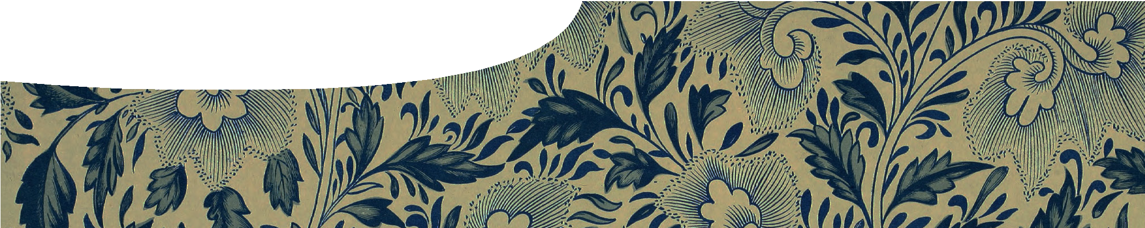

**teachers guide**

**Atoms and elements 4:**

**Element fingerprints**

# Components

|  |  |  |  |
| --- | --- | --- | --- |
|  | NAME | DESCRIPTION | AUDIENCE |
|  | *Element fingerprints*  teachers guide | This guide describes how to use applications of trace elemental analysis to elaborate on students’ understanding of atoms and elements. | teachers |
|  | *Forensics, fakes and fingerprinting*  fact sheet | This fact sheet describes some applications of ICP-MS, a method of analysing amounts of trace elements in a  product. It draws on current research from The University of Western Australia. | students |

Purpose

To **Elaborate** on concepts of atoms and elements by looking at applications of ICP-MS, a method of elemental analysis.

# Activity summary

Outcomes

Students:

* understand that atoms can be separated based on their atomic structure;
* realise that science is an on-going human endeavour;
* describe practical applications of atomic theory; and
* research current science.

|  |  |
| --- | --- |
| ACTIVITY | POSSIBLE STRATEGY |
| Students read the first page of the fact sheet, *Forgeries, fakes and fingerprinting*. Conduct a class discussion that links information  to Anna’s research featured in the video, *Atoms and elements 1: Fingerprinting bullets*. | working individually or whole class |
| Split class into four groups. To each group, assign one of the fingerprinted substances (diamonds, micro debris, oriental porcelain or tea) discussed in the fact sheet, *Forgeries, fakes and fingerprinting*. Students read the relevant section. | small groups |
| Students discuss information they’ve read and prepare a short presentation to inform the class about their topic. Suggested discussion points are in **Teacher notes** below. | small groups |

# Teacher notes

The following questions may be used to give students a starting point for their group discussion and presentation:

* Which substance was studied?
* Why did scientists fingerprint it?
* How did scientists analyse it?
* What were the scientists’ findings?
* Why is there variation in trace elements found in this substance?
* What is the impact of this research?

This activity may be extended by asking students to use the Internet to research other applications of ICP- MS in forensics.

A good starting point for students’ research is the website <http://www.tswanalytical.com.au/> foodforensic.html. TSW Analytical has a strong

partnership with the Centre for Forensic Science at The University of Western Australia.

Follow the links to read case studies on wine, pork meat, kiwi fruit or coffee.

Students individually, in pairs, or small groups, may present their findings to the class, or prepare a written report. Use the above questions as a guide.

# Technical requirements

The teachers guide and fact sheet require Adobe Reader (version 5 or later), which is a free download from [www.adobe.com.](http://www.adobe.com/)

# Acknowledgements

Thanks to Winthrop Professor John Watling, Centre for Forensic Science, at The University of Western Australia.

Designed and developed by the Centre for Learning Technology, The University of Western Australia.

Production team: Sally Harban, Bob Fitzpatrick, Alwyn Evans, Dan Hutton, Paul Ricketts and Michael Wheatley, with thanks to Beate Ferbert-Booth, Jenny Gull and Wendy Sanderson.

Banner image: ‘Examples of Chinese ornament’ by Owen Jones (1867), PD, commons.wikimedia.org/wiki/File:Owen_ Jones_-_Examples_of_Chinese_Ornament_-_1867_-_ plate_008.png

# SPICE resources and copyright

All SPICE resources are available from the Centre for Learning Technology at The University of Western Australia (“UWA”). Selected SPICE resources are available through the websites of Australian State and Territory Education Authorities.

Copyright of SPICE resources belongs to The University of Western Australia unless otherwise indicated.

Teachers and students at Australian and New Zealand schools are granted permission to reproduce, edit, recompile and include in derivative works the resources subject to conditions detailed at spice. wa.edu.au/usage.

All questions involving copyright and use should be directed to SPICE at UWA.

Web: spice.wa.edu.au Email: [spice@uwa.edu.au](mailto:spice@uwa.edu.au) Phone: (08) 6488 3917

Centre for Learning Technology (M016) The University of Western Australia

35 Stirling Highway

Crawley WA 6009

# Associated SPICE resources

*Atoms and elements 4: Element fingerprints* may be used in conjunction with related SPICE resources to teach the topic of atomic structure.

|  |  |
| --- | --- |
| DESCRIPTION | LEARNING PURPOSE |
| *Atoms and elements (overview)* |  |
| *Atoms and elements 1: Elementary forensics*  A video shows how a forensic scientist uses knowledge of differences between elements to characterise bullets. | **Engage** |
| *Atoms and elements 2: Looking at atoms*  Students use an interactive learning object to explore how advances in scientific understanding have lead to knowledge of atomic structure that explains differences between elements. | **Explore** |
| *Atoms and elements 3: Creating atoms*  Students use an interactive learning object to create elements from protons, electrons and neutrons. | **Explain** |
| *Atoms and elements 4: Element fingerprints*  Students research trace element analysis and its applications in forensic science. | **Elaborate** |