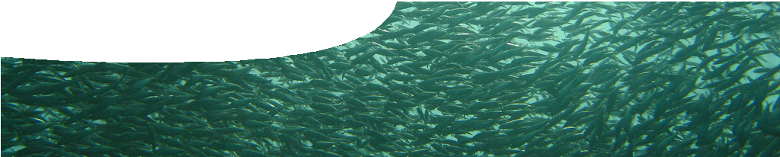
teacher guide
Feeding relationships 1:
Animal interactions

Components
NAME DESCRIPTION AUDIENCE

 | Animal interactions  teacher guide | This guide shows how a video and book extract may be used to engage student interest in feeding relationships and introduced species. | teachers
 | Cane toads  background sheet | This background sheet summarises information about cane toads and problems they pose for native wildlife. Cane toads are used as an example of introduced species throughout this collection of resources. | teachers
 | The food files  video | This news-style video discusses feeding relationships and introduced species. | students
 | Toad rage  worksheet | An extract from Toad Rage, by Morris Gleitzman, followed by student questions, makes links between feeding relationships and introduced species. | students

Purpose
To Engage student interest in feeding relationships and introduced species.

Activity summary
Outcomes
Students:
- realise that living things are linked by what they eat;
- understand that introducing new species into an environment has impacts on plants, animals and feeding relationships;
- use prior knowledge and new ideas to engage with problems presented by introduced species; and
- assimilate ideas from a different perspective.

ACTIVITY POSSIBLE STRATEGY
Students watch the video, The food files. | whole class
Class discussion of the video. See Teacher notes below for key questions. | whole class
Students use the worksheet, Toad rage, read a book extract, and answer questions. Discuss answers as a class. | individually then whole class

Technical requirements
The teacher guide, background sheet and worksheet require Adobe Reader (version 5 or later), which is a free download from www.adobe.com. The worksheet is also available in Microsoft Word format.
A modern browser (eg Internet Explorer 9 or later, Google Chrome, Safari 5.0+, Opera or Firefox) is required to view the video. A high quality MP4 version of the video is available by download from the SPICE website.

Teacher notes

QUESTION SUGGESTED ANSWER
small marsupials | shark fish  ants cockroach  rakali fish  woylie nuts  bilby nuts  rufous hare wallaby nuts  burrowing bettong nuts  fox small marsupials  cat small marsupials  sea turtle jellyfish  black cockatoos seeds  bees pollen and honey  cane toad insects  caterpillar leaf  dingo small marsupials wedge-tailed eagle small marsupials snake cane toad
Why do animals eat? | Animals eat food to gain energy needed to perform all their daily activities.
Name three introduced species seen in this video. | cats, foxes, bees, cane toads …
Why did people introduce each of these animals into an environment? | cats – as pets, for biological control (to catch mice) foxes – for sport  bees – to pollinate introduced plants  cane toads – biological control (cane beetles)
What negative impacts could each of these introduced animals have on the native environment? | cats – prey on native animals foxes – prey on native animals bees – compete for shelter  cane toads – poison native animals, may compete for food and shelter
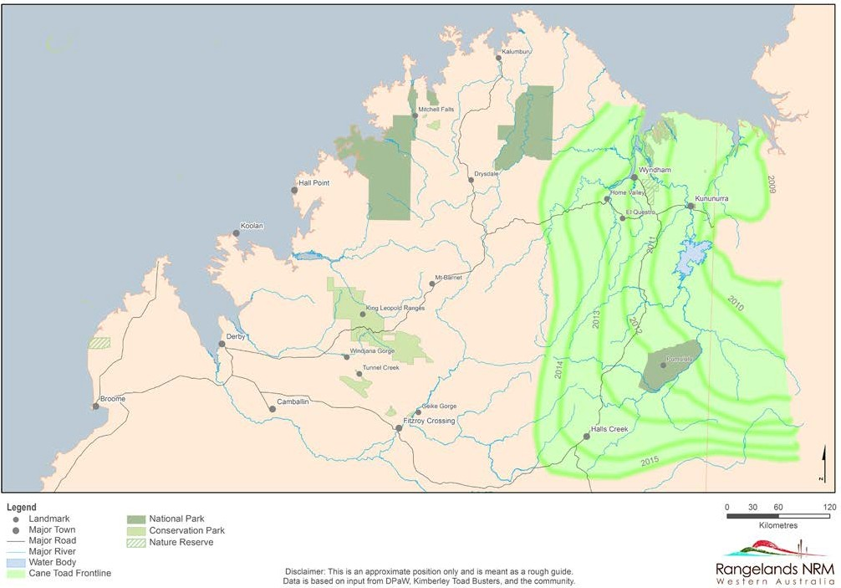
Cane toads move into Western Australia: bands show approximate position of front line between 2009 and 2015.

Image credits
- ‘Baitball, Cocos Island’ by Kip Evans (Mountain and Sea Productions), used under licence, kipevansphotography. com/Pond5
- ‘Green sea turtle eating jellyfish’ by Rems Production (Images from Under), used under licence, www. ImagesFromUnder.com/Pond5
- ‘Burn panorama, Crowea’ by The Last Stand Studio, CC-BY-NC-2.0, www.flickr.com/photos/ thelaststandstudio/7037814953/
- ‘Clearfell, south west Western Australia’ by The Last Stand Studio, CC-BY-NC-2.0, www.flickr.com/photos/ thelaststandstudio/6891717308/in/photostream/
- ‘Lunch for two: wedge-tailed eagles, Currumbin ‘by Michael Jefferies, CC-BY-NC-2.0, www.flickr.com/photos/ ogcodes/2217924590/
- ‘Dingo, Fraser Island, Queensland’ by Michael Dawes, CC-BY-NC-2.0, www.flickr.com/photos/tk_ five_0/2824575950/
- ‘European red fox’ by Harley Kingston, CC-BY-2.0, www. flickr.com/photos/harlz_/7377707596/
- ‘Feral cat’ by Bob MacInnes, CC-BY-2.0, www.flickr.com/ photos/lonetown/422404439/
- ‘Hollow formed on stag tree’ by Ron Johnstone © Western Australian Museum
- Cane toad video footage courtesy of Channel 9, Perth, used by permission
- ‘Delivering sugar cane to the mill at Marburg, Queensland, Australia’ by Henry Mobsby, Fryer Library, The University of Queensland Library, PD, espace.library.uq.edu.au/view/ UQ:132150
- ‘Sugar cane growing at Marburg, Queensland, Australia’ by Henry Mobsby, Fryer Library, The University of Queensland Library, PD, espace.library.uq.edu.au/view/ UQ:137360
- ‘Dead bird’, ‘Dead brown snake’ and ‘Cane toad eggs’ © Kimberley Toad Busters, used by permission
- banner image: ‘Sardines’ by Juuyoh Tanaka. CC-BY-2.0, www.flickr.com/photos/tanaka_juuyoh/1775405862/

Acknowledgements
Thanks to Professor Rick Shine (School of Biological Sciences, The University of Sydney), Kimberley Toad Busters, Corrin Everitt (Department of Environment and Conservation, Kununurra Office), Cassandra Rowles, Kaarakin Black Cockatoo Rehabilitation Centre and Roger Harris (Herdsman Lake Wildlife Centre).
Video presenters: Toby Travers and Yvette Leong.
Designed and developed by the Centre for Learning Technology, The University of Western Australia.
Production team: Anton Ball, Pauline Charman, Alwyn Evans, Sally Harban, Dan Hutton, Emma Pointon, Jodie Ween and Michael Wheatley, with thanks to Bob Fitzpatrick, Jenny Gull and Wendy Sanderson.

SPICE resources and copyright
All SPICE resources are available from the Centre for Learning Technology at The University of Western Australia (“UWA”). Selected SPICE resources are available through the websites of Australian State and Territory Education Authorities.
Copyright of SPICE Resources belongs to The University of Western Australia unless otherwise indicated.
Teachers and students at Australian and New Zealand schools are granted permission to reproduce, edit, recompile and include in derivative works the resources subject to conditions detailed at spice. wa.edu.au/usage.
All questions involving copyright and use should be directed to SPICE at UWA.
Web: spice.wa.edu.au Email: spice@uwa.edu.au Phone: (08) 6488 3917
Centre for Learning Technology (M016) The University of Western Australia
35 Stirling Highway
Crawley WA 6009

Associated SPICE resources
Feeding relationships 1: Animal interactions may be used in conjunction with related SPICE resources to address the broader topic of food chains and webs.

DESCRIPTION LEARNING PURPOSE
Feeding relationships (overview)
This learning pathway shows how a number of SPICE resources can be combined to teach the topic of food chains and webs.
Feeding relationships 1: Animal interactions  Students watch a video designed to engage students and provoke questions about animal feeding relationships and introduced species. Students then read a book extract, raising further discussion about cane toads and their impacts. | Engage
Feeding relationships 2: Predators and prey  Students explore concepts of feeding relationships and food chains by competing against each other in three activities: a quiz about what animals eat; a card game; and an outdoor role-play game. | Explore
Feeding relationships 3: Food webs  Food webs are explained in a student fact sheet. Students use an iPad app or a cut-and- paste activity to create a food web that shows feeding relationships between animals in the Kimberley. Students introduce cane toads into their web to examine effects on other species in the ecosystem. They answer questions on an accompanying worksheet to check understanding. | Explain
Feeding relationships 4: Impact of cane toads  This resource elaborates the topic of introduced species. Students watch video clips of people living in the Kimberley describing impacts of cane toads. An accompanying worksheet probes students’ understanding. | Elaborate
Feeding relationships 5: Managing cane toads  This resource extends and applies students’ understanding of cane toads as an example of impacts caused by introduced species. Students suggest ways to solve the cane toad problem; read fact sheets that include up-to-date science research; and participate in a class debate to determine the best solution. They need to develop a persuasive argument that considers ethics, cost and viability of their option. | Elaborate
Feeding relationships 6: Kimberley creations  This resource encourages students to employ techniques used in Aboriginal art to make their own symbolic representation of feeding relationships in an environment of their choice. | Elaborate

