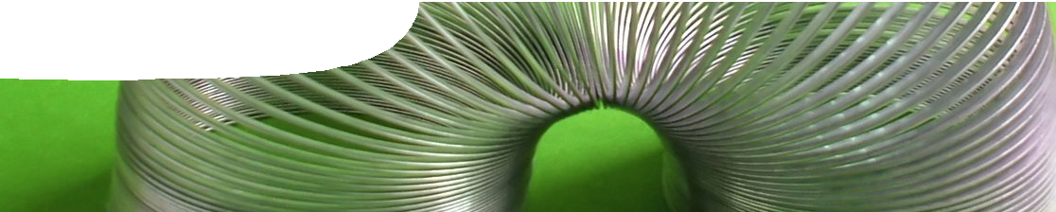
teacher guide
Mechanical waves 2: Wave properties

Components

 | NAME | TYPE | AUDIENCE
 | Wave properties  teacher guide | This provides teachers with suggestions on how to use the learning object in this resource. | teachers
 | Wave properties explorer  learning object | Students interact with a variety of waves to understand their properties. | teachers students
 | Waves  worksheet | This worksheet contains questions that involve concepts of wave type, amplitude, frequency and interference. | students

Purpose
To Explain characteristics and properties of mechanical waves.

Activity summary
Outcomes
Students:
- describe movement of particles in transverse and longitudinal waves;
- explain the meaning of amplitude, wavelength, frequency, speed and period of mechanical waves;
- describe relationships between speed, wavelength and frequency, and between frequency and period of waves; and
- explain interference caused by interacting waves.

ACTIVITY | POSSIBLE STRATEGY
Students explore the interactive program, Wave properties explorer, guided by the worksheet, Waves. | individually or pairs
Discussion of worksheet questions and additional questions such as:  - Is a ‘Mexican’ wave really a wave?  - In what ways has a wave been represented? (visual, descriptive, graphical) | teacher-led whole group

Technical requirements
The learning object requires Adobe Flash Player version 8 or later (this is a free download from www. adobe.com). It can be placed on a web or file-server and run either locally or remotely in a web browser.
The teacher guide and worksheet require Adobe Reader (version 5 or later), which is a free download from www.adobe.com. The worksheet is also provided in Microsoft Word format.

move in a circular pattern, however the motion is retrograde (anti-clockwise in the animation) whereas motion in water waves is prograde (clockwise in
the animation). Motion in a Rayleigh wave changes direction at depth, from retrograde to prograde.
Rayleigh waves are the slowest of earthquake waves, however they are amongst the most destructive.
Because they propagate in two dimensions (across the surface) rather than three dimensions (through the volume of the Earth in the case of P- and
S-waves) they dissipate much more slowly so they can carry a greater amount of energy further.

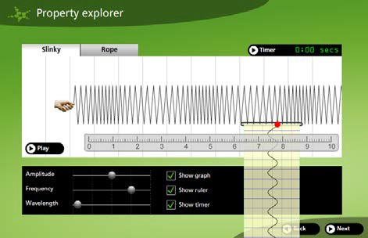

Property explorer screen
Students use the second screen in the animation to make a detailed investigation of three properties of mechanical waves: amplitude, frequency and wavelength.
Each can be varied for two principal wave types: a slinky spring (longitudinal wave); and a rope wave (transverse wave). The speed of the wave is constant, so varying frequency affects wavelength and vice versa according to the equation v = f # m
(speed = frequency multiplied by wavelength).
Controls are included to display a graph of particle motion, a moveable ruler and a timer. Using these tools, students may determine other properties such as motion period and wave speed.
Amplitude
Adjusting the amplitude slider changes the amount the hand generating the waves moves. Rope wave amplitude can be easily determined on screen by measuring the distance between top and bottom of wave crests. Measure the slinky wave amplitude by selecting the Show graph checkbox. Changing amplitude has no effect on wavelength, period, frequency or speed of a wave. Large amplitude waves carry more energy (eg a big water wave or a loud sound).

Frequency
Moving the frequency slider changes the rate the hand moves up and down or back and forth. Use the Timer to determine frequency by counting how many waves pass a fixed point in a unit of time. Frequency can be varied between 0.25 Hz and 1.25 Hz (slinky wave) and 0.5 Hz and 2.5 Hz (rope wave). Wavelength automatically adjusts as frequency is changed in order to keep speed constant.

Wavelength
Moving the wavelength slider changes the wavelength. The Ruler can be used to determine wavelength, which varies between 8 and 1.6 units (slinky wave) and 2 and 0.4 units (rope wave).
Frequency automatically varies as wavelength is adjusted in order to keep speed constant.

Speed
Speed may be calculated using the Ruler and Timer. For the slinky spring it should be 2 units s-1 and for the rope wave 1 unit s-1.

Period
Period of the wave may be measured using the Timer. It’s the time taken for one complete wave to pass any given reference point. The period is calculated as 1/f (reciprocal of the frequency).

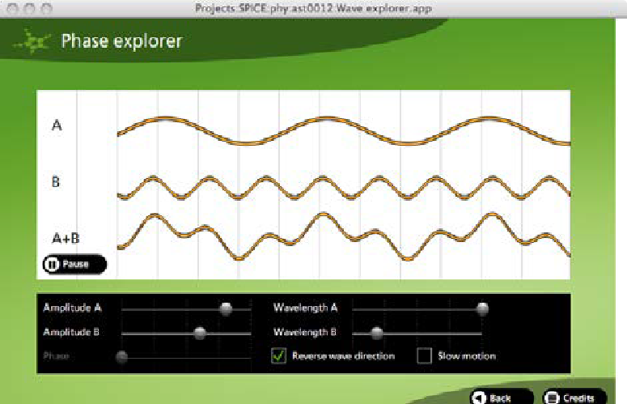

Phase explorer screen
The third simulation screen may be used to investigate how waves combine. Two transverse waves (A and B) are shown, together with the result of adding the waves together (A + B).
Amplitude and wavelength of the two source waves may be independently varied using sliders for each. Phase difference between waves may also be adjusted so that waves are in phase or out of phase.
Select Reverse wave direction to reverse the direction of one wave. With this setting standing waves can be generated.

Associated SPICE resources
Mechanical waves 2: Wave properties may be used in conjunction with related SPICE resources to address the broader topic of mechanical waves.

DESCRIPTION | LEARNING PURPOSE
Mechanical waves
This learning pathway shows how a number of SPICE resources may be combined to teach the topic of mechanical waves.
Mechanical waves 1: The physics of tsunamis  Video and a fact sheet compare surface waves with tsunami waves. | Engage
The sequence overview in Mechanical waves contains suggested Explore activities suitable for use at this point. | Explore
Mechanical waves 2: Wave properties  This resource includes a learning object (in which students interact with a variety of waves to understand their properties), and associated student worksheets. | Explain
Mechanical waves 3: Graphing waves  These student worksheets describe experiments with longitudinal waves. | Elaborate
Mechanical waves 4: Tsunami problems  These student worksheets cover a range of problems concerning the physics of tsunamis and other waves. | Elaborate
The sequence overview in Mechanical waves contains suggested Explore/Explain  activities suitable for use at this point. | Explore/Explain
Mechanical waves 5: The physics of whale stranding  An interview with physicist Dr Ralph James illustrates how his research into microwaves led him to develop and test a theory to explain whale beaching. | Elaborate

Acknowledgements
Concept design: Bob Fitzpatrick (Armadale Senior High School). Program design: Dr Michael Wheatley (Centre for Learning Technology). Production by the Centre for Learning Technology at The University of Western Australia).

SPICE resources and copyright
All SPICE resources are available from the Centre for Learning Technology at The University of Western Australia (“UWA”). Selected SPICE resources are available through the websites of Australian State and Territory Education Authorities.
Copyright of SPICE Resources belongs to The University of Western Australia unless otherwise indicated.
Teachers and students at Australian and New Zealand schools are granted permission to reproduce, edit, recompile and include in derivative works the resources subject to conditions detailed at spice.wa.edu.au/usage.
All questions involving copyright and use should be directed to SPICE at UWA.
Web: spice.wa.edu.au Email: spice@uwa.edu.au Phone: (08) 6488 3917
Centre for Learning Technology (M016) The University of Western Australia
35 Stirling Highway
Crawley WA 6009

