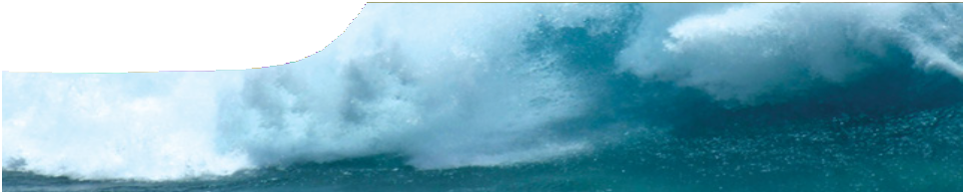
teacher guide
Mechanical waves 1:
The physics of tsunamis

Components

 | NAME | DESCRIPTION | AUDIENCE
 | The physics of tsunamis  teacher guide | This shows how the resource may be used to engage student interest in the properties of mechanical waves. It provides advice on use of the various learning assets and suggests questions for group discussion. | teachers
 | Tsunami physics  background sheet | This provides basic information for teachers on the physics of tsunamis. | teachers
 | Dangerous waves  fact sheet | This explains differences between wind-waves and tsunamis to enlighten student discussion on how these waves form, how they move and why tsunamis are so destructive. | students
 | Dangerous waves  video | This contrasts two different but dangerous waves: surfers riding giant waves, and the Boxing Day tsunami crashing ashore. | students

Purpose
To Engage students’ interest and inquiry in waves.

Activity summary
Outcomes
Students:
- compare surface waves with tsunami waves
- identify what they know and need to know about waves using information from videos.

ACTIVITY | POSSIBLE STRATEGY
Show the video.  WARNING! Preview the video sequence before it is used in the classroom as it contains images that may distress some students. | Think, Pair, Share
Pose questions (see Using the video) and discuss student responses. | whole group discussion
Distribute and use the fact sheet Dangerous waves to support the discussion. | KWL chart

Technical requirements
A modern browser (eg Internet Explorer 9 or later, Google Chrome, Safari 5.0+, Opera or Firefox) is required to view the video. A high quality MP4 version of the video is available by download from the SPICE website.
The teacher guide, fact sheet and background sheet require Adobe Reader (version 5 or later), which is a free download from www.adobe.com.

Using the video
Play the video Dangerous waves and discuss it with students to contrast two different but dangerous waves: surfers riding giant waves, and the Boxing Day tsunami crashing ashore.
Student discussion following the video may be teacher-led as a whole group discussion, or in small groups using strategies such as Think, Pair, Share. Suitable discussion questions include:
- Do waves all look the same?
- What do you know about water waves like these?
- Which waves are the most dangerous?
- Why are some waves more damaging than others?
- In what ways are all these waves similar?
- If you had to, which type of wave would you rather face?

Guiding further learning
The fact sheet provides further information for students on wind-waves and tsunamis.
A KWL strategy may be introduced after students have seen the video, then read the fact sheet. In groups, students complete the first two columns: what I know and what I want to know about waves. As students continue to learn about wave characteristics and properties through later activities they can add to their questions, and write their own answers in the column headed L (what have I learnt).

Associated SPICE resources
Mechanical waves 1: The physics of tsunamis may be used in conjunction with related SPICE resources to address the broader topic of mechanical waves.

DESCRIPTION | LEARNING PURPOSE
Mechanical waves
This learning pathway shows how a number of SPICE resources may be combined to teach the topic of mechanical waves.
Mechanical waves 1: The physics of tsunamis  Video and a fact sheet compare surface waves with tsunami waves. | Engage
The sequence overview in Mechanical waves contains suggested Explore activities suitable for use at this point. | Explore
Mechanical waves 2: Wave properties  This resource includes a learning object (in which students interact with a variety of waves to explore their properties) and associated student worksheets. | Explain
Mechanical waves 3: Graphing waves  These student worksheets describe experiments with longitudinal waves. | Elaborate
Mechanical waves 4: Tsunami problems  These student worksheets cover a range of problems concerning the physics of tsunamis and other waves. | Elaborate
The sequence overview in Mechanical waves contains suggested Explore/Explain  activities suitable for use at this point. | Explore/Explain
Mechanical waves 5: The physics of whale stranding  An interview with physicist Dr Ralph James illustrates how his research into microwaves led him to develop and test a theory to explain whale beaching. | Elaborate

Acknowledgements
Designed and developed by the Centre for Learning Technology, The University of Western Australia.
Project team: Leanne Bartoll, Emma Donnelly, Jan Dook, Alwyn Evans, Bob Fitzpatrick, Paul Ricketts, Gary Thomas, Jodie Ween and Michael Wheatley with thanks to Fred Deshon, Roger Dickinson, Jenny Gull and Wendy Sanderson. Additional thanks to Walt Lyons (Skyfire Productions), Chloe Rice (BBC Worldwide Australia Pty Ltd) and Tom Warner (ZT Research).

SPICE resources and copyright
All SPICE resources are available from the Centre for Learning Technology at The University of Western Australia (“UWA”). Selected SPICE resources are available through the websites of Australian State and Territory Education Authorities.
Copyright of SPICE Resources belongs to The University of Western Australia unless otherwise indicated.
Teachers and students at Australian and New Zealand schools are granted permission to reproduce, edit, recompile and include in derivative works the resources subject to conditions detailed at spice.wa.edu.au/usage.
All questions involving copyright and use should be directed to SPICE at UWA.
Web: spice.wa.edu.au Email: spice@uwa.edu.au Phone: (08) 6488 3917
Centre for Learning Technology (M016) The University of Western Australia
35 Stirling Highway
Crawley WA 6009

