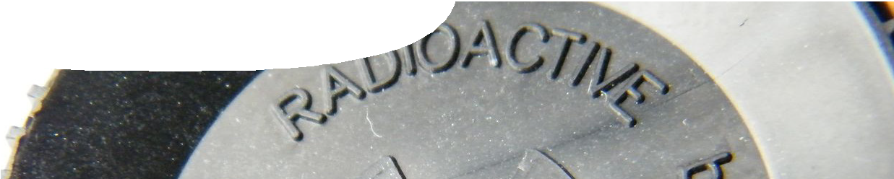
teacher guide
Nuclear reactions 7:
Radioisotopes in research

Components

 | NAME | DESCRIPTION | AUDIENCE
 | Radioisotopes in research  teachers guide | The guide describes how this resource can be used to illustrate use of radioisotopes in research. | teachers
 | Super-sensitive plants  fact sheet | Phosphorus-33 is used to investigate why some native plants are super-sensitive to phosphate. | students
 | Protein pathways  fact sheet | Phosphorus-32 is used to investigate the processes involved in protein phosphorylation. | students
 | Dynamic dunnarts  fact sheet | Rubidium-86 is used to measure the field metabolic rate of a small nocturnal marsupial. | students
 | Tough teeth  fact sheet | Iron-55 is used to investigate how chitons (marine molluscs) incorporate magnetite into their teeth. | students

Purpose
To enable students to develop their understanding of applications of radioisotopes in scientific research.

Outcomes
Students:
- explain how radioisotopes can be used safely in research; and
- describe a variety of different ways in which radioisotopes are used in different situations.

Activity summary

ACTIVITY | POSSIBLE STRATEGY
Students use the jigsaw strategy to share concepts from four fact sheets. Working in four groups (each with a different fact sheet), students first summarise information before a spokesperson for each group delivers salient points to students from the other groups. | Jigsaw strategy with four groups based upon four fact sheets
Students develop a placemat to highlight the main ideas from the four examples or they submit four quiz questions (with answers) to be used in a class quiz about radioisotopes in research. | Placemat in groups or quiz

Technical requirements
The teacher guide and fact sheets require Adobe Reader (version 5 or later), which is a free download from www.adobe.com.

Acknowledgements
Science advisors: Dr Patrick Finnigan (School of Plant Biology, The University of Western Australia), Dr Paul Besant (School of Biomedical, Biomolecular and Chemical Sciences, The University of Western
Australia), Sean Tomlinson (School of Animal Biology, The University of Western Australia) and Edd Stockdale (Centre for Microscopy, Characterisation and Analysis, The University of Western Australia). Additional photography by Dr Allan Jones (School of Life Sciences, University of Dundee) and Miriam Sullivan.
Designed and developed by the Centre for Learning Technology, The University of Western Australia.
Production team: Jan Dook, Alwyn Evans, Bob Fitzpatrick, Paul Ricketts, Gary Thomas and Michael Wheatley, with thanks to Roger Dickinson, Jenny Gull and Wendy Sanderson.
banner image: ‘Americium container in a smoke detector’ by Whitepaw. PD. en.wikipedia.org/wiki/File:Americium-241.jpg

Associated SPICE resources
SPICE resources and copyright
All SPICE resources are available from the Centre for Learning Technology at The University of Western Australia (“UWA”). Selected SPICE resources are available through the websites of Australian State and Territory Education Authorities.
Copyright of SPICE Resources belongs to The University of Western Australia unless otherwise indicated.
Teachers and students at Australian and New Zealand schools are granted permission to reproduce, edit, recompile and include in derivative works the resources subject to conditions detailed at spice. wa.edu.au/usage.
All questions involving copyright and use should be directed to SPICE at UWA.
Web: spice.wa.edu.au Email: spice@uwa.edu.au Phone: (08) 6488 3917
Centre for Learning Technology (M016) The University of Western Australia
35 Stirling Highway
Crawley WA 6009

Nuclear reactions 7: Radioisotopes in research may be used in conjunction with related SPICE resources to address the broader topic of nuclear physics.

DESCRIPTION | LEARNING PURPOSE
Nuclear reactions
This learning pathway shows how a number of SPICE resources can be combined to teach the topic of ionising radiation and nuclear reactions.
Nuclear reactions 1: Mines to medicine  Students express their opinions on a moral issue after viewing a film of demonstrators at a uranium mine and after a medical physicist explains why nuclear medicine is so important to diagnostic and therapeutic procedures. | Engage
Nuclear reactions 2: Nuclear radiation  Students investigate types and properties of radiation with particular attention to penetrative characteristics. | Explore 1
Nuclear reactions 3: Nuclear decay  Students manipulate variables in an interactive simulation to investigate connections between decay and half-life. An alternative procedure using dice is provided. | Explore 2
Nuclear reactions 4: Decay chains  In three separate interactive simulations, students experience modelling as an alternative way of exploring nuclear decay and half-life. | Explore 3
Nuclear reactions 5: Fission and fusion  Worked examples explain how to calculate mass defect and binding energy for fission and fusion reactions. The experimental ITER fusion reactor is also discussed. | Explain
Nuclear reactions 6: Nuclear medicine  Students explore applications of radioisotopes in medicine. | Elaborate 1
Nuclear reactions 7: Radioisotopes in research  Fact sheets illustrate the use of radioisotopes in research being undertaken at The University of Western Australia. | Elaborate 2

