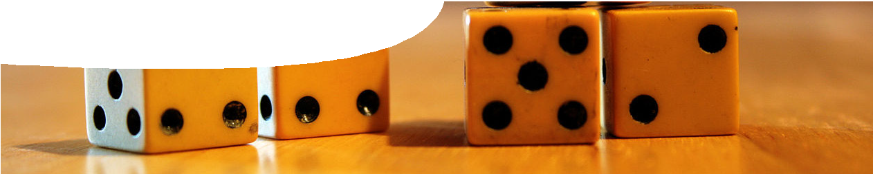
teacher guide
Nuclear reactions 3:
Nuclear decay

Components

 | NAME | DESCRIPTION | AUDIENCE
 | Nuclear decay  teachers guide | This guide shows how simulations may be used to explore radioactive decay. | teachers
 | Isotopes  fact sheet | This fact sheet describes applications of isotopes in environmental science and dating. | students
 | Nuclear decay simulator  learning object | Students investigate how selected radioisotopes decay over time. | students
 | Investigating nuclear decay  worksheet | This worksheet provides a framework for student use of the nuclear decay simulator. | students
 | Decay with dice  worksheet | Students engage in a simulation by throwing dice to represent nuclei decaying. | students

Purpose
To Explore the mathematical rules that govern radioactive decay.

Outcomes
Students:
- explain the meaning of nuclear decay,
- explain rate of nuclear decay and half-life using different radioactive isotopes,
- describe the relationship between decreasing amount of parent isotope and growth of daughter products, and
- understand that simulations are a legitimate alternative to actual laboratory experiences.

Activity summary

ACTIVITY | POSSIBLE STRATEGY
Students explore the interactive learning object, Nuclear decay simulator. They use the interaction to respond to questions posed on the worksheet, Investigating nuclear decay. | individually, in pairs or as a whole class activity
Discuss the worksheet, Investigating nuclear decay, then complete it. | teacher-led discussion
As an alternative, students simulate nuclear decay by throwing dice, recording results in a table, and answering questions in the  worksheet, Decay with dice. See details below under Dice simulation. | whole class activity
The fact sheet, Isotopes, describes some practical applications of stable and radioactive isotopes (Science as a Human Endeavour concepts). | individual study

Teacher notes: Nuclear decay simulator
The Nuclear decay simulator contains data for 16 radioactive isotopes. Decay of a fixed number of atoms is simulated over a user-adjustable
timescale. The selected isotopes have half-lives in the range of a few seconds to thousands of years. Two of the isotopes have a two-stage decay with an intermediate daughter product that is itself radioactive, and one isotope has a branched decay leading to two stable daughters.
All interaction in this learning object takes place on one screen. The screen is divided into three panels. The left panel lists the Parent isotope,
Number of atoms and Timescale — all with a variety of selections. The centre panel displays a visual representation of the decaying atoms and includes controls to Start, Pause, Resume and Reset the simulation. The right panel graphs number of atoms of an isotope against time.

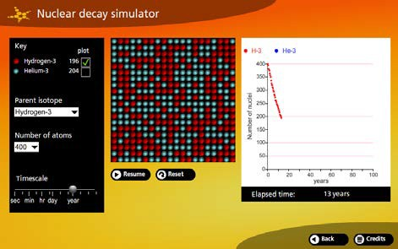
Figure 1: Nuclear decay simulator interface
For most isotopes a single parent and daughter isotope will be displayed: e g hydrogen-3 (parent) and helium-3 (daughter). Students may choose to graph: just the parent isotope (where the number of atoms decreases with time); just the daughter isotope (where the number of atoms increases with time); or both parent and daughter isotopes simultaneously.
For two of the isotopes (oxygen-20 and
strontium-90) an intermediate radioactive daughter is also produced and can be graphed. One isotope (iridium-192) has a branched decay scheme.
Approximately 95% of the isotope decays via β-decay to a stable isotope (platinum-192), and 5% via electron capture to a stable isotope (osmium-192).
The timescale can be adjusted whilst the simulation is running. This provides a quick way of determining an appropriate timescale setting for any given parent isotope. Once a suitable timescale has been located, the simulation can be reset then run again.
Move the cursor over the graph to display x and y-coordinates. The half-life of an isotope can
be determined by moving the cursor over the intersection of the decay trace with the horizontal ordinate that corresponds to half the starting number of atoms decayed.
Table 1 lists parent isotopes included in this learning object, with daughter products and half-life.

PARENT | DAUGHTER | HALF-LIFE
hydrogen-3 | helium-3 | 12.32 yr
beryllium-11 | boron-11 | 13.81 s
carbon-14 | nitrogen-14 | 5730 yr
carbon-10 | boron-10 | 19.255 s
carbon-15 | nitrogen-15 | 2.449 s
nitrogen-16 | oxygen-16 | 7.13 s
nitrogen-17 | oxygen-17 | 4.173 s
oxygen-19 | fluorine-19 | 26.91 s
oxygen-20 | fluorine-20* | 13.51 s
fluorine-20 | neon-20 | 11.0 s
caesium-137 | barium-137 | 30.2 yr
iodine-131 | xenon-131 | 8 days
polonium-210 | lead-206 | 138.37 days
strontium-90 | yttrium-90* | 29.1 yr
yttrium-90 | zirconium-90 | 64 hr
iridium-192 | platinum-192 (95%)  osmium-192 (5%) | 73.8257 days
Table 1: Parent and dughter isotopes in Nuclear decay simulator. Daughter products marked (*) are themselves radioactive.

Dice simulation

Materials
100 dice

Method
- Distribute dice evenly among students.
- Make provision for results of the demonstration to be displayed to students (e g a table on the whiteboard).
- Inform students that:
  - dice are radioactive ‘nuclei’;
  - each throw is an equal time interval of, say, one day; and
  - a six is a decayed nucleus.
- On a command from the teacher students throw their dice onto the desk and note the number of sixes (decayed nuclei). Record total number that have decayed and total number of nuclei remaining.
- Remove decayed nuclei from the experiment.
- Repeat steps 4 and 5 until all nuclei have decayed.
- Issue worksheets to students, who copy results into their own table and answer questions about the experiment.

Why are some isotopes stable and others radioactive?

Equations modelling the behaviour of particles in atomic nuclei are complex, but it’s possible to get some idea of the mathematics of isotopes by
considering neutron stability. A neutron in isolation is unstable, quickly decaying into a proton, electron and antineutrino. A neutron in an atomic nucleus can be completely stable. How does this difference arise?
1 n → 1 p + e− + ν

Let’s now consider the case of a deuterium (hydrogen-2) atom. A deuterium nucleus contains a proton and a neutron, bound together by the
strong interaction. In addition to mass energy of the neutron and proton there’s also binding energy to consider. This is potential energy that arises from interaction between the proton and neutron. In this case binding energy is negative. That is, it requires energy to separate the proton and neutron.

0 1 { 1 n + 1 p} → 1 p + 1 p + e− + ν

Neutron decay (or beta decay) takes place when a down quark converts into an up quark through the weak interaction. For this decay to happen spontaneously, total mass energy of the products
cannot be greater than the mass energy of the initial neutron.
Masses of neutrons, electrons and protons are well known, so the energy budget of the reaction can be calculated using Einstein’s equation relating mass and energy, E = mc2.
Mass energies in Table 2 are expressed in gigaelectron-volts (GeV) where 1 GeV = 109 eV.

MASS ENERGY OF INITIAL PARTICLE IN GeV |  | MASS ENERGY OF PRODUCTS IN GeV
neutron | 0.939 565 | proton | 0.938 272
 |  | electron | 0.000 511
 |  | antineutrino | 0.000 000
total | 0.939 565 | total | 0.938 783

Table 2: energy budget for free neutron decay

Total mass energy of the products is less than the mass energy of the neutron, so this neutron decay can spontaneously occur. The missing energy of
0.000 782 GeV doesn’t just disappear: it’s given to the products as kinetic energy.
With negligible mass the antineutrino has effectively no kinetic energy, so kinetic energy is distributed between the proton and electron. The small mass of an electron explains why it may be ejected from a nucleus at close to the speed of light in beta decay.
0 1 1 1

MASS ENERGY OF INITIAL PARTICLES IN GeV |  | MASS ENERGY OF PRODUCTS IN GeV
proton | 0.938 272 | 2 protons | 1.876 544
neutron | 0.939 565 | electron | 0.000 511
binding energy | -0.002 225 | antineutrino | 0.000 000
total | 1.875 612 | total | 1.877 055
Table 3: Energy budget for neutron decay in deuterium

Now we find that the energy of the products is greater than the starting energy, and that’s even before we’ve added kinetic energy to the products. Therefore this process can’t happen spontaneously, and a neutron in a deuterium nucleus is stable.
Repeating these calculations for other isotopes yields varying results: sometimes potential decay products have less mass energy than starting particles (leading to unstable isotopes); sometimes they have more (stable isotopes).
These results account for the stability of different isotopes.
- A free neutron decays to a proton, electron and antineutrino within an average of 15 minutes.
- A deuterium (hydrogen-2) atom is stable.
- A tritium (hydrogen-3) atom decays by beta- emission (neutron decay) with a half-life of 12.32 years.

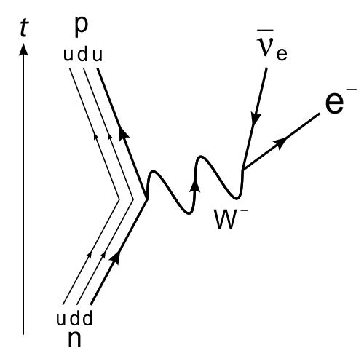
Figure 2: Feynman diagram for decay of a neutron into a proton, electron and antineutrino, via an intermediate W boson
image: Joel Holdsworth, en.wikipedia.org/wiki/File:Beta_Negative_Decay.svg

Associated SPICE resources
Nuclear reactions 3: Nuclear decay may be used in conjunction with related SPICE resources to address the broader topic of nuclear physics.

DESCRIPTION | LEARNING PURPOSE
Nuclear reactions
This learning pathway shows how a number of SPICE resources can be combined to teach the topic of ionising radiation and nuclear reactions.
Nuclear reactions 1: Mines to medicine  Students express their opinions on a moral issue after viewing a film of demonstrators at a uranium mine and after a medical physicist explains why nuclear medicine is so important to diagnostic and therapeutic procedures. | Engage
Nuclear reactions 2: Nuclear radiation  Students investigate types and properties of radiation with particular attention to penetrative characteristics. | Explore 1
Nuclear reactions 3: Nuclear decay  Students manipulate variables in an interactive simulation to investigate connections between decay and half-life. An alternative procedure using dice is provided. | Explore 2
Nuclear reactions 4: Decay chains  In three separate interactive simulations, students experience modelling as an alternative way of exploring nuclear decay and half-life. | Explore 3
Nuclear reactions 5: Fission and fusion  Worked examples explain how to calculate mass defect and binding energy for fission and fusion reactions. The experimental ITER fusion reactor is also discussed. | Explain
Nuclear reactions 6: Nuclear medicine  Students explore applications of radioisotopes in medicine. | Elaborate 1
Nuclear reactions 7: Radioisotopes in research  Fact sheets illustrate the use of radioisotopes in research being undertaken at The University of Western Australia. | Elaborate 2

Technical requirements
The learning object requires Adobe Flash Player version 8 or later on the client machine (this is a free download from www.adobe.com).

The teachers guide, fact sheet and worksheets require Adobe Reader (version 5 or later), which is a free download from www.adobe.com. The worksheets are also available in Microsoft Word format.

Acknowledgements
Developed by the Centre for Learning Technology, UWA. Production team: Brett Boughton (Willetton Senior High School), Alan Cadby, Fred Deshon, Bob Fitzpatrick, Jenny Gull, Trevor Hutchison, Paul Ricketts, Gary Thomas and Michael Wheatley.
banner image: ‘Five ivory dice’ by Liam Quin. CC-BY-3.0. en.wikipedia.org/wiki/File:Five_ivory_dice.jpg

SPICE resources and copyright
All SPICE resources are available from the Centre for Learning Technology at The University of Western Australia (“UWA”). Selected SPICE resources are available through the websites of Australian State and Territory Education Authorities.
Copyright of SPICE Resources belongs to The University of Western Australia unless otherwise indicated.
Teachers and students at Australian and New Zealand schools are granted permission to reproduce, edit, recompile and include in derivative works the resources subject to conditions detailed at spice.wa.edu.au/usage.
All questions involving copyright and use should be directed to SPICE at UWA.
Web: spice.wa.edu.au Email: spice@uwa.edu.au Phone: (08) 6488 3917
Centre for Learning Technology (M016) The University of Western Australia
35 Stirling Highway
Crawley WA 6009

