teacher guide
Energy transformations 2:
Investigating energy

Components

 | NAME | DESCRIPTION | AUDIENCE
 | Investigating energy  teacher guide | This guide explains how students can explore concepts of energy types and transformations through practical activities. | teachers
 | Junk cars  procedure sheet | Students use recycled material to make a car that rolls as far as possible down a slope. They investigate a variety of ways to provide their car with energy, including: wind energy, solar energy and chemical energy. | students
 | Waste energy  procedure sheet | A series of short activities demonstrates that waste energy is released as heat during various energy transformations. | students

Purpose
Students Explore ways energy can be converted to kinetic energy to make a car move. They also explore how energy is wasted, as heat, during energy transformations.

Activity summary
Outcomes
Students:
- understand that energy is required to bring about change or make things happen;
- list some types of energy and give examples of their sources;
- explain that energy can be transformed from one type to another;
- understand that energy transformations are not always efficient, and that energy is often wasted as heat; and
- design and carry out an investigation to solve a problem.

ACTIVITY POSSIBLE STRATEGY
Students perform an investigation described in the procedure, Junk cars. Suggestions and possible examples are included below in Teacher notes. | small groups
Students use the procedure sheet, Waste energy, to explore where wasted energy goes. | small groups

Technical requirements
The teacher guide and procedure sheets require Adobe Reader (version 5 or later), which is a free download from www.adobe.com. The procedure sheets are also provided in Microsoft Word format.

Acknowledgements
Thanks to Glenda Leslie (Curriculum Consultant P–12 science, AISWA).
Designed and developed by the Centre for Learning Technology, The University of Western Australia.
Production team: Alwyn Evans, Bob Fitzpatrick, Sally Harban, Dan Hutton, Paula Lourie, Dominic Manley, Bec McKinney, Paul Ricketts, Kate Vyvyan and Michael Wheatley with thanks to Beate Ferbert- Booth, Jan Dook, Jenny Gull, Wendy Sanderson and Jodie Ween.

Elastic band powered
Equipment:
- basic junk car with rotating rear axle
- 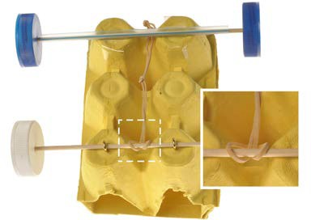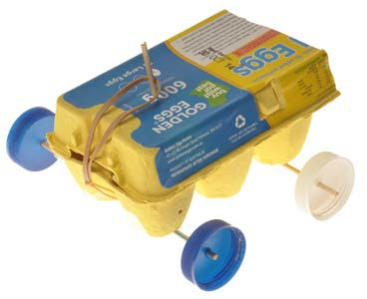2 elastic bands

Chemical reaction powered
Equipment:
- basic junk car
- film canister
- sodium bicarbonate
- vinegar and tape
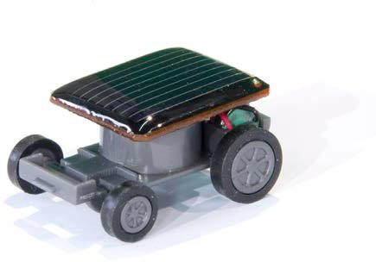
- or you could use antacid tablet and water for reaction

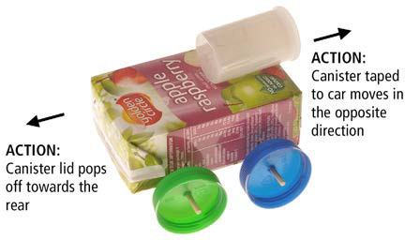

Alternative activity
Small solar cars may be used as an alternative to this activity. Students can plan and execute an open investigation into factors that affect the performance of a solar car.

SPICE resources and copyright
All SPICE resources are available from the Centre for Learning Technology at The University of Western Australia (“UWA”). Selected SPICE resources are available through the websites of Australian State and Territory Education Authorities.
Copyright of SPICE Resources belongs to The University of Western Australia unless otherwise indicated.
Teachers and students at Australian and New Zealand schools are granted permission to reproduce, edit, recompile and include in derivative works the resources subject to conditions detailed at spice.wa.edu.au/usage.
All questions involving copyright and use should be directed to SPICE at UWA.
Web: spice.wa.edu.au Email: spice@uwa.edu.au Phone: (08) 6488 3917
Centre for Learning Technology (M016) The University of Western Australia
35 Stirling Highway
Crawley WA 6009

banner image: Mayang Texture Library

Associated SPICE resources
Energy transformations 2: Investigating energy may be used in conjunction with related SPICE resources to address the broader topic of energy transfer, transformation and conservation.

DESCRIPTION | LEARNING PURPOSE
Energy transformations (overview)
Energy transformations 1: Comparing cars  A video compares conventional internal combustion powered cars to REV vehicles and introduces some associated energy transformations. | Engage
Energy transformations 2: Investigating energy  Students make model vehicles that use different energy sources to investigate energy transformations. | Explore
Energy transformations 3: Analysing energy  Students develop explanations of energy transformations by analysing data from a simulated electric vehicle journey. | Explain
Energy transformations 4: Car choices  Students use data about a range of conventional, electric and hybrid vehicles to decide and communicate which car is suited to specific purposes. | Elaborate

