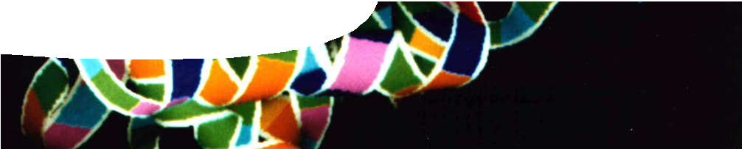
teacher guide

Reaction rates 4:
Enzymes

Components

 | NAME | DESCRIPTION | AUDIENCE
 | Enzymes  teacher guide | This explains the use of various teaching resources and gives practical information about the enzyme demonstration in the procedure sheet, Catalyst experiment. | teachers
 | Catalyst experiment  procedure sheet | An experiment shows enzymes catalysing the decomposition of hydrogen peroxide. | students
 | Enzymes in the body  fact sheet | This fact sheet explains how enzymes work, and highlights research work at The University of Western Australia on catalase and aging in mice. | students

Purpose
To Elaborate on student understandings of reaction rates, by examining enzymes and iron(III) nitrate as an examples of catalysts.

Activity summary
Outcomes
Students:
- explain how enzymes and iron(III) nitrate function as catalysts;
- explain that a catalyst works by providing an alternate pathway with lower activation energy, for a chemical reaction;
- draw energy profile diagrams for a reaction, with or without a catalyst; and
- observe changes in how an enzyme functions when factors such as temperature and pH are modified.

ACTIVITY POSSIBLE STRATEGY
Either, teacher demonstration to show how catalase, an enzyme present in fresh liver, catalyses the decomposition of hydrogen peroxide, or  students perform the experiment described on procedure sheet,  Catalyst experiment. | whole class or pairs
Students complete the worksheet based on the experiment. | individuals
Students read the fact sheet, Enzymes in the human body. | individuals

Teacher notes
The catalase investigation described in Catalyst experiment may be done either as a student experiment or a teacher demonstration. In either case, questions on the procedure sheet may be used as a follow-up activity.
Catalase enzyme may be purchased from SIGMA pharmaceuticals as an alternative to using liver.
Fresh liver is used, as catalase may be deactivated by freezing. Boiled liver is included, to demonstrate that enzymes become inactive after being denatured by temperature extremes.
In the procedure sheet, Catalyst experiment, the test tube ‘D’ is included as a control, and may lead to discussion of experimental design.
During the catalysis by iron(III) nitrate, colour changes from yellow to black, and then back to yellow. The black colour generated when H2O2 is added to the catalyst solution is due to an intermediate Fe-H2O2 complex that is believed to form during the reaction. Catalysis depends upon the presence of Fe3+, so take care to use freshly prepared Fe(III) nitrate solution.
The effect of temperature and pH on enzyme is an optional part of the activity. As with most mammalian enzymes, the optimum temperature of catalase is close to body temperature and the optimum pH close to the pH of the particular animals’ organ. In cattle, the normal body temperature is slightly higher than in humans, around 38–39°C, so for bovine catalase, optimum conditions are 40 °C and pH 7. Catalase is active in acidic conditions as low as pH 4, and will still be active at normal room temperatures.
Information about enzymes is included in the worksheet students complete after the demonstration or practical experiment.

Using the fact sheet, Enzymes in the human body
It is assumed students have completed the worksheet on enzymes, with either a practical or demonstration, before reading the fact sheet. If this is not the case, some introduction to enzymes needs to be provided by the teacher. After reading the fact sheet, students can summarise the information in a ‘Let’s consider’ format. To do this they complete four statements, beginning:
- I never knew that …
- I’ve changed my mind about …
- The most important thing I’ll remember is …
- I’m still wondering about …

Technical requirements
The guide, procedure sheet and fact sheet require Adobe Reader (version 5 or later), which is a free download from adobe.com. The procedure sheet is also provided in Microsoft Word format.

Acknowledgements
Thanks to Associate Professor Peter Arthur, School of Biomedical, Biomolecular and Chemical Sciences, The University of Western Australia.
Designed and developed by the Centre for Learning Technology, The University of Western Australia.
Production team: Leanne Bartoll, Alwyn Evans, Bob Fitzpatrick, Sally Harban, Trevor Hutchison, Emma Pointon, Paul Ricketts, Michael Wheatley and Yvonne Woolley, with thanks to Fred Deshon, Roger Dickinson, Jenny Gull and Wendy Sanderson.

SPICE resources and copyright
All SPICE resources are available from the Centre for Learning Technology at The University of Western Australia (“UWA”). Selected SPICE resources are available through the websites of Australian State and Territory Education Authorities.
Copyright of SPICE Resources belongs to The University of Western Australia unless otherwise indicated.
Teachers and students at Australian and New Zealand schools are granted permission to reproduce, edit, recompile and include in derivative works the resources subject to conditions detailed at spice.wa.edu.au/usage.
All questions involving copyright and use should be directed to SPICE at UWA.
Web: spice.wa.edu.au Email: spice@uwa.edu.au Phone: (08) 6488 3917
Centre for Learning Technology (M016) The University of Western Australia
35 Stirling Highway
Crawley WA 6009

Associated SPICE resources
Reaction rates 4: Enzymes may be used with related SPICE resources to address the broader topic of reaction rates.

DESCRIPTION | LEARNING PURPOSE
Reaction rates (overview)
This learning pathway shows how a number of SPICE resources can be combined to teach the topic of reaction rates.
Reaction rates 1: Photochemical smog  A video shows how environmental factors can increase chemical reactions that occur in the atmosphere, to produce photochemical smog. | Engage
Reaction rates 2: Investigating reaction rates  Students investigate how they can change the rate of a real-life chemical reaction in the laboratory. | Explore
Reaction rates 3: Controlling reactions  An interactive learning object explains relationships between reaction rates, collision theory, energy profile diagrams and kinetic energy distribution graphs. | Explain
Reaction rates 4: Enzymes  Students extend their knowledge of catalysts by studying how enzymes work. | Elaborate

