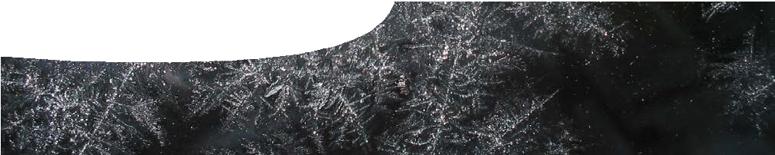
teacher guide
Reaction rates 3:
Controlling reactions

Components

 | NAME | DESCRIPTION | AUDIENCE
 | Controlling reactions  teacher guide | The guide shows how this resource may be used to explain concepts of collision theory, energy profile diagrams and kinetic energy distribution graphs. | teachers
 | Looking at reactions  learning object | Computer animations show students relationships between reaction rates, collision theory, energy profile diagrams and kinetic energy. | students
 | Factors affecting reactions  worksheet | This student worksheet questions students’ understandings of concepts demonstrated in the learning object. | students

Purpose
To Explain to students, the relationship between reaction rates, collision theory, energy profile diagrams and kinetic energy distribution graphs, through the use of computer animations.

Activity summary
Outcomes
Students:
- explain rates of different reactions in terms of energy changes and collision theory;
- interpret energy profile diagrams to show transition state, activation energy, uncatalysed and catalysed pathways, and heat of reaction; and
- explain the relationship between collision theory, kinetic energy distribution graphs, and rate of reaction.

ACTIVITY POSSIBLE STRATEGY
Students work through the computer-based learning object. This may be done in one lesson, but is best to complete over two or three lessons with supplementary class activities or discussion. | individuals or pairs (depending on computer access)
Students complete the worksheet while using the learning object. | individuals or in pairs

Use of the learning object
The learning object may be used together with the worksheet, Factors affecting reactions, to provide opportunities for discussion of concepts involved when considering reaction rates.
The first two screens in the learning object address two aspects of collision theory: energy of collisions and orientation of particles.
The screen titled ‘Burning magnesium’ explores bond- breaking and bond-making processes, and energy transfers that are involved.
The next screen explores effects of changing concentration, temperature and particle size (surface area to mass ratio) on reaction rate.

The screen titled ‘Kinetic energy distribution’ introduces the idea of activation energy and how it relates to energy distribution of a large number of molecules.
The screen ‘Energy profile diagrams’ may be used to explore energy changes within endothermic and exothermic reactions.
‘Transition states’ introduces the role of activated complexes in transition states within reactions. This enables later discussion of acid-catalysed reactions, such as decomposition of methanoic acid.
The final screen may be used to compare energy profile and energy distribution of uncatalysed and catalysed reactions.

Experiment to demonstrate the presence of a reaction intermediate
The reaction between hydrogen peroxide and tartaric acid is very slow at room temperature, without a catalyst. If cobalt (II) ions are added and the reaction mixture warmed, evolution of oxygen and carbon dioxide is readily observed. The effect of the catalyst is also easily observed as the solution changes from pink (CoCl2) to green as the cobalt(III)-tartrate intermediate complex forms and the reaction becomes vigorous. As reactants are used up, the catalyst is regenerated as CoCl2 and the pink colour returns.

Solutions required:
- 0.3M potassium sodium tartrate (dissolve 84.6 g KNaC4H4O6.4H2O make up to 1.00 L of solution);
- 6% hydrogen peroxide (dilute 100 mL 30% H2O2 to make 500 mL of solution, or use 20 volume H2O2);
- 0.3M cobalt(II) chloride (dissolve 10.0 g to make up to 250 mL of solution).

Procedure:
Set up two beakers, one to be used as a control. Place 200 mL of potassium sodium tartrate solution and
65 mL of 6% hydrogen peroxide in each beaker and warm these to approximately 65 °C.
Point out that the reaction is proceeding very slowly, if at all, as no gas bubbles are visible.
Add 15 mL of pink cobalt chloride solution to one of the beakers. TAKE CARE as the reaction will be vigorous and may overflow. A green cobalt-tartrate activated complex will be visible throughout the reaction.
On completion of the reaction the pink colour of the cobalt chloride will return.
More reaction mixture from the control can be added to demonstrate that the catalyst has been regenerated and not consumed during the reaction.

Safety:
Handle hydrogen peroxide with care – gloves and safety glasses are recommended. Watch out for splattering during the catalysed reaction.

Technical requirements
The learning object can be placed on a web or file- server and run either locally or remotely in a web browser. It requires Adobe Flash Player version 8 or later on the client machine (this is a free download from adobe.com).
The guide and worksheet require Adobe Reader (version 5 or later), which is a free download from adobe.com.

Acknowledgements
Image: ‘Ice crystals on glass’ by James. CC-BY-2.0, commons.wikimedia.org/wiki/File:Ice_crystals_on_glass.jpg
Designed and developed by the Centre for Learning Technology, The University of Western Australia.
Production team: Leanne Bartoll, Alwyn Evans, Bob Fitzpatrick, Sally Harban, Trevor Hutchison, Emma Pointon, Paul Ricketts, Michael Wheatley and Yvonne Woolley, with thanks to Fred Deshon, Roger Dickinson, Jenny Gull and Wendy Sanderson.

SPICE resources and copyright
All SPICE resources are available from the Centre for Learning Technology at The University of Western Australia (“UWA”). Selected SPICE resources are available through the websites of Australian State and Territory Education Authorities.
Copyright of SPICE Resources belongs to The University of Western Australia unless otherwise indicated.
Teachers and students at Australian and New Zealand schools are granted permission to reproduce, edit, recompile and include in derivative works the resources subject to conditions detailed at spice. wa.edu.au/usage.
All questions involving copyright and use should be directed to SPICE at UWA.
Web: spice.wa.edu.au Email: spice@uwa.edu.au Phone: (08) 6488 3917
Centre for Learning Technology (M016) The University of Western Australia
35 Stirling Highway
Crawley WA 6009

Associated SPICE resources
Reaction rates 3: Controlling reactions may be used with related SPICE resources to address the broader topic of reaction rates.

DESCRIPTION | LEARNING PURPOSE
Reaction rates (overview)
This learning pathway shows how a number of SPICE resources can be combined to teach the topic of reaction rates.
Reaction rates 1: Photochemical smog  A video shows how environmental factors can increase chemical reactions that occur in the atmosphere, to produce photochemical smog. | Engage
Reaction rates 2: Investigating reaction rates  Students investigate how they can change the rate of a real-life chemical reaction in the laboratory. | Explore
Reaction rates 3: Controlling reactions  An interactive learning object explains relationships between reaction rates, collision theory, energy profile diagrams and kinetic energy distribution graphs. | Explain
Reaction rates 4: Enzymes  Students extend their knowledge of catalysts by studying how enzymes work. | Elaborate

