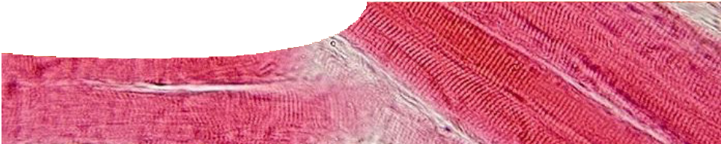
teachers guide
Buffers 2:
Buffering ability of muscles

Components
NAME DESCRIPTION AUDIENCE

 | buffering ability of muscles  teachers guide | This shows how an experiment to measure the buffering ability of different muscles can be used to explore students’ understanding of pH and buffering. | teachers
 | Buffering in muscles  procedure sheet | Students perform an experiment to investigate the buffering ability of different chicken muscles. They measure pH and buffering ability, and answer questions relating to the experiment. | students

Purpose
To conduct an experiment that compares the buffering ability of different muscles.

Outcomes
Students:
s understand that a buffer is a substance that resists changes in pH when small quantities of an acid or base are added to it;
s analyse their data to find that different muscles have different buffering capacities;
s explore the importance of buffering in muscles; and s measure changes in pH, using a pH meter.

Activity summary
ACTIVITY POSSIBLE STRATEGY
Students perform the experiment, Buffering ability of chicken muscle.  If there are time constraints, allocate one type of muscle to each group to test, then share results with the class. | small groups
Students answer questions relating to the experiment on their procedure sheet. | individual
Compare class results and discuss answers to worksheet questions. | whole class

Teachers notes
Depending on available time, it may be easier to prepare the three chicken muscle homogenates before the class begins. Homogenates must be freshly prepared on the day of the experiment. Clean the blender after each type of muscle. Record the mass of each type of muscle blended, for students to use in their calculations.
It is acceptable to use frozen chicken. Ensure that it is defrosted, and skin and bone have been removed, before it is placed in the blender. It may help to chop
up the chicken with scissors to ensure even blending of muscle tissue.
Remind students not to put homogenates down the sink. Collect them in a plastic bag and place in bin.

Concentrations used in this procedure are based on preparation of muscle in a domestic blender.
If a commercial homogeniser is used then the concentration of NaOH used in step 5 of the procedure should be increased from 0.002 mol L-1 to 0.02 mol L-1.

Second hand data for the experiment,
Buffering ability of muscles
The following data are based on experimental results. They can be used at the teacher’s discretion if reasonable student results are difficult to obtain. In this experiment 7.5 g of each muscle type was used.

HEART MUSCLE
total volume of pH total µmol of NaOH NaOH added (mL) added
0.0 | 5.90
0.2 | 6.28
0.4 | 6.61
0.6 | 6.64
0.8 | 7.25

THIGH MUSCLE
total volume of pH total µmol of NaOH NaOH added (mL) added
0.0 | 5.83
0.2 | 6.22
0.4 | 6.47
0.6 | 6.69
0.8 | 6.90
1.0 | 7.11

BREAST MUSCLE
total volume of pH total µmol of NaOH NaOH added (mL) added
0.0 | 5.98
0.2 | 6.18
0.4 | 6.41
0.6 | 6.58
0.8 | 6.74
1.0 | 6.89
1.2 | 7.06
1.4 | 7.22

Technical requirements
The teachers guide and procedure sheet require Adobe Reader (version 5 or later), which is a free download from www.adobe.com. The procedure sheet is also available in Microsoft Word format.

Acknowledgements
Banner image: Skeletal muscle – longitudinal section’, by Department of Histology, Jagiellonian University Medical College. GFDL, commons. wikimedia.org/wiki/File:Skeletal_muscle_-_ longitudinal_section.jpg
Thanks to staff of the School of Biochemistry at The University of Western Australia for assistance in developing this activity.
Designed and developed by the Centre for Learning Technology, The University of Western Australia.
Production team: Leanne Bartoll, Jan Dook, Alwyn Evans, Jenny Gull, Sally Harban and Michael Wheatley, with thanks to Pauline Charman, Bob
Fitzpatrick, Wendy Sanderson and Charmaine White.

SPICE resources and copyright
All SPICE resources are available from the Centre for Learning Technology at The University of Western Australia (“UWA”). Selected SPICE resources are available through the websites of Australian State and Territory Education Authorities.
Copyright of SPICE Resources belongs to The University of Western Australia unless otherwise indicated.
Teachers and students at Australian schools are granted permission to reproduce, edit, recompile and include in derivative works the resources subject to conditions detailed at spice.wa.edu.au/usage.
All questions involving copyright and use should be directed to SPICE at UWA.
Web: spice.wa.edu.au Email: spice@uwa.edu.au Phone: (08) 6488 3917
Centre for Learning Technology (M016) The University of Western Australia
35 Stirling Highway
Crawley WA 6009

Associated SPICE resources
Buffers 2: Buffering ability of muscles may be used in conjunction with related SPICE resources to address buffering concepts.

DESCRIPTION LEARNING PURPOSE
Buffers
This learning pathway shows how a number of SPICE resources can be combined to teach the topic of buffering.
Buffers 1: pH control in the body  A video shows the important role played by blood in keeping a constant pH in the body. A sports scientist explains his research into the effect of food supplements on sporting performance. | Engage
Buffers 2: Buffering ability of muscles  Students use a pH meter to measure the buffering capacity of different muscles of a chicken. This exploration leads students to question how buffering occurs. | Explore
Buffers 3: Explaining buffers  An interactive learning object and associated worksheet explains what a buffer is, and how it works. | Explain
Buffer 4: Buffering in the ocean  Students examine scientific data, read about the research of two scientists investigating ocean acidification and its possible consequences, then conduct an experiment to compare the buffering capacity of seawater and freshwater. | Elaborate

