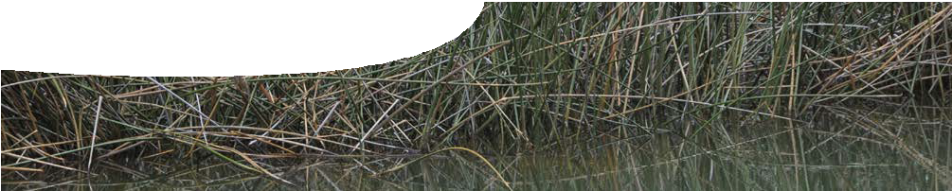
teachers guide
Redox reactions 4
Bioremediation

Components

 | NAME | DESCRIPTION | AUDIENCE
 | Bioremediation  teachers guide | The guide shows how an investigation may be used to extend student understanding of redox reactions within the context of acid sulfate soils. | teachers
 | Repairing with redox  procedure sheet | This procedure uses organic matter to increase the pH of acid soils. | students
 | Solving acid soil problems  worksheet | Various methods of reducing the impact of acid soils are outlined in a case study, and questions posed about the effectiveness of these processes. | students

Purpose
To enable students to enrich their understanding of methods used to reduce the effects of acid sulfate soils.

Activity summary
Outcomes
Students:
- explain how organic materials can be used to reduce soil acidity through bioremediation processes that involve redox reactions;
- communicate the results of their investigations to others; and
- analyse procedures for dealing with acid soils, and comment on their effectiveness.

ACTIVITY | POSSIBLE STRATEGY
Student groups complete the procedure, Repairing with redox, by selecting an organic substance to investigate and appropriate materials from the equipment list. | students in small groups
When the results of the trials have been completed, findings may be collated and conclusions used to develop recommendations. | Students communicate their results and recommendations to the class.
Students study methods used to deal with acid soils and answer questions on the worksheet, Solving acid soil problems. | students in small groups or individually

Technical requirements
The teachers guide, procedure sheet and worksheet require Adobe Reader (version 5 or later), which is a free download from www.adobe.com. The procedure sheet and worksheet are also provided in Microsoft Word format.

Acknowledgments
Thanks to PhD students Talitha Santini and Bree Morgan (School of Earth and Environment, The University of Western Australia) and Associate Professor Andrew Rate (School of Earth and Environment, The University of Western Australia).
Designed and developed by the Centre for Learning Technology, The University of Western Australia.
Production team: Bob Fitzpatrick, Helen Billiald, Alwyn Evans, Sally Harban, Dan Hutton, Gary Thomas and Michael Wheatley, with thanks to Pauline Charman, Jenny Gull, Wendy Sanderson and Charmaine White.

Teacher notes on procedure
Safety warning: Bioreactors may be made from a 250 mL beaker with a petri dish lid that is taped on during the ‘fermentation’. The teacher can extract the sample for pH testing, using a Pasteur pipette, to reduce risks to students. Bioreactors may also be sterilised, by heating, before they are opened.
This activity requires seawater. If none is available, it may be prepared by dissolving 24 g of NaCl, 5 g of MgCl2, 4 g of Na2SO4, 0.5 g of KCl and 0.7 g of FeCl3
in 1 L of water. To acidify seawater, add HCl until the
pH is about 4. Record the actual value as students will need to compare this pH with their results, after the experiment is completed.
Prepare glucose solution by dissolving 1.5 g of glucose in 1 L of water.
To compare the effectiveness of the various organic materials, allocate each group a different substance and report their results in a whole class discussion at the end of the activity. To allow for a fair comparison, use equal masses of organic materials and equal volumes of ‘acid water’.
After a week the organic materials should slowly develop a black, slimy coating. This is a precipitate of metal sulfides (mostly FeS).
It may take longer than a week to observe any significant change in the pH of filtered solutions from the various bioreactors. If this is the case allow the experiment to run for an extended period. A class discussion about the effectiveness of each organic substance and recommendations for use may follow the reporting of results.

SPICE resources and copyright
All SPICE resources are available from the Centre for Learning Technology at The University of Western Australia (“UWA”). Selected SPICE resources are available through the websites of Australian State and Territory Education Authorities.
Copyright of SPICE Resources belongs to The University of Western Australia unless otherwise indicated.
Teachers and students at Australian schools are granted permission to reproduce, edit, recompile and include in derivative works the resources subject to conditions detailed at spice.wa.edu.au/usage.
All questions involving copyright and use should be directed to SPICE at UWA.
Web: spice.wa.edu.au Email: spice@uwa.edu.au Phone: (08) 6488 3917
Centre for Learning Technology (M016) The University of Western Australia
35 Stirling Highway
Crawley WA 6009

Associated SPICE resources
Redox reactions 4: Bioremediation may be used in conjunction with related SPICE resources to address the broader topic of redox.

DESCRIPTION | LEARNING PURPOSE
Redox reactions (overview)
This learning pathway shows how a number of SPICE resources can be combined to teach the topic of redox reactions.
Redox reactions 1: Acid soils  A video shows scientists studying acid sulfate soils in two different environments and raises student awareness of the broader problem. | Engage
Redox reactions 2: Sulfide chemistry  Students explore the chemistry of sulfides through laboratory-based activities. | Explore
Redox reactions 3: Acid soils and redox  An interactive learning object explains the chemistry of redox processes that lead to the formation of acid sulfate soils. | Explain
Redox reactions 4: Bioremediation  Students investigate how acid sulfate soil problems can be dealt with through a practical activity and a case study. | Elaborate

