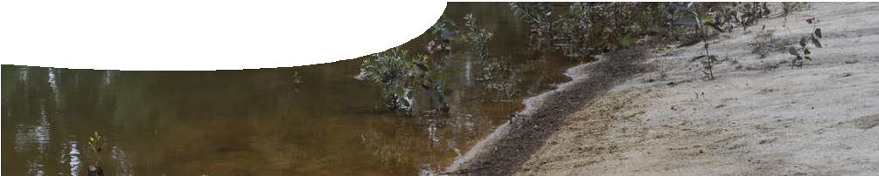
teachers guide
Redox reactions 1
Acid soils

Components

 | NAME | DESCRIPTION | AUDIENCE
 | Acid soils  teachers guide | This guide describes how the video Acid underground can be used to engage students in the topic of redox reactions in the context of acid soils. | teachers
 | Acid underground  video | This video shows two researchers investigating acid soil in Perth and Mandurah. On-site testing of soil pH and remediation are featured. | teachers and students

Purpose
To arouse interest in the problem of acid soils and the impact such soils have on the community, as well as elicit students’ prior knowledge of oxidation and reduction chemistry.

Activity summary
Outcomes
Students:
- appreciate human impact on the environment;
- understand that acidic soils are the result of chemical processes, such as oxidation and reduction and acid-base equilibria;
- understand that acidic soils impact on flora and fauna; and
- appreciate that scientific research can lead to alternative ways to solve problems.

ACTIVITY | POSSIBLE STRATEGY
Teacher introduces the video, Acid underground, which features University of Western Australia researchers, Talitha Santini and Bree Morgan. They explain the problem of acidity in soil caused by soil disturbance due to urban development. | Teacher provides a KWL chart to encourage students to show what they Know, state what they Want to find out and reflect on what they Learned later in the sequence.

Acknowledgements
Thanks to PhD students Talitha Santini and Bree Morgan (School of Earth and Environment, The University of Western Australia) and Associate Professor Andrew Rate (School of Earth and Environment, The University of Western Australia).
Designed and developed by the Centre for Learning Technology, The University of Western Australia.
Production team: Bob Fitzpatrick, Helen Billiald, Alwyn Evans, Sally Harban, Dan Hutton, Paul Ricketts, Gary Thomas and Michael Wheatley, with thanks to Pauline Charman, Jenny Gull, Wendy Sanderson and Charmaine White.

Technical requirements
The teachers guide requires Adobe Reader (version 5 or later), which is a free download from www.adobe.com.
QuickTime version 7 or later is required to view the video. This is a free download from www.apple.com/ quicktime. A high quality MP4 version is available on CD-ROM or download from the SPICE website.
The video contains closed captions.

SPICE resources and copyright
All SPICE resources are available from the Centre for Learning Technology at The University of Western Australia (“UWA”). Selected SPICE resources are available through the websites of Australian State and Territory Education Authorities.
Copyright of SPICE Resources belongs to The University of Western Australia unless otherwise indicated.
Teachers and students at Australian schools are granted permission to reproduce, edit, recompile and include in derivative works the resources subject to conditions detailed at spice.wa.edu.au/usage.
All questions involving copyright and use should be directed to SPICE at UWA.
Web: spice.wa.edu.au Email: spice@uwa.edu.au Phone: (08) 6488 3917
Centre for Learning Technology (M016) The University of Western Australia
35 Stirling Highway
Crawley WA 6009

Teacher notes
Presenters in the video mention several sulfide species, including iron monosulfide (FeS) and pyrite (FeS2). Both species contribute to the formation of monosulfidic sediment (also known as monosulfidic black ooze or MBO).
Some solutions and current management options to deal with acid sulfate soils are discussed in
Redox reactions 4: Bioremediation.
The following questions may form the basis of class discussion after viewing the video.

QUESTION | SUGGESTED RESPONSE
Why is hydrogen peroxide used to demonstrate formation of acid in the lake? | Hydrogen peroxide reacts with water to produce large quantities of oxygen that hasten the formation of acidic species.
How does disturbing iron sulfides, such as pyrite, cause the formation of acid? | Iron sulfides are exposed to oxygen in the air when disturbed. The reaction between oxygen and sulfides produces acid.
How could local building works cause soils to become acidic? | Building works could disturb pyrite trapped underground. On exposure to air, pyrite produces acid that is retained in the topsoil.
Suggest why acid soils have been identified as such a serious problem in Mandurah compared to other coastal areas south of Perth. | Compared to other coastal sites south of Perth, Mandurah is a rapidly expanding region. It is likely that more iron sulfides will be exposed and hence more likelihood of acid soils being formed, compared to less developed sites.
How can increasing the depth of bore holes in the Stirling district reduce the incidence of bore water killing plant life? | By tapping into water that lies below acidic groundwater reserves, water that is not acidic can be brought to the surface to water gardens.
Iron sulfides are mentioned in the video. Write formulae for three common iron sulfides. | FeS2 (pyrite); FeS (pyrrhotite); Fe3S4 (greigite)
What might be done to reduce lake acidity, in the short term. | Acidity may be reduced by adding limestone, or a similar compound, to neutralise the acid.

Associated SPICE resources
Redox reactions 1: Acid soils may be used in conjunction with related SPICE resources to address the broader topic of redox.

DESCRIPTION | LEARNING PURPOSE
Redox reactions (overview)
This learning pathway shows how a number of SPICE resources can be combined to teach the topic of redox reactions.
Redox reactions 1: Acid soils  A video shows scientists studying acid sulfate soils in two different environments and raises student awareness of the broader problem. | Engage
Redox reactions 2: Sulfide chemistry  Students explore the chemistry of sulfides through laboratory-based activities. | Explore
Redox reactions 3: Acid soils and redox  An interactive learning object explains the chemistry of redox processes that lead to the formation of acid sulfate soils. | Explain
Redox reactions 4: Bioremediation  Students investigate how acid sulfate soil problems can be dealt with through a practical activity and a case study. | Elaborate

