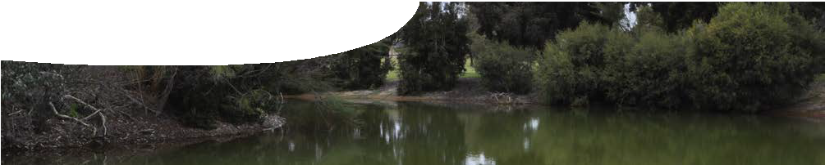
teachers guide
Redox reactions 3
Acid soils and redox

Components

 | NAME | DESCRIPTION | AUDIENCE
 | Acid soils and redox  teachers guide | This guide explains how a learning object and accompanying worksheet can be used to explain how redox processes cause some soils to become acidic. | teachers
 | Redox explorer  learning object | A learning object demonstrates how a series of redox reactions, involving sulfides and iron, produces acidic soils. | students
 | Redox processes  worksheet | This worksheet accompanies the learning object, Redox explorer. Students use the learning object to answer questions about redox processes. | students

Purpose
To Explain how acid soils are formed so students can develop their understanding of oxidation and reduction processes.

Activity summary
Outcomes
Students:
- explain how redox reactions can lead to the formation of sulfide rich sediments;
- explain how redox reactions cause some soils to become acidic; and
- assign oxidation numbers, and write balanced redox equations, using half equations.

ACTIVITY | POSSIBLE STRATEGY
Students use the learning object, Redox explorer, to complete the worksheet, Redox processes. | Pairs or individuals work through learning object.  Students complete the worksheet individually.
Class discussion of answers and points of interest. | whole class

Teacher notes

Explanation of oxidation in waterlogged soil
Question 7e on the worksheet asks about reactions that take place in waterlogged soil. The learning object shows two reduction reactions taking place, but the oxidation half reaction is not shown as this chemistry is complex. Carbon is oxidised from organic

Hydrogen sulfide then converts metal ions to metal sulfide deposits.
H2S + M2 + → MS( ) + 2H+
s
Pyrite, however, has a complex structure in which the two sulfur ions act as a S 2- group and not as

matter, represented by CH2O (oxidation number 0), to -
2
2+ 2-

form carbon dioxide (oxidation number +4).
Anaerobic, sulfur-reducing bacteria use sulfate in respiration processes, instead of oxygen, to oxidise carbon in organic matter.
2CH2O + SO2 − + 2H+ → H S + 2H O + 2CO
4 2 2 2
separate S ions in each Fe S2 formula unit of pyrite.
The worksheet that accompanies the learning object focusses upon reactions which do not involve this group, but involve the S2- ion.

Further practice
Further practice in determining oxidation numbers can be gained by students completing Set 24 – Oxidation Number in STAWA Exploring Chemistry Stage 2, page 174.

Technical requirements
The teachers guide and worksheet require Adobe Reader (version 5 or later), which is a free download from www.adobe.com.
The learning object requires Adobe Flash Player version 8 or later (this is a free download from www. adobe.com). It can be placed on a web or file-server and run either locally or remotely in a web browser.

Acknowledgements
Designed and developed by the Centre for Learning Technology, The University of Western Australia.
Production team: Bob Fitzpatrick, Anton Ball, Helen Billiald, Alwyn Evans, Sally Harban, Dan Hutton, Gary Thomas and Michael Wheatley, with thanks to Pauline Charman, Jenny Gull, Wendy Sanderson and Charmaine White.

SPICE resources and copyright
All SPICE resources are available from the Centre for Learning Technology at The University of Western Australia (“UWA”). Selected SPICE resources are available through the websites of Australian State and Territory Education Authorities.
Copyright of SPICE Resources belongs to The University of Western Australia unless otherwise indicated.
Teachers and students at Australian schools are granted permission to reproduce, edit, recompile and include in derivative works the resources subject to conditions detailed at spice.wa.edu.au/usage.
All questions involving copyright and use should be directed to SPICE at UWA.
Web: spice.wa.edu.au Email: spice@uwa.edu.au Phone: (08) 6488 3917
Centre for Learning Technology (M016) The University of Western Australia
35 Stirling Highway
Crawley WA 6009

Associated SPICE resources
Redox reactions 3: Acid soils and redox may be used in conjunction with related SPICE resources to address the broader topic of redox.

DESCRIPTION | LEARNING PURPOSE
Redox reactions (overview)
This learning pathway shows how a number of SPICE resources can be combined to teach the topic of redox reactions.
Redox reactions 1: Acid soils  A video shows scientists studying acid sulfate soils in two different environments and raises student awareness of the broader problem. | Engage
Redox reactions 2: Sulfide chemistry  Students explore the chemistry of sulfides through laboratory-based activities. | Explore
Redox reactions 3: Acid soils and redox  An interactive learning object explains the chemistry of redox processes that lead to the formation of acid sulfate soils. | Explain
Redox reactions 4: Bioremediation  Students investigate how acid sulfate soil problems can be dealt with through a practical activity and a case study. | Elaborate

