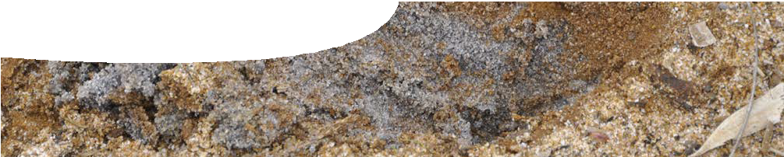
teachers guide
Redox reactions 2
Sulfide chemistry

Components

 | NAME | DESCRIPTION | AUDIENCE
 | Sulfide chemistry  teachers guide | This guide describes how practical activities can be used by students to explore the chemistry of sulfides. | teachers
 | Investigating sulfides  procedure sheet | This practical activity investigates how soils become acidic due to redox processes. See note about safety in the Activity summary. | students

Purpose
To enable students to Explore concepts of oxidation and reduction, within the context of soil chemistry.

Activity summary
Outcomes
Students:
- apply their knowledge of oxidation and reduction reactions to metal sulfide reactions;
- appreciate that redox reactions occur in a variety of everyday phenomena, including acid sulfate soils;
- investigate chemical reactions that involve the transfer of electrons and do not necessarily involve oxygen;
- observe reactions involving metal cations and soluble sulfide ions; and
- observe chemical reactions that lead to the production of acid soils.

ACTIVITY | POSSIBLE STRATEGY
Students are guided through four sections of the procedure, Investigating sulfides.  However it may be more appropriate for parts B and C to be done as teacher demonstrations as there are some vigorous reactions involving hydrogen peroxide. | students in small groups, or teacher demonstration for parts B and C
Students answer questions within the procedure sheet. | individuals

Teacher notes
Safety consideration: The activities described in the procedure, Investigating sulfides, should be carried out in a fume cabinet due to the likely production of hydrogen sulfide gas.
It is assumed that students have some background in redox reactions before investigating oxidation and reduction in the context of soil chemistry. They should be familiar with definitions of oxidation and reduction, writing half equations and writing redox equations.
It is suggested that practical activities in Experiment 25 from STAWA Exploring Chemistry Stage 2, particularly part B, be completed by students before progressing to Investigating sulfides.

In part B, question 8 of Investigating sulfides asks students to write a general equation that represents hydrogen peroxide reacting with a sulfide. It may not be obvious from the equation why this reaction lowers pH. This arises because of disproportionation (simultaneous oxidation and reduction) of hydrogen peroxide, as shown by this equation:
H2O2(aq ) → 2H+ + O2(g ) + 2e−
If there is no natural pyrite rich soil readily available for parts C and D of this procedure then artificial soil can be produced by adding about 2% pyrite (by mass) to sand.

Acknowledgements
Thanks to PhD students Talitha Santini and Bree Morgan (School of Earth and Environment, The University of Western Australia) and Associate Professor Andrew Rate (School of Earth and Environment, The University of Western Australia).
Designed and developed by the Centre for Learning Technology, The University of Western Australia.
Production team: Bob Fitzpatrick, Helen Billiald, Alwyn Evans, Sally Harban, Dan Hutton, Paul Ricketts, Gary Thomas and Michael Wheatley, with thanks to Pauline Charman, Jenny Gull, Wendy Sanderson and Charmaine White.

Technical requirements
The teachers guide and procedure sheet require Adobe Reader (version 5 or later), which is a free download from www.adobe.com. The procedure sheet is also available in Microsoft Word format.

SPICE resources and copyright
All SPICE resources are available from the Centre for Learning Technology at The University of Western Australia (“UWA”). Selected SPICE resources are available through the websites of Australian State and Territory Education Authorities.
Copyright of SPICE Resources belongs to The University of Western Australia unless otherwise indicated.
Teachers and students at Australian schools are granted permission to reproduce, edit, recompile and include in derivative works the resources subject to conditions detailed at spice.wa.edu.au/usage.
All questions involving copyright and use should be directed to SPICE at UWA.
Web: spice.wa.edu.au Email: spice@uwa.edu.au Phone: (08) 6488 3917
Centre for Learning Technology (M016) The University of Western Australia
35 Stirling Highway
Crawley WA 6009

Associated SPICE resources
Redox reactions 2: Sulfide chemistry may be used in conjunction with related SPICE resources to address the broader topic of redox.

DESCRIPTION | LEARNING PURPOSE
Redox reactions (overview)
This learning pathway shows how a number of SPICE resources can be combined to teach the topic of redox reactions.
Redox reactions 1: Acid soils  A video shows scientists studying acid sulfate soils in two different environments and raises student awareness of the broader problem. | Engage
Redox reactions 2: Sulfide chemistry  Students explore the chemistry of sulfides through laboratory-based activities. | Explore
Redox reactions 3: Acid soils and redox  An interactive learning object explains the chemistry of redox processes that lead to the formation of acid sulfate soils. | Explain
Redox reactions 4: Bioremediation  Students investigate how acid sulfate soil problems can be dealt with through a practical activity and a case study. | Elaborate

