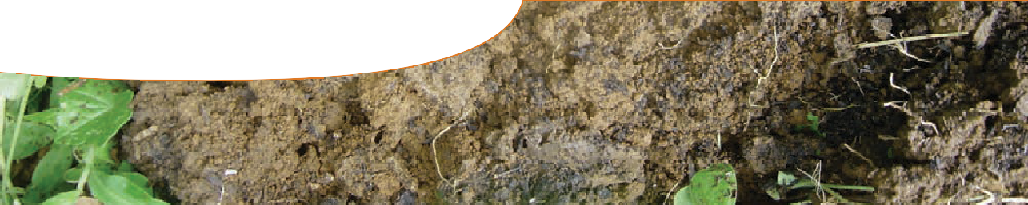
fact sheet
Soil stories

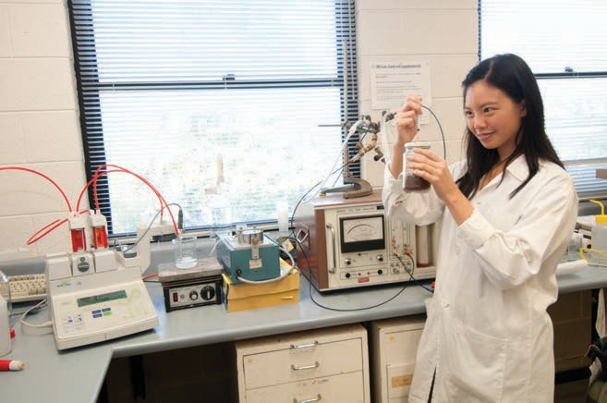Meet…
Deborah is aDeborah Lin

postgraduate student at the School of Earth and Environment, University of
Western Australia.

My research is focused on… soil microbes and how they might be our allies in the cleanup of petroleum hydrocarbons after a spill.

I chose this area of research because… we can all do something to change the world! We all use oil and gas everyday and this research is one way I can take some responsibility for that.

I hope this research will…
improve our understanding of how soil microbes can be used in the breakdown of pollutants after a spill.
I sample at… power generator sites in the north-west around Derby,
“

You need a different kind of ‘smart’ to be good at research – you certainly don’t have to be top of the class at school.
”

At each of my sites…
I had three sampling areas measuring four metres squared.
I knew the soil at these sites was fairly undisturbed, homogeneous and unpolluted. I sampled four soil cores at random from each plot, which I then mixed together.
Exmouth and Carnarvon.

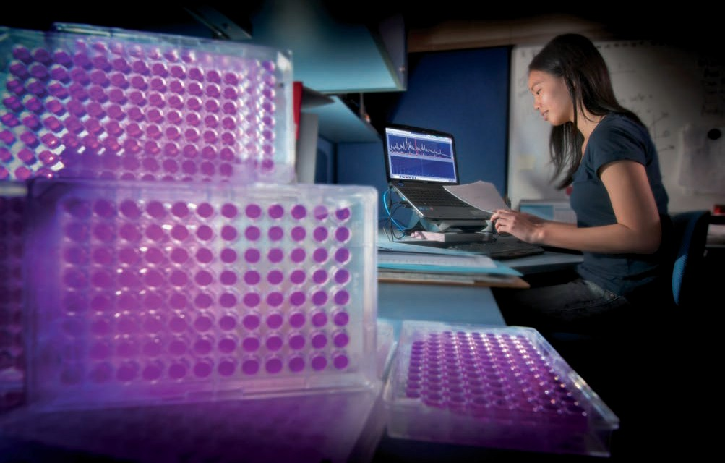
Back in the lab… I divided the soil from each of the three areas into two. Half of the samples had hydrocarbons added and these were called ‘with oil’. The other half were left untreated and these were called ‘without oil’. I then investigated how the microbes at each site responded to the hydrocarbons over time by measuring their activity.
So far my research has shown… most microbes are killed when the hydrocarbons are added, but some can increase in number even in this polluted environment. I’ve also found that microbial communities from different soils respond differently to these pollution events, and soils can sometimes take more than 20 years to be completely cleaned up from an oil spill.

I’ve learnt that in research…
you have to get things wrong - I’ve got so many things wrong! It’s hard when you hit problems, but then it’s so exciting when you find a way through. You need a different kind of ‘smart’ to be good at research – you certainly don’t have to be top of the class at school. It’s also really hard work, so it’s best to choose a topic that you absolutely love!

Martha is an international postgraduate student in the School of Earth and Environment, University of
Meet…
Martha Orozco Aceves
Western Australia.

My research is focused on… how plants and soil organisms interact, and how these interactions shape both plant development and soil community structure. In particular I am focussing on how these phenomena work in rehabilitated bauxite mined soils.

I chose this area of research because… I’ve always been interested in biological science – I think I was born with that! Plus studying the rehabilitation of mine sites is a great way of learning about soil ecology.
I hope this research will… help people appreciate the wonderful complexity of life in the soil. We know that thousands of interactions take place between plants and soil organisms, particularly in a very special site: the rhizosphere!! This is the site where roots and organisms make contact - the exciting thing is working out how this contact affects both plants and soil organisms.
My research area is… native jarrah-forest near Jarrahdale. I sampled from two jarrah-forest sites: a rehabilitation site last mined for bauxite in 2008, and an unmined site. At each site I randomly selected about 40 plants, roughly one third from each of three different species: Eucalyptus marginata (jarrah), Acacia pulchella (prickly moses) and Bossiaea ornata (broad leaved brown pea). I collected soil samples from the roots of each of the selected plants.

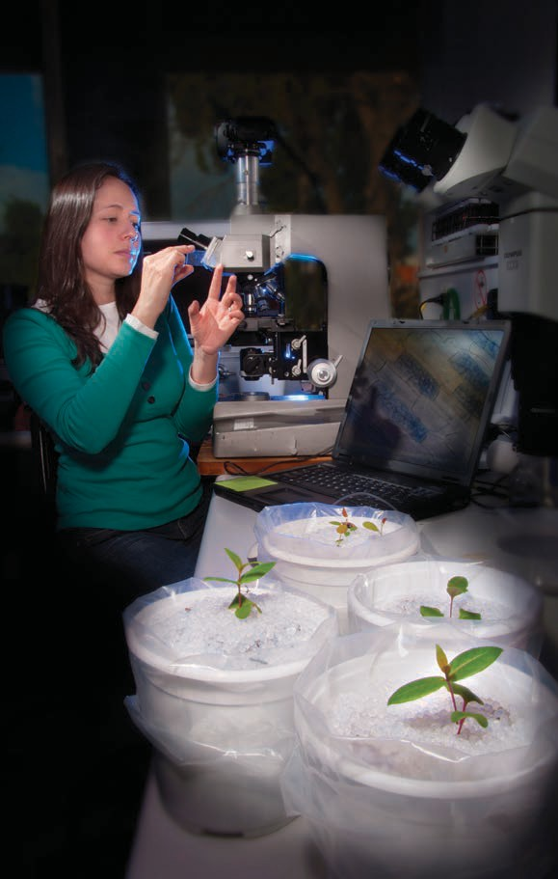
Back in the lab… I mixed together all the soil from the rehabilitation site, and transferred it into 24 plant pots. I then mixed together all the soil from the unmined site and transferred that into another 24 plant pots. The mixing ensured that any
soil organisms living around the three plant species were spread throughout the soil.
The pots were split into four groups:
- unplanted
- planted with jarrah seedlings
- planted with prickly moses seedlings, and
- planted with broad-leafed pea seedlings.
The pots were placed into two root- cooling tanks at a constant temperature to ensure that the interactions between
roots and soil organisms were not affected by environmental temperature changes. I distributed pots equally and randomly in both tanks and rotated them within and between tanks every two weeks.
I harvested the plants… after 18 weeks, oven-dried and weighed shoots and roots, and extracted and counted the number of organisms in the soil. This included bacteria, fungi, mycorrhizae, protozoa and nematodes.
I also measured chemical aspects of the soils like: pH, carbon, nitrogen, phosphorus, potassium contents and others.
So far my research has shown… that like any other organism on Earth (including us) plants like to be comfortable where they live, that is why they change the physical, chemical and biological characteristics of the soil they inhabit. This plant-driven change occurs
differently in rehabilitated and unmined soils. The most interesting result is that most Australian plants need soil organisms inhabiting their roots to help deal with adverse conditions and to grow healthily. As a result the beneficial organisms are always able to grow on and around the roots; however, there are always ‘bad guys’ causing problems to plants — believe it or not the rhizosphere is a war zone!
I’ve learnt that in research… you need a strong argument to back up whatever it is you’re proposing, plus careful planning to ensure you waste little time and resources. Oh, and you have to be prepared to work hard!

