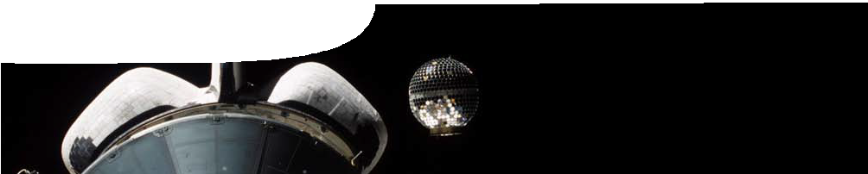
sequence overview
Satellites

ENGAGE/EXPLORE
EXPLAIN
ELABORATE

Background
These SPICE resources are intended to assist teachers in teaching aspects of motion in a gravitational field, through the context of satellites. The materials are designed to support teachers and students in their understanding of concepts relating to motion in a gravitational field and circular motion.
The resources form a sequence that includes all elements of the constructivist learning approach based on the 5-E model where teachers may:
- Engage students’ interest in the range of satellites orbiting Earth. Through the interactive learning object, Satellite explorer, students see a small sample of the hundreds of satellites in orbit around Earth in different types of orbit.
- Provide opportunities for students to Explore orbits of satellites and to visualise what Earth looks like from a satellite.
- Explain the physics of satellite motion and the sensation of weightlessness experienced by astronauts in Earth- orbiting spacecraft.
- Provide opportunities for students to Elaborate on their knowledge of satellite orbits in considering how satellites and their associated technologies impact on everyday life.
- Evaluate students’ progress throughout the learning pathway.
The pathway is designed for students studying Unit 3A Physics: Motion and forces in a gravitational field.

Purpose
These learning resources enable students to:
- explain and apply Newton’s Law of Universal Gravitation and the concept of gravitational acceleration;
- explain conditions for a satellite to remain in a stable circular orbit in a gravitational field, and calculate the parameters of such satellites using the relationships:

v = s , a
= v 2 , resultant F = ma = mv 2 , F

= G m1m2
and g = G M ; and

av t c r

r g r ² r ²

- describe and explain impacts of satellites and associated technologies on everyday life.

Learning resources

ENGAGE/EXPLORE
EXPLAIN
ELABORATE
Satellites 1: Orbiting Earth
Orbiting Earth comprises a teachers guide, an interactive learning object and a student worksheet.
The interactive learning object is designed to engage students’ interest in satellites. It enables them to explore different types of satellite orbits and to visualise what Earth looks like from different types of orbit. The worksheet guides students to explore satellite orbits and consider how information collected by satellites might impact on our everyday lives. See the teachers guide for detailed information on the purpose and use of this resource.

Activity: Observing satellites
The purpose of this activity is to engage students’ interest in satellites by directly observing them in the night sky.
The activity
Encourage students to access the Heavens above website (or similar) to find information on when and where to view a range of satellites with the naked eye.
The Heavens above website at
http://www.heavens-above.com is an online resource that shows when the International Space Station (ISS) and several other satellites are visible. The information that follows will help students to use the website.
Configuration: On the home page, select your location using the database by entering your country and town to customise search results for your location. Ten day predictions for the ISS and other satellites such as the Hubble Space Telescope (HST) can be selected. A table is displayed that shows all night-time satellite passes in the next ten days when the satellite will be visible from your location.
Magnitude (Mag.) is an indication of the relative brightness of the object. The satellite is brightest when its magnitude is as large a negative number as possible. (For comparison, Venus has a magnitude of about -4).
Altitude (Alt.) is the angle of the satellite above the horizon. Look for passes where the altitude is as large as possible (90 indicates a satellite pass directly overhead).
Azimuth (Az.) is the direction you should face to view the satellite at the time shown in the time column.
The International Space Station (ISS) is often readily visible due to its low orbit and large size. At first sight, it looks like an aircraft passing high overhead but moving much faster. Click on the Date link, then Ground track to see the ground track of the ISS. If
there are no suitable passes, check the website again a week later.

ENGAGE/EXPLORE
EXPLAIN
ELABORATE
Satellites 2: Satellite motion
Satellite motion comprises a teachers guide, fact sheet and student worksheet.
Students use a fact sheet to learn about different types of satellite orbit including their shape, centricity, altitude and inclination. The worksheet provides opportunities for students to calculate and explain the motion of satellites, and the sensation of weightlessness experienced by orbiting astronauts. See the teachers guide for detailed information on the purpose and use of this resource.

ENGAGE/EXPLORE
EXPLAIN
ELABORATE
Satellites 3: Impact of satellites
Impact of satellites comprises a teachers guide, fact sheet and worksheet.
These resources provide an opportunity for students to elaborate upon their understanding of satellites and their impact on everyday life. The fact sheet provides information about types of satellites, their orbits and potential uses of information they provide. The teachers guide provides three alternative activities through which students can use the fact sheet to enhance their understanding of the impact of satellites and their associated technologies on everyday life. See the teachers guide for detailed information on the purpose and use of this resource.

Acknowledgements
Designed and developed by the Centre for Learning Technology, The University of Western Australia.
Production team: Graham Baker, Leanne Bartoll, Geoff Cody, Alwyn Evans, Jenny Gull, Trevor Hutchison and Michael Wheatley, with thanks to Roger Dickinson, Bob Fitzpatrick, Pauline Charman and Wendy Sanderson.
Banner image: A small satellite called STARSHINE 2 is deployed from a canister in the payload bay of Space Shuttle Endeavour. credit: NASA

SPICE resources and copyright
All SPICE resources are available from the Centre for Learning Technology at The University of Western Australia (“UWA”). Selected SPICE resources are available through the websites of Australian State and Territory Education Authorities.
Copyright of SPICE Resources belongs to The University of Western Australia unless otherwise indicated.
Teachers and students at Australian schools are granted permission to reproduce, edit, recompile and include in derivative works the resources subject to conditions detailed at spice.wa.edu.au/usage.
All questions involving copyright and use should be directed to SPICE at UWA.
Web: spice.wa.edu.au Email: spice@uwa.edu.au Phone: (08) 6488 3917

Centre for Learning Technology (M016) The University of Western Australia
35 Stirling Highway
Crawley WA 6009

