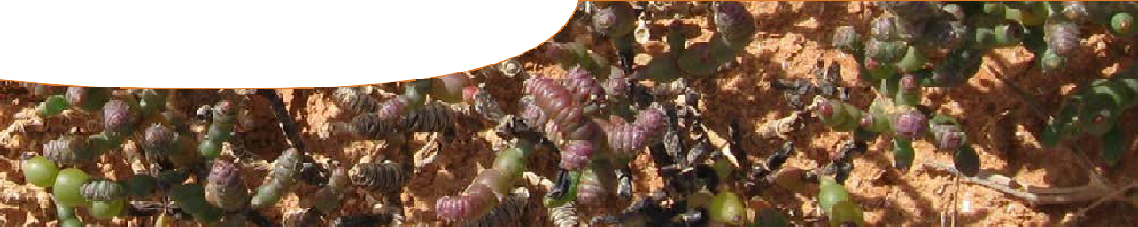
fact sheet
Researching samphires

Meet…
‘Tecticornia mellaria male flowers’ by Bindy Datson, Actis Environmental Services
Right now I am working on mechanisms of tolerance in plants to salinity and water logging. We are working on new pasture species for salt affected

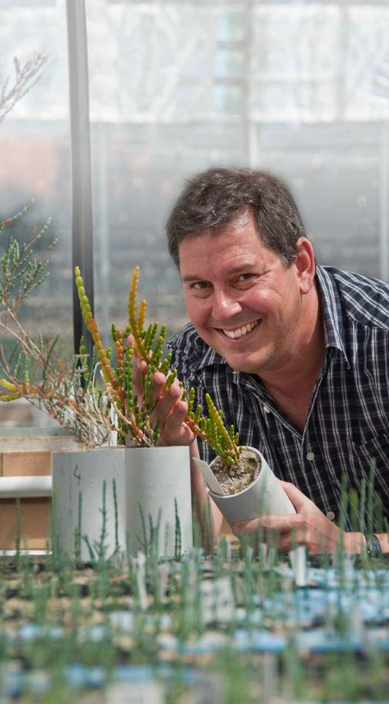Tim Colmer
Tim is a Professor in the School of Plant Biology at The University of Western Australia. He’s fascinated by samphires and the way they’re able to cope with a range of conditions – from salinity to flooding to drought. His work has helped revegetate farming and mining land.
Discussion questions
Why are people so interested in studying samphires? Why would it be useful to modify other plants to have traits like samphires?
agricultural land, and on Australian halophytes (salt-loving plants) for revegetation of saline agricultural and mining lands. That’s where samphires fit in.
My research on samphires started when a mining company at Kalgoorlie contacted us and asked us about using samphires to revegetate saline mining tailings. We used a nearby salt lake as a model system
to understand where different species of samphire grow, what sort of salinity and flooding they can cope with, and which would be the best ones to try and revegetate the tailings. The company have had some success in getting samphires and other halophytes established on their saline waste areas.

I am hoping my research on samphires will teach us about saline
ecosystems in Australia and the place of plants in those ecosystems. There’s real potential to use these different species in rehabilitation of saline land, and stabilising the land surface so that you don’t get erosion from water and wind, when it’s bare.
So far my research has shown something about what species grow where and therefore which ones we might use in certain situations. It’s also shown that we really don’t understand the full biodiversity of these kinds of plants.
In the future tolerance mechanisms, in these plants, to such high salinity might have applications in biotechnology. These traits could be used to modify other plants.
My research involves looking at how plants grow in their natural environments. I also collect seed and grow plants under controlled conditions to test hypotheses about their tolerances to flooding, drought
and salinity.

I chose a career in science because I loved chemistry at school. We had a great chemistry teacher and he was inspiring. When I looked further into what people with chemistry degrees could do I saw that agriculture actually had
a lot of applied chemistry so I chose to go down the agricultural science route. Science is an exciting career because you are always asking new questions, discovering new things, and meeting interesting people. It’s also an international career where you get to interact with people from all round the world.

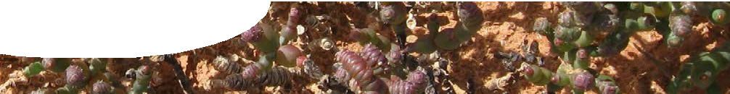
fact sheet
Researching samphires

Meet…
Kelly Shepherd
Kelly is a senior research scientist at the Herbarium of Western Australia. She spends a lot of time around salt lakes looking for new species of samphire which she then takes back to the lab and tries to identify.
Right now I am working on a samphire species complex in the Pilbara region of WA. People collecting plants in this area, usually associated with the mining industry, need to know what is on the ground for conservation reasons, and for any rehabilitation following mining. I’m here to help with identification.
It’s difficult to conserve a species if you don’t have a name for it so part of my work is identifying new species and giving that species a name that describes its characteristics or features. As there are thousands of salty lakes in Australia I have no doubt there are lots of new species, all subtly different from each other, that may be found at these lakes.

I chose to research samphires by
happy accident! When I returned from backpacking overseas I looked for work and found myself doing a PhD that was focussed on rehabilitation of salty habitats at a mining site at Kalgoorlie. I knew nothing about samphires. I really enjoy the challenge of solving puzzles about samphires. They are difficult plants to work on but when I get a breakthrough it feels really good.

I am hoping my research will teach us
samphires are a plant group that have been overlooked and their saline habitats are often considered to be wastelands. However, samphires are the most salt-tolerant species in the world and so have an important role to play.
My research involves collecting in various parts of Australia all year around as different parts of samphires (flowers, seeds) are available at different times of the year. Collecting on a salt lake during summer is tough!
There’s a lot of lab work: two weeks in the field equals a year’s work in the lab. I use scanning electron microscopy and light microscopy to identify species.

Discussion questions
Why is it important to try to identify and name samphires found in newly discovered salt lakes?
Kelly believes that we should care about samphires even though they aren’t very attractive plants and of no immediate use, such as fodder for farm animals. Do you agree?
Suggest reasons why there are so many species of samphire, each only found in such defined areas.

I chose a career in science because
I have a curious nature. I was good at biology and geography at school but not physics. I decided that I liked systems and processes but not formulae. I use maths now, in an applied way.
I like the diversity of the job and feel that it’s a natural fit for me.
My research involves looking at how plants grow in their natural environments. I also collect seed and grow plants under controlled conditions to test hypotheses about their tolerances to flooding, drought
and salinity.
Something else about my work is that I’m an ‘approved botanist’ which means I’m involved in forensic science.
The Herbarium does forensic work for the police; mainly identifying cannabis plants and seeds. I’ve been the forensic expert in a double murder trial!

