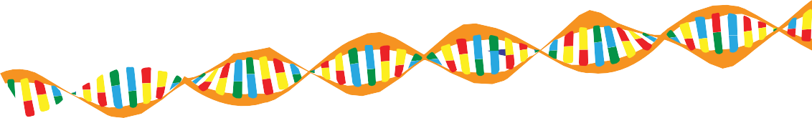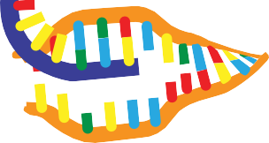

**fact sheet**

**Protein synthesis summary**

# Stage one: transcription

## Transcription produces a messenger RNA (mRNA) strand from a DNA template.

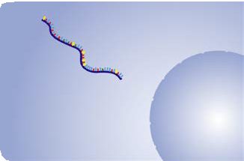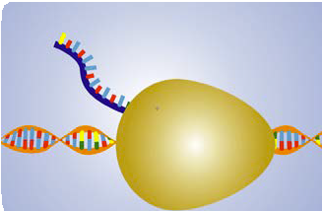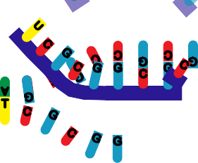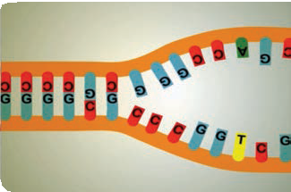

DNA strands separate, exposing nucleotides ready for

copying.

Messenger RNA (mRNA) pairs with a DNA template strand as follows:

* guanine (G) to cytosine (C),
* adenine (A) to thymine (T), and
* uracil (U) to adenine (A).

Nucleotides are added until RNA polymerase reaches a

termination sequence in the DNA and releases mRNA.

mRNA moves out of the nucleus, through nuclear pores,

into cytoplasm.

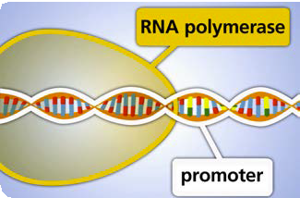

|  |  |  |
| --- | --- | --- |
|  |  | RNA polymerase attaches to the promotor region of a gene on a strand of DNA. |

sequence continues over page

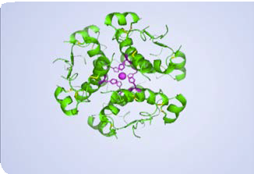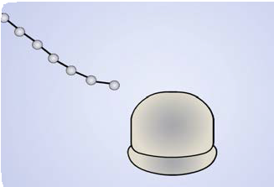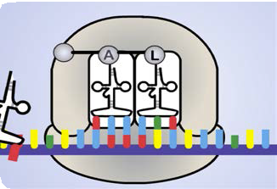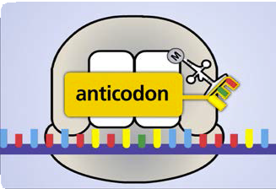

Transfer RNA (tRNA) has a complementary anticodon

that attaches to a corresponding mRNA codon. tRNA carries an amino acid.

As the ribosome moves along the strand of mRNA,

more amino acids are added to the growing chain.

At the STOP codon (UAG in this sequence), the

ribosome releases the mRNA and an amino acid chain.

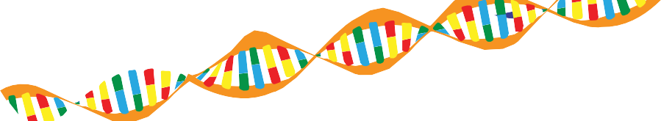

**fact sheet**

**Protein synthesis summary**

# Stage two: translation

## Translation, which occurs in cytoplasm, produces an amino acid chain from a strand of mRNA.

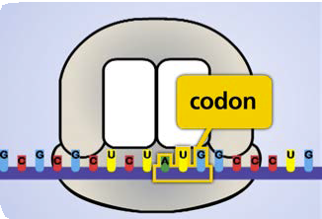

|  |  |  |
| --- | --- | --- |
|  |  | A ribosome binds with a START codon in mRNA. The start codon is AUG. |

|  |  |  |
| --- | --- | --- |
|  |  | The amino acid chain folds into a three dimensional shape, called a protein. |