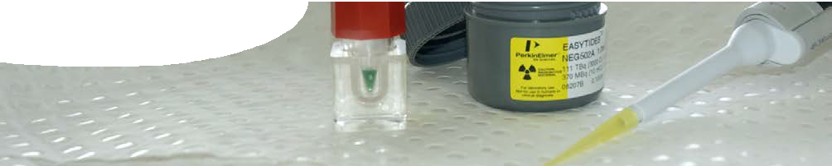
fact sheet
Protein pathways

In the School of Biomedical, Biomolecular and Chemical Sciences at The University of Western Australia,
Dr Paul Besant is studying the process of phosphorylation of protein molecules.
Paul uses phosphorus-32 (32P), instead of stable phosphorus-31 (31P), as a tag to trace molecules involved in the process of protein phosphorylation. Phosphorylation is a process where a phosphoryl
group (PO3) is added to a protein. It is an active process (this means that
it uses energy) and is often a control point in a series of biochemical processes.
Some proteins require addition of a phosphoryl group to continue a reaction, and some proteins require a phosphoryl group to be removed. These can act as ‘on’ and ‘off’ switches in biochemical pathways.
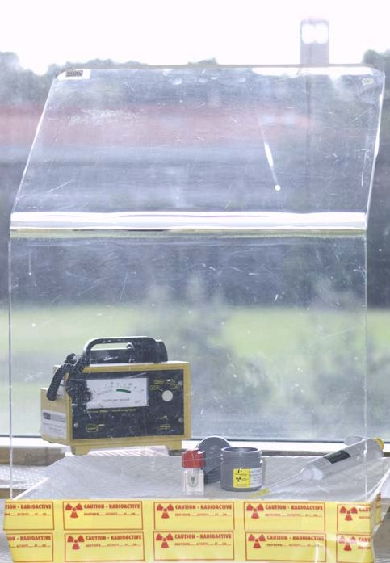
Use of radioisotopes
Use of radioisotopes to ‘tag’ molecules allows researchers to follow and understand a cascade of biological events in cells, because the tag can be detected and therefore followed. The tag can also indicate where in the body or cell these processes take place.
Radioactive tags are useful because, unlike bulky fluorescent labels, they do not alter activity of a protein or affect the reaction.
32P is a radioactive isotope of stable phosphorus. It is a high-energy beta-emitter with a half-life of 14.3 days. The properties of the isotope mean
that only small amounts are needed and therefore perspex shielding and normal protective clothing methods are sufficient for
safety.

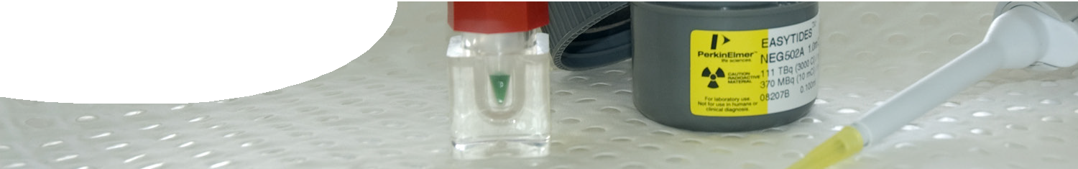
fact sheet
Protein phosphorylation

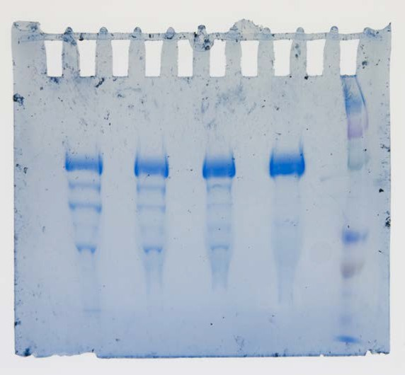

Why is this important?

Tagged molecules are separated using electrophoresis. This is a technique that separates proteins of different molecular weights — the lighter the molecule, the further it moves along the gel. Once electro- phoresis is complete, the gel is placed on
X-ray film.
Radioactive tags in a gel are detected using X-ray film. Beta particle emissions pass straight through the film so they don’t leave an image and an intensifying screen is required. This screen is coated in calcium
tungstate which fluoresces (emits light) when struck by beta particles. The fluorescent
light energy hits the film leaving an image. Equipment is cooled to -70 °C, which sharpens the image.
Radioactively tagged proteins show up as black bands on the film. The X-ray of these tagged bands can be used like a map to help find and then cut out an interesting protein from the gel for further analysis.

Understanding protein structure, positions on a molecule that become phosphorylated, and where in the cell this activity occurs, is important in drug discovery. This knowledge allows researchers to manipulate the protein and the pathway involved.
All of this information helps us to understand what goes wrong during a disease process, how to target therapies to correct the system and how to develop tests for diagnosis.
For example, in liver cancer it has been found that specific proteins are phosphorylated in cancerous cells but not in normal cells. Researchers use a 32P tagged phosphorylation to track the reaction to find out whether it can be changed to help stop progression of cancer in the liver.

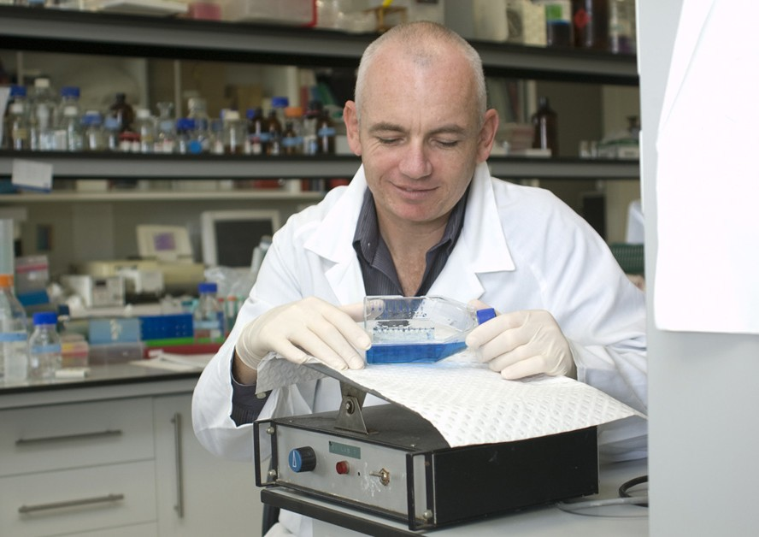
Research applications
Based on this type of experimental work, companies are beginning to design drugs that can either block or enhance phosphorylation. This may provide drugs that could fight cancer.
The anticancer medicine Gleevec is an example of a drug that targets a specific protein in a phosphorylation pathway.
Detecting phosphorylation events is also important in the diagnosis of some
diseases such as Creutzfeldt–Jakob disease (the human form of mad-cow disease).

