The physics of gases under pressure
Pressure change influences gas behaviour, which has serious implications for immersed divers as air is stored in various regions of the body. Two laws govern relationships between gas volume, pressure and solubility: Boyle’s law and Henry’s law.
Boyle’s Law: For a fixed mass of gas at constant temperature, pressure and volume are inversely related. Double the pressure and the
volume is halved. As a diver descends, increase in pressure results in a decrease in gas volume (compression). Conversely, as the diver ascends compressed gas expands.
figure 2: Boyle’s Law - impact of depth on pressure and volume
background sheet
Problems with pressure

The underwater environment poses serious physiological challenges for air-breathing animals. Many of these challenges arise from the impact of pressure increasing with depth.

Underwater pressure
The pressure at sea level is 1 atmosphere (atm). Every 10 m below the ocean surface results in a pressure increase of 1 atm. So, at a depth of a 100 m, hydrostatic pressure is 11 atm. Pressure has a number of implications for air-breathing animals: compression of gases; squeezing or distortion of air spaces; and toxicity associated with increased absorption of gases.
10 m = 2 atm
20 m = 3 atm
30 m = 4 atm
sea level = 1 atm
figure 1: pressure at sea level and depth

depth | atm | air volume
0 | 1 | 100%
10 m | 2 | 50%
20 m | 3 | 33%
30 m | 4 | 25%
40 m | 5 | 20%

Risks for human divers
figure 3: Henry’s Law – an increase in pressure leads to more gas dissolving in solution
descending
More gas molecules are soluble at higher pressure
ascending
Henry’s Law: At constant temperature, the amount of gas that dissolves in solution increases with gas pressure. As pressure decreases, gas becomes less soluble and comes out of solution.
Solubility of a gas vs pressure

Increase pressure
Three major factors, related to pressure, limit performance of humans in an underwater environment.

Barotraumas
Differences in pressure between the external environment (water) and the internal environment (body) can result
in physical injury to tissues, known as barotraumas. Barotraumas are a serious problem for both scuba divers and freedivers.
Boyle’s Law shows that air compresses during descent, and expands during ascent. The human body has air-filled
spaces, such as lungs and sinuses. As pressure increases, air within these spaces compresses. This can cause
distortion and trauma of surrounding tissues.
Lung barotrauma is a risk for a scuba diver during ascent as compressed air within the lungs expands. Lungs may overexpand and rupture if the diver does not exhale.
A freediver faces a different problem. During deep dives, weight of surrounding water can cause excessive compression of lungs and rib cage, resulting in fractures, capillary ruptures and haemorrhage.

Decompression sickness
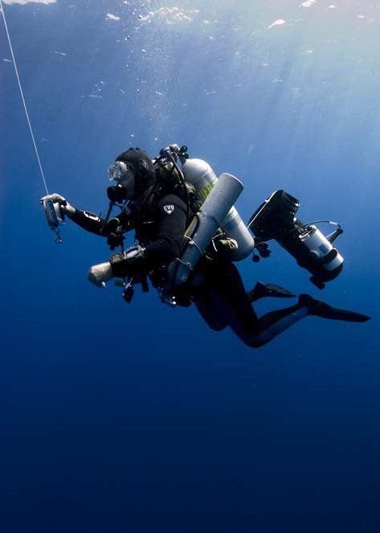Decompression sickness, also known as the bends, is caused by excessive nitrogen absorption at depth and insufficient washout of nitrogen during ascent.
figure 4: diving archaeologist descending photo by Tane Casserley, NOAA/MONITOR NMS
The partial pressure of nitrogen increases at depth. According to Henry’s law, rise in partial pressure causes increased amounts of nitrogen to dissolve in body tissues. As pressure reduces on ascent, this dissolved nitrogen comes out of solution. If ascent is too fast the amount
of nitrogen coming out of solution exceeds normal washout levels. This results in nitrogen bubbles entering the bloodstream and tissues causing severe symptoms, and in some cases death. Scuba divers are at greater risk of decompression sickness as they breathe compressed air at depth. However, freedivers have been reported
to suffer decompression sickness after repeated dives with insufficient time between them to clear the body of nitrogen.

Nitrogen narcosis

The partial pressure of nitrogen increases with pressure, which produces a narcotic effect. Nitrogen narcosis affects both scuba divers and freedivers. It causes depression
of the central nervous system, which leads to feelings of euphoria, disorientation and irrational behaviour.

Divers need to consider absorption rates of different gases in order to avoid conditions such as nitrogen narcosis, and decompression sickness.

Coping with pressure: adaptations of diving animals
Air-breathing diving animals must cope with increase in pressure at depth.

Avoiding barotraumas

Air-breathing, diving animals have air-filled sinus cavities which could potentially be the site of pressure-related injuries at depth. Seals and whales avoid this issue as their middle ear sinuses are lined with extensive blood vessels. Scientists believe these blood vessels become blood-filled at depth. This prevents formation of a pressure gradient and avoids mechanical damage to tissues.

The flexible trachea of dolphins can be compressed at depth without subsequent distortion of tissues. Other animals, including seals and sea otters, have tracheas and bronchioles reinforced with cartilage and smooth muscle to prevent compression and tissue damage.

A significant adaptation of many diving animals, including seals, dolphins and whales, is complete collapse of their
lungs during descent. Chest walls of many diving animals are flexible and compressible, enabling their lungs to collapse completely under surrounding water pressure. This removes risk of lung tissue barotrauma. Residual air within the lungs is forced into reinforced bronchioles and/ or the trachea. Lung compression has another advantage for diving animals: they become less buoyant as their lungs collapse and volume decreases. Many marine mammals take advantage of negative buoyancy by gliding during descent, consequently conserving oxygen.

Avoiding decompression sickness and nitrogen narcosis

Complete collapse of lungs in diving animals forces air out of the lungs, and away from the gas-exchange surface (the alveoli). As lungs collapse, air is forced into spaces, such as bronchioles and trachea, where gas-exchange does not occur. Nitrogen absorption, and consequently risk of decompression sickness and nitrogen narcosis, is limited.

Many diving animals dive with a relatively small amount of oxygen in their lungs. Instead they rely on alternate
oxygen stores in muscles and blood. This further minimises risks of pressure-related physical injury, narcotic effects of nitrogen at pressure, and risk of decompression sickness.

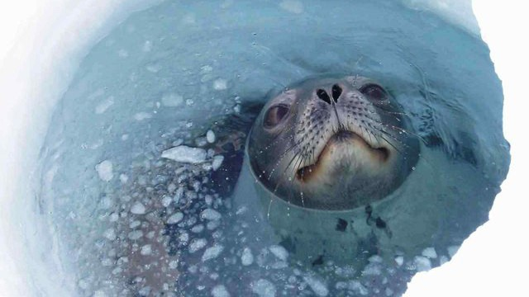
figure 5: Weddell seal at ice hole, photo by D McVeigh © Australian Antarctic Division

Who copes best with pressure?
Underwater performance of humans is severely limited by lack of structural and physiological adaptations. Training can enhance performance through acclimatisation, but these results are quickly lost when training ceases. In contrast, diving animals have adaptations that enable them to cope with pressures encountered at depth, without damage.

