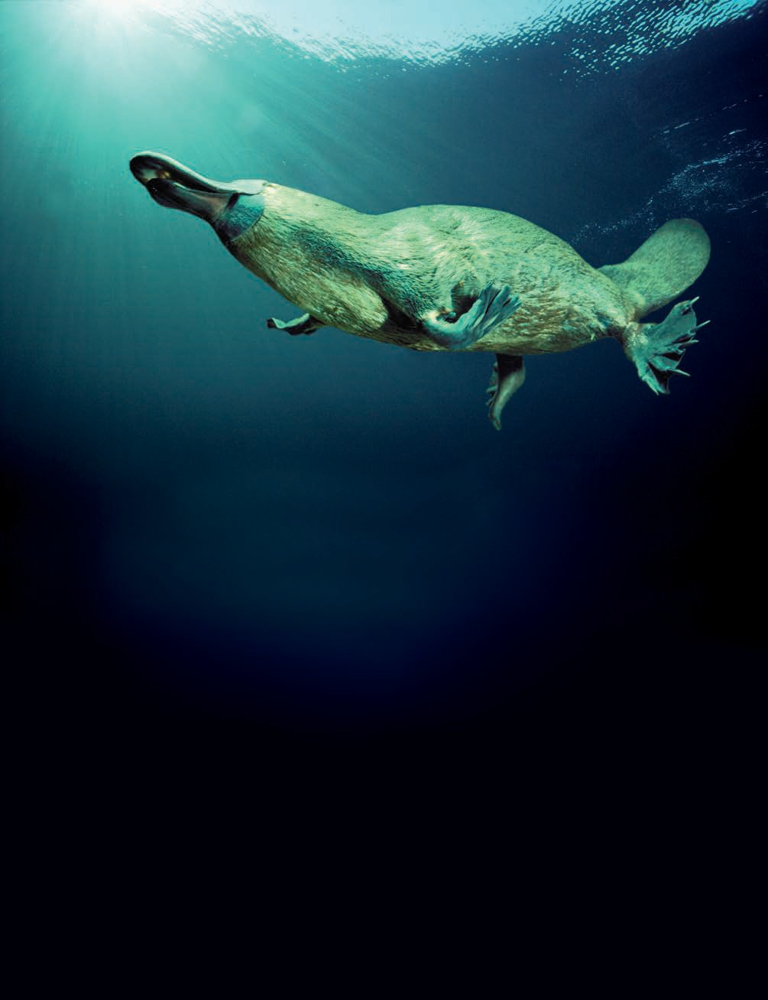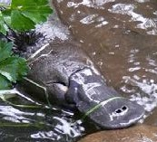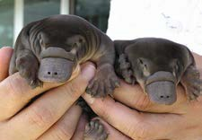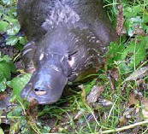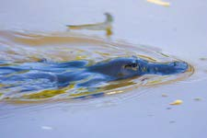
fact sheet
Platypus electroreception

The platypus has a talent for the unusual.
It’s an egg-laying, semi-aquatic mammal, the extraordinary owner of a duck-like bill, webbed feet and snake-like venom.
Now, to push its weird and wonderful status still higher, scientists have found it uses electrical currents to track down its food.

Finding grub
Platypus hunt for prey such as insect larvae, shrimps and yabbies in streams, rivers and pools. Once underwater we know it closes its nostrils, ears and eyes, leaving us with the question ‘How on Earth can it navigate, let alone hunt?’
It wasn’t until the 1980s that scientists came up with an answer. They already knew that some fish and amphibians have an extra sensory system (a sixth sense) that enables them to detect electric fields. Now it appeared that the platypus too, was capable of electroreception, and the necessary equipment to do this was located in its unique bill.

The bill
Unlike a duck’s bill, a platypus bill is soft and pliable. It is covered with 40 000 large modified mucous glands arranged in rows running lengthways down the bill.
These glands first caught scientists’ attention because they resembled the ampullary electroreceptors found in fish. Like these the glands are electroreceptors, sensing electric fields in the platypuses’ aquatic home. Each electroreceptor has up to 30 different nerve endings at its base, ready to send signals to the platypus brain.

ast1401 | Electrical circuits 6: Platypus electroreception (fact sheet) developed for the Department of Education WA
© The University of Western Australia 2010 for conditions of use see spice.wa.edu.au/usage version 2.0 revised February 2015 page 1 Licensed for NEALS

fact sheet
Platypus electroreception

Hunting
Watch a platypus hunting and you’ll see it sweep its bill from side to side, scanning the water for prey.
When a shrimp flicks its tail to move,
the muscle contraction generates an electrical pulse.
Current thinking is that this telltale sign is picked up
by electroreceptors
in the platypus bill, causing the platypus to turn its head
towards the signal source. Work by scientists has shown this reflex response is prompted by electrical fields as low as 20 µV cm-1. In fact, they’re so sensitive that scientists recommend shielding platypus enclosures from external electrical noise that could stress the animals.
There’s more to a platypus bill than these electroreceptors. 60 000 mechanoreceptors
are also scattered across its surface. These are made of small rod-like pillars that respond to mechanical stimuli such as
touch. They’re useful when the platypus rummages through the streambed with its bill. They also detect mechanical pressure pulses generated by prey moving through water.
Using this combination of receptors, the platypus pinpoints and snaps up its prey. When you realise a platypus eats up to half its body weight in a night, the system seems to work pretty well.

The future
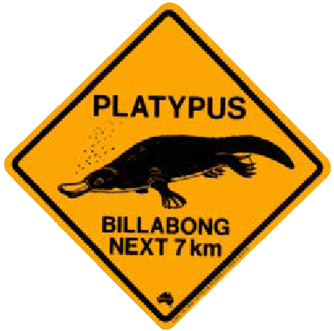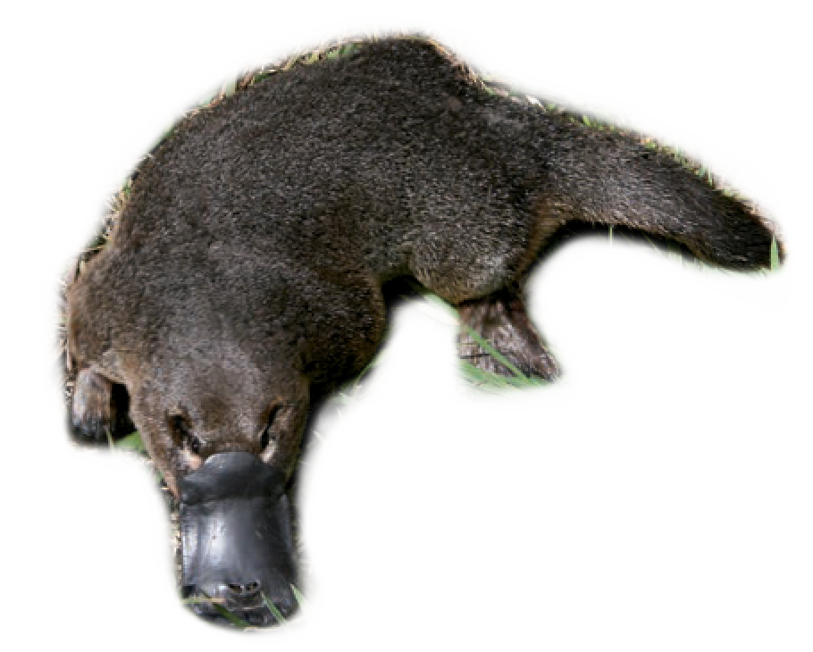The story doesn’t end here. There’s lots about platypus electroreception and its mechanisms yet to be understood. For example, the platypus appears to be able to judge prey distance as well as direction, but scientists are still unsure exactly how. Current thinking is that it uses the difference in arrival times between mechanical and electrical signals.
Experiments: demonstrating electroreception
Scientists demonstrated electroreception by platypus with a series of simple experiments.
- A platypus was offered a choice between a 1.5 V miniature alkaline battery, a piece of shrimp tail and a dead battery. It repeatedly chose the active battery.
- Two carbon electrodes were placed behind a brick and switched on or off. The platypus turned over the brick significantly more often when an electric field between the two electrodes was present.
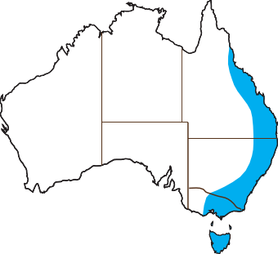Fact file
- Platypus live for up to 21 years in the wild. They’re found in eastern Queensland, New South Wales and Victoria, as well as throughout Tasmania.
- The platypus has a lower body temperature than most other mammals, so it needs less energy to keep warm in cool water.

  - Adult males can reach 60 cm long from bill-tip to tail-tip. Males also have a 1.5 cm venomous spur on their rear legs.

- They’re largely nocturnal, spending around 12 of every 24 hours feeding in the water.
- The platypus may use its electrosense to find its way around its freshwater home, as well as for locating prey.

Future research
In 2008, the DNA from a platypus called Glennie was sequenced.
By comparing her genome (genetic code) with that of other animals,
scientists can see which unusual platypus traits (for example, egg laying) have been retained from its ancestors. They can also work out traits, including venom and electroreception, which developed after it split from a common ancestral mammal around 166 million years ago. It’s hoped that by comparing the platypus genome with our own we’ll learn more about our own genes and how they function.

Image credits
Page one, main image: © Dave Watts Wildfire Photography, used under licence. Platypus habitat: © Kathie Atkinson, used by permission. Platypus bill photos: © Garry Conroy-Cooper, used by permission. Platypus twins: © Faye Bedford, Department of Sustainability and Environment, Government of Victoria, used by permission. Swimming platypus: © AusBatPerson (Bruce), used by permission. Page two, platypus: © Mark Jekabsons, used by permission.

ast1401 | Electrical circuits 6: Platypus electroreception (fact sheet) developed for the Department of Education WA
© The University of Western Australia 2010 for conditions of use see spice.wa.edu.au/usage version 2.0 revised February 2015 page 2

