workbook
PCR and melanoma mutations
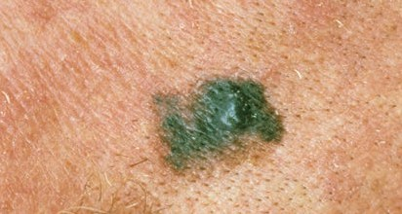
Melanoma usually occurs on your skin; rare forms appear on your eyes and mouth.
© Cancer Council Western Australia
Melanoma
Australia has one of the highest rates of melanoma in the world. Each year 11 545 Australians are diagnosed with melanoma, and over 1500 die from the disease.
Melanoma, like all cancers, occurs when one or more genes mutate. Mutations can be inherited (germline mutation), or acquired over a person’s lifetime (somatic mutation). Over 90% of all melanomas are acquired.

Melanoma mutations
Melanoma is associated with hundreds, even thousands, of mainly acquired genetic mutations. Metastatic melanoma occurs when localised tumour cells enter your circulatory or lymphatic system and spread to other parts of your body.

Meet Mel and Tania, both have been diagnosed with metastatic melanoma.

BRAF and mutated BRAF
Until recently, prognosis was poor for patients with metastatic melanoma, like Mel and Tania. Although melanoma is the least common type of skin cancer, it’s the most dangerous, accounting for 75% of all skin cancer deaths. However, in the past decade, biotechnological advances are giving patients like Mel and Tania a chance to increase their lifespan.
It’s now possible to test melanoma patients for genetic mutations commonly associated with the disease.
Mutations in genes, such as BRAF, NRAS, and KIT, play an important role in melanoma development and
progression. Identifying these mutations in patients can improve treatment outcomes. This activity focuses on mutations found in the BRAF gene.

The BRAF gene is located in normal cells. It codes for a protein that’s part of a cell-signalling pathway involved in cell division.
Over 50% of melanomas have mutations in the BRAF gene. The most common type of BRAF mutation found in melanoma is V600E. This mutation involves a single nucleotide change: thymine (T) to adenine (A), resulting in an amino acid change in the BRAF protein: valine to glutamic acid.
A mutated BRAF protein is continuously active, triggering the cell-signalling cascade, and speeding cell growth into overdrive.
Understanding the role of BRAF in cell growth has led to development of inhibitor drugs that block the action of the mutated BRAF protein. Early trials with BRAF inhibitors have produced positive results, increasing patients’ lifespans.

Cell-signalling pathway
– the role of BRAF
growth
factor
cell membrane
RAS BRAF
the rate of cell growth
BRAF plays a role in
and division.
MEK
requir Normally BRAF
the RAS protein to
es a signal from become active.
ERK
BRAF then signals
pr
otein MEK, resulting
its neighbouring
in cell growth.
normal cell
growth
Nucleus
Cell-signalling pathway
– the role of mutated BRAF V600E
growth
factor
cell membrane

RAS
Mutated BRAF is
always active.
mutation
BRAF
It no longer needs a
signal from the RAS
MEK
protein.
continuously signals
Mutated BRAF
ERK
the cell grows and
protein MEK and
its neighbouring
divides.
Nucleus
Cell-signalling pathway
– the role of BRAF inhibitor
growth
factor
cell membrane

RAS
(VEM) blocks the
Vemurafenib
BRAF
mutated BRAF
action of the
protein.

MEK
pr Blocking this
otein stops the
cell-signalling

ERK
halts cell growth
cascade and
death of cancer
or causes the
cellular
cells.
proliferation

Does Mel or Tania have a BRAF mutation?
VEM
abnormal cell growth
To see if either Mel or Tania is eligible for treatment that inhibits the action of mutated BRAF protein, it’s necessary to determine the genetic sequence of their melanoma tumours. To do this, a small segment of DNA from the BRAF gene is amplified by polymerase chain reaction (PCR) to provide enough material for sequencing. Genetic sequencing determines the exact order of nucleotides in a DNA segment, gene, or entire genome.
If either Mel or Tania has the BRAF mutation they may be eligible to be treated with BRAF inhibitor drugs, hopefully extending their lifespan.

PCR – amplifying BRAF
In the laboratory, samples of Mel’s and Tania’s melanoma cells and normal skin cells are taken. These samples undergo PCR, amplifying (copying) a segment of the BRAF gene known to contain the V600E mutation. This segment is 247 base pairs (bp) in length.

What is needed to amplify DNA?
To amplify DNA, specific components and chemical solutions are needed. The following components are critical.

Primers
A primer is a short strand of DNA, complementary to part of the target gene sequence. Primers are essential for DNA polymerase to attach, enabling amplification to begin. As DNA has two strands, two primers are required: a forward primer and reverse primer. DNA has two different ends: 3’ (3 prime) and 5’ (5 prime), and is always transcribed from 3’ to 5’. Primers always anneal (bind) at the 3’ end.
double-stranded DNA
5’ 3’

3’ 5’
Each strand of DNA needs a primer.
5’ 3’
forward primer
reverse primer

5’
5’

3’ 5’

5’
3’
3’
Create a forward and reverse primer, 10 base pairs in length, for each strand of DNA. Write both primers, in the correct position, next to each strand.
5’

Taq polymerase
Copying any DNA requires DNA polymerase. In this activity you’ll use the enzyme Taq DNA polymerase. Taq polymerase comes from the bacterium Thermus aquaticus that tolerates extreme temperatures, and lives in hot springs and hydrothermal vents.
PCR requires application of high temperatures (> 90°C) to separate strands of DNA. Taq polymerse remains stable at temperatures up to 95°C. This stability means it’s commonly used in PCR.

Nucleotides
Taq polymerase requires building blocks to synthesise new DNA sequences. These building blocks are the four nucleotides that make up DNA: cytosine (C), guanine (G), adenine (A), and thymine (T). Taq polymerase adds nucleotides to the end of each primer and builds a complementary strand of DNA.

Thermocycler
Primers, Taq polymerase and nucleotides are combined with chemicals and added to DNA samples. This mix is placed into a thermocycler, a machine that heats and cools DNA repeatedly, amplifying DNA.
There are three stages in PCR:
- denaturing: high temperature that causes double-stranded DNA to denature (separate into single strands);
- annealing: cooling that allows primers to anneal (bind) to DNA strands; and
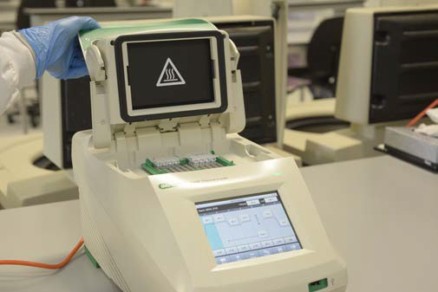
- elongation: increased temperature that allows Taq polymerase to add nucleotides, to build new DNA strands.
Repeating these temperature cycles 25 – 35 times produces billions of copies of the target DNA sequence.
Temperature settings are pre-programmed and vary according to the DNA segment to be amplified, type of polymerase, length and composition of primers.
In this PCR example, denaturation occurs at 92°C, annealing at 60°C, and elongation at 72°C.

Thermocycler: repeated cooling and heating of DNA samples amplifies DNA.

How does PCR work?

Make a Master Mix: this contains reagents required for DNA amplification.

primers

MgCl2

Taq
polymerase

Master Mix

dNTPʻs

buffer

H2O

Add the Master Mix to the DNA samples.

DNA samples

Place in thermocycler, this will run 35 cycles of heating and cooling producing billions of copies of the target segment.

thermocycler

The three stages of PCR:
- denature
- anneal
- elongate

100
90
80
70
temperature (˚C)
60
50
40
30
20
10
0

0
Three temperature cycles of PCR
denature DNA
nucleotides added
elongation

anneal primers

5’ 3’
primer
primer
3’ 5’

1 2 3 4 5
time (mins)

PCR review

- What stage of PCR occurred at 92°C?

........................................................................................................................................................................

........................................................................................................................................................................

........................................................................................................................................................................

- What stage of PCR occurred at 60°C?

........................................................................................................................................................................

........................................................................................................................................................................

........................................................................................................................................................................

- What stage of PCR occurred at 72°C?

........................................................................................................................................................................

........................................................................................................................................................................

........................................................................................................................................................................

- How many primers are needed for PCR? Explain the function of primers.

........................................................................................................................................................................

........................................................................................................................................................................

........................................................................................................................................................................

........................................................................................................................................................................

- What is the role of Taq polymerase during PCR?

........................................................................................................................................................................

........................................................................................................................................................................

........................................................................................................................................................................

........................................................................................................................................................................

- What is complementary base pairing?

........................................................................................................................................................................

........................................................................................................................................................................

........................................................................................................................................................................

........................................................................................................................................................................

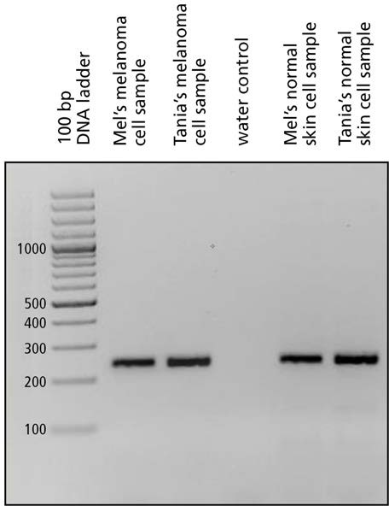Visualising PCR results

PCR gel showing successful amplification of a segment of the BRAF gene. All samples from Mel and Tania appear as bands on the gel at approximately 247 bp on the DNA ladder. There is no band from the water control sample, which reveals that there is no DNA contamination of samples.
PCR aims to produce multiple copies of a DNA segment of specific length. You’ve modelled this in PCR challenge. In the laboratory an amplified gene (a 247 bp segment of the BRAF gene) is subjected to gel electrophoresis to determine if PCR has successfully created multiple copies of the DNA segment.
Gel electrophoresis uses an electrical current to separate fragments of DNA, which are negatively-charged molecules. Applying an electric current through an agarose gel causes DNA molecules to migrate towards the positive anode. Short segments of DNA travel faster and further through the gel, while longer segments move more slowly and cover less distance.
PCR samples are always run alongside a DNA ladder. A DNA ladder contains DNA fragments of known size,
measured in base pairs (bp). Like a ruler, the DNA ladder allows you to estimate the size of your PCR product.
Stain is added to the gel or to PCR samples to enable visualisation of the bands. Imaging technology is then used to generate an image of DNA bands on the gel.

Sequencing BRAF
Once Mel’s and Tania’s DNA have been amplified, and verified by gel electrophoresis, the PCR product is
sequenced to determine if either Mel or Tania carries the BRAF V600E mutation.
DNA sequencing enables the precise order of nucleotides
within a DNA fragment, gene, chromosome or full genome to be determined. Many sequencing technologies are currently available, and time taken to sequence genes and genomes has become shorter in the last few years. It’s now possible to sequence an entire human genome in days, for relatively low cost.
Sequence results below, of the 247 bp segment of BRAF amplified by PCR, are for normal skin cells and melanoma cells, from Mel and Tania. The V600E mutation occurs at base number 1799 of the BRAF gene. It involves a single nucleotide change from thymine (T) to adenine (A).
The sequence below shows an amplified region of BRAF from the normal skin sample.

Normal skin sequence
forward strand:
↓1674
ACTCTTC | ATAATGCTTG | CTCTGATAGG | AAAATGAGAT | CTACTGTTTT | CCTTTACTTA
CTACACCTCA | GATATATTTC | TTCATGAAGA | CCTCACAGTA | AAAATAGGTG | ATTTTGGTCT
AGCTACAGTG | AAATCTCGAT | CGGAGTGGGT | CCCATCAGTT | TGAACAGTTG | TCTGGATCCA
TTTTGTGGAT  GCTGCTGAGT | GGTAAGAATT | GAGGCTATTT | TTCCACTGAT | TAAATTTTTG | GCCCTGAGAT

- Identify base number 1799 (the first ‘A’ is at base number 1674) and write down the base found in this position.

........................................................................................................................................................................

Sequences below show amplified regions of BRAF from melanoma cells of both Mel and Tania.

- Identify base number 1799 (start counting at base number 1674) in each sequence. Write down the base in this position for both patients.

Mel: ................................................................................................................................................................

Tania: ..............................................................................................................................................................

PATIENT A (Mel)

forward strand:
↓1674
ACTCTTC ATAATGCTTG CTCTGATAGG AAAATGAGAT CTACTGTTTT CCTTTACTTA CTACACCTCA GATATATTTC TTCATGAAGA CCTCACAGTA AAAATAGGTG ATTTTGGTCT AGCTACAGAG AAATCTCGAT GGAGTGGGTC CCATCAGTTT GAACAGTTGT CTGGATCCAT TTTGTGGATG GTAAGAATTG AGGCTATTTT TCCACTGATT AAATTTTTGG CCCTGAGATG CTGCTGAGTT

PATIENT B (Tania)

forward strand:
↓1674

ACTCTTC ATAATGCTTG CTCTGATAGG AAAATGAGAT CTACTGTTTT CCTTTACTTA CTACACCTCA GATATATTTC TTCATGAAGA CCTCACAGTA AAAATAGGTG ATTTTGGTCT AGCTACAGTG AAATCTCGAT GGAGTGGGTC CCATCAGTTT GAACAGTTGT CTGGATCCAT TTTGTGGATG GTAAGAATTG AGGCTATTTT TCCACTGATT AAATTTTTGG CCCTGAGATG CTGCTGAGTT

- Which patient carries the BRAF V600E mutation?
........................................................................................................................................................................

........................................................................................................................................................................

- Based on what you understand about the role of BRAF in a cell, describe what may be occurring in this patient’s melanoma cells, as a result of the BRAF V600E mutation.

........................................................................................................................................................................

........................................................................................................................................................................

........................................................................................................................................................................

........................................................................................................................................................................

Melanoma sequencing and treatment
Identifying the BRAF V600E mutation in melanoma samples provides important information to practitioners, regarding patient treatment options. Patients with inoperable metastatic melanoma, who carry the BRAF V600E mutation, are eligible for treatment with pharmaceuticals that inhibit function of the BRAF mutated protein.

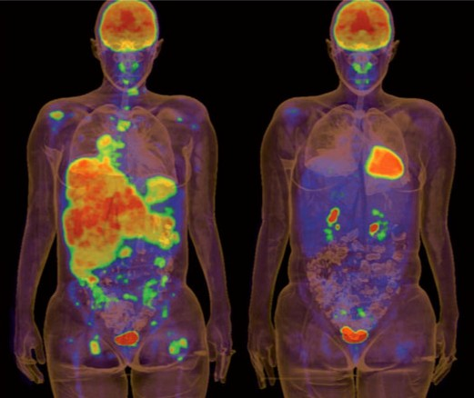
pre-treatment 2 weeks vemurafenib

PET scans of a melanoma patient before treatment with vemurafenib and after two weeks of treatment. Positron emission tomography scans reveal areas of high metabolic activity in the body, such as the brain, heart, bladder and kidneys as well as fast- growing cancer cells. In the scan, these areas appear ‘brighter’ than others. © G. McArthur and R. Hicks, Peter MacCallum Cancer Centre, Melbourne, Australia

