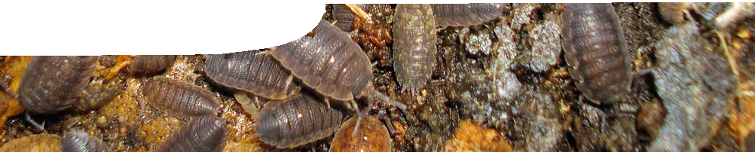
resource overview
Introduction to soil science

Background
Several SPICE resources, designed for high school students, enable students to investigate soil ecosystems and feeding relationships between soil organisms. These materials may be adapted for upper primary school students to teach science inquiry skills and biological science content. The following resources are drawn from the SPICE sequence, Soil life, and an investigation program, Monitoring soil science. Further details for both of these programs are available on the SPICE website.

Learning resources
Introduction to soil science 1: Life in the soil
Life in the soil comprises a presentation and teachers guide.
This presentation engages students in the comparison of a variety of ecosystems and provides the opportunity to demonstrate their prior knowledge of ecology. See the teachers guide for further information on the purpose and use of this resource.

Introduction to soil science 2: Exploring soil
Exploring soil includes a teachers guide, procedure sheet, interactive learning object with two associated worksheets and two instructional videos.
This resource enables students to explore the variety of life in the soil through sampling of soil and observation of soil organisms. The learning object and worksheets introduce the size range of soil organisms and their feeding relationships. See the teachers guide for further information on the purpose and use of this resource.

Introduction to soil science 3: Investigating soil fauna
Investigating soil fauna contains a scaffolded procedure sheet that provides opportunities for students to plan and carry out open investigations into how soil fauna may be affected by environmental change.

Introduction to soil science 4: Soil science techniques
This collection of background and procedure sheets introduces common soil science techniques.
s Soil science provides a general introduction to soil science and the importance of soil fauna to soil health and productivity.
s Mites and springtails introduces the most abundant soil-dwelling arthropods: mites and springtails.
s Measuring soil organic matter describes a procedure for students to measure the amount of organic matter in a soil sample and thereby compare different soils.
s Measuring soil bulk density and moisture content procedure sheet enables students to examine two physical characteristics of soil. These procedures are more challenging than previous activities.
s Measuring soil pH and electrical conductivity procedure sheet enables students to examine two further physical characteristics of soil. These procedures are more challenging than previous activities.

Acknowledgements
Thanks to Honorary Associate Professor Adrianne Kinnear (School of Natural Sciences, Edith Cowan University) and Winthrop Professor Lynette Abbot (Faculty of Natural and Agricultural Sciences, The University of Western Australia).
Special thanks to Maya Breen, Science Communication Practicum Student, The University of Western Australia, for her work on the videos within this sequence.
Designed and developed by the Centre for Learning Technology, The University of Western Australia.
Production team: Anton Ball, Leanne Bartoll, Kim Braimbridge, Jan Dook, Alwyn Evans, Bob Fitzpatrick, Dan Hutton, Bec McKinney, Paul Ricketts, Jodie Ween and Michael Wheatley, with thanks to Pauline
Charman, Gary Thomas, Jenny Gull, Wendy Sanderson and Charmaine White.

Banner image: ‘Isopoda’ by Mick Talbot. CC-BY-2.0, used by permission, www.flickr.com/photos/25258702@ N04/3229291933/in/photostream/

SPICE resources and copyright
All SPICE resources are available from the Centre for Learning Technology at The University of Western Australia (“UWA”). Selected SPICE resources are available through the websites of Australian State and Territory Education Authorities.
Copyright of SPICE Resources belongs to The University of Western Australia unless otherwise indicated.
Teachers and students at Australian and New Zealand schools are granted permission to reproduce, edit, recompile and include in derivative works the resources subject to conditions detailed at spice. wa.edu.au/usage.
All questions involving copyright and use should be directed to SPICE at UWA.
Web: spice.wa.edu.au Email: spice@uwa.edu.au Phone: (08) 6488 3917

Centre for Learning Technology (M016) The University of Western Australia
35 Stirling Highway
Crawley WA 6009

