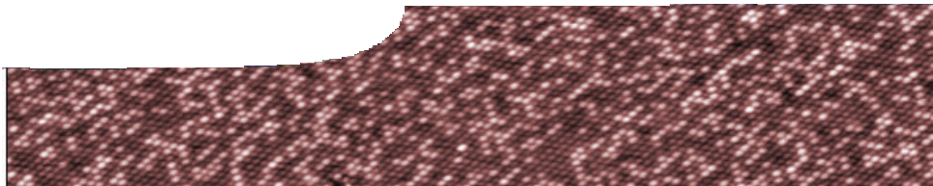
sequence overview
Atoms and elements

Links to the Australian Curriculum: Science Year 9

Science understanding concepts include:
Chemical sciences: All matter is made of atoms which are composed of protons, neutrons and electrons; natural radioactivity arises from the decay of nuclei in atoms (ACSSU177)
- describing and modelling the structure of atoms in terms of the nucleus, protons, neutrons and electrons
- comparing the mass and charge of protons, neutrons and electrons
Science as a human endeavour concepts include:
Nature and development of science: Scientific understanding, including models and theories, are contestable and are refined overtime through a process of review by the scientific community (ACSHE157)
- investigating the historical development of models of the structure of the atom
Use and influence of science: The values and needs of contemporary society can influence the focus of scientific research (ACSHE228)
Science inquiry skills concepts include:
Communicating: Communicate scientific ideas and information for a particular purpose, including constructing evidence-based arguments and using appropriate scientific language, conventions and representations (ACSIS174)
- presenting results and ideas using formal experimental reports, oral presentations, slide shows, poster presentations and contributing to group discussions
- using secondary sources as well as students’ own findings to help explain a scientific concept
- using the internet to facilitate collaboration in joint projects and discussions

ENGAGE
EXPLORE EXPLAI

Background
N ELABORATE
These SPICE resources may be drawn together into a learning pathway to develop students’ understanding of structure of atoms and how it differs between elements. The pathway is structured around a constructivist model based on the 5-Es where teachers may:
- Engage students’ interest in the concept of atoms and elements by watching a video about forensic analysis of bullets. This raises questions about differences between elements.
- Provide opportunities for students to Explore atomic structure using an interactive learning object, which guides them around a virtual laboratory.
- Explain atomic structure and how it varies between elements. Students use an interactive learning object to alter numbers of protons, neutrons and electrons in an atom in order to build specific elements. Students also learn about modelling atomic structure.
- Elaborate on the topic of atoms and elements by applying knowledge gained to learn about trace element analysis. This draws on current research at The University of Western Australia.
- Evaluate students’ progress through the pathway and through summative reflection.
The resource is designed for year 9 chemistry students, but may also be used with students from other years at the discretion of the teacher.

Learning pathway

ENGAGE

EXPLORE EXPLAI
N ELABORATE

Atoms and elements 1: Elementary forensics
Elementary forensics includes a teachers guide, background sheet and video.
Students watch a video about a scientist who analyses bullets with a method that uses differences between masses of elements. The video is designed to engage student interest in atoms and differences between elements. A background sheet gives teachers more information about how the ICPMS analysis used by the scientist works. See the teachers guide for detailed information on the purpose and use of this resource.

ENGAGE

EXPLORE EXPLAI
N ELABORATE

Atoms and elements 2: Looking at atoms
Looking at atoms includes a teachers guide, learning object and student worksheet.
Students explore atomic structure by completing an interactive learning object that guides them through a virtual laboratory. They have an opportunity to: view powerful microscope images of atoms; see experiments involving electrons; and compare properties of subatomic particles. This helps them piece together ideas of what an atom might look like. See the teachers guide for detailed information on the purpose and use of this resource.

ENGAGE

EXPLORE EXPLAI
N ELABORATE

Atoms and elements 3: Creating atoms
Creating atoms includes a teachers guide, learning object and two student worksheets.
Students use an interactive learning object to see how atoms of different elements contain varying numbers of protons, neutrons and electrons. Students also examine a variety of atomic models, and build their own. See the teachers guide for detailed information on the purpose and use of this resource.

ENGAGE

EXPLORE EXPLAI
N ELABORATE

Atoms and elements 4: Element fingerprints
Element fingerprints includes a teachers guide and fact sheet.
Students apply their knowledge of atomic structure and elements to learn more about trace element analysis and its applications in forensic science. See the teachers guide for detailed information on the purpose and use of this resource.

Acknowledgements
Thanks to Anna Bradley and Winthrop Professor John Watling, Centre for Forensic Science at The University of Western Australia. Thanks also to the Western Australian Police, Forensic Field Operations.
Designed and developed by the Centre for Learning Technology, The University of Western Australia.
Production team: Sally Harban, Bob Fitzpatrick, Anton Ball, Alwyn Evans, Dan Hutton, Paul Ricketts, Jodie Ween, Kate Vyvyan and Michael Wheatley, with thanks to Beate Ferbert-Booth, Jenny Gull and Wendy Sanderson.

banner image: ‘PtRh alloy’ by Institut für Angewandte Physik, used by permission, www.iap.tuwien.ac.at/www/ surface/stm_gallery/chemical_resolution

SPICE resources and copyright
All SPICE resources are available from the Centre for Learning Technology at The University of Western Australia (“UWA”). Selected SPICE resources are available through the websites of Australian State and Territory Education Authorities.
Copyright of SPICE Resources belongs to The University of Western Australia unless otherwise indicated.
Teachers and students at Australian and New Zealand schools are granted permission to reproduce, edit, recompile and include in derivative works the resources subject to conditions detailed at spice.wa.edu.au/usage.
All questions involving copyright and use should be directed to SPICE at UWA.
Web: spice.wa.edu.au Email: spice@uwa.edu.au Phone: (08) 6488 3917
Centre for Learning Technology (M016) The University of Western Australia
35 Stirling Highway
Crawley WA 6009

