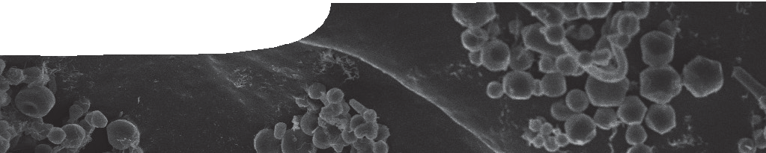
sequence overview
Structure and bonding

ENGAGE
EXPLORE EXPLAI

Background
N ELABORATE
These SPICE resources can be drawn together into a learning pathway for students to develop their understanding of structure and bonding and how they relate to the properties of materials. The pathway is structured around a constructivist model based on the 5-Es where teachers can:
- Engage students interest and minds in the concepts. Students watch a video that explains how chemists create a new structure.
- Provide opportunities for students to Explore what they know about the concepts. Laboratory-based activities lay the foundation for students to link properties of common materials with types of bonding.
- Explain the concepts. A learning object builds an explanation of the relationship between bonding, structure and properties of materials.
- Provide opportunities for students to Elaborate on the concepts. Here students can apply their knowledge in different contexts and extend their knowledge of and about science.
- Evaluate students’ progress throughout the pathway.
The pathway has been designed for teachers of senior school chemistry but it may also be used with students in earlier years at the discretion of the teacher.

Learning pathway

N ELABORATE

ENGAGE
EXPLORE EXPLAI

Structure and bonding 1: Molecular structures
Molecular structures includes a videoclip, teachers guide and worksheet.
This resource engages students by showing the steps a chemist goes through to create a new structure. See the teachers guide for detailed information on the purpose and use of this resource.

ENGAGE
EXPLORE EXPLAI

N ELABORATE
Structure and bonding 2: Exploring conductivity
Exploring conductivity comprises a teachers guide, a worksheet and a procedure sheet.
In this resource students classify common substances into groups based on their conductivity in solid and liquid states, and aqueous solution. See the teachers guide for further information on the purpose and use of this resource.

ENGAGE

EXPLORE EXPLAI

N ELABORATE

Structure and bonding 3: Chemical bonds
Chemical bonds comprises a teachers guide, interactive learning object and student worksheet.
Students complete a worksheet that guides them through animations of different types of chemical bond. See the teachers guide for further information on the purpose and use of this resource.

ENGAGE
EXPLORE EXPLAI

Structure and bonding 4: Molecules by design
Molecules by design comprises a teachers guide and four fact sheets for students.
This resource shows how scientists use, make and break chemical bonds to create new materials and structures with required properties. See the teachers guide for further information on the purpose and use of this resource.

Acknowledgements

N ELABORATE
Designed and developed by the Centre for Learning Technology, The University of Western Australia.
Acknowledgements for the four resources in this sequence can be found in the teachers guides: Molecular structures, Exploring conductivity, Chemical bonds and Molecules by design.

SPICE resources and copyright
All SPICE resources are available from the Centre for Learning Technology at The University of Western Australia (“UWA”). Selected SPICE resources are available through the websites of Australian State and Territory Education Authorities.
Copyright of SPICE Resources belongs to The University of Western Australia unless otherwise indicated.
Teachers and students at Australian schools are granted permission to reproduce, edit, recompile and include in derivative works the resources subject to conditions detailed at spice.wa.edu.au/usage.
All questions involving copyright and use should be directed to SPICE at UWA.
Web: spice.wa.edu.au Email: spice@uwa.edu.au Phone: (08) 6488 3917
Centre for Learning Technology (M016) The University of Western Australia
35 Stirling Highway
Crawley WA 6009

