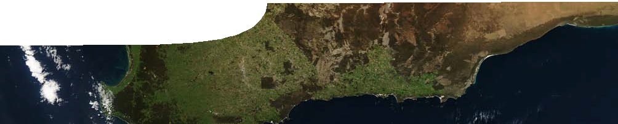
sequence overview
Food and energy

ENGAGE

EXPLORE EXPLAI
N ELABORATE

Background
These SPICE resources can be drawn together into a learning pathway for students to develop their understanding of energy flow through an ecosystem, using the honey possum as an example of how this can be traced. The pathway is structured around a constructivist model based on the 5-Es where teachers may:
- Engage students’ interest and minds in the concepts through discussion of the honey possum;
- allow students to Explore an environment where honey possums have been surveyed, to determine abundance and effects of environmental change on the species through analysis of real data;
- Explain the process of respiration and its role in needs and expenditure of energy in organisms; and
- Elaborate on these concepts through use of an interactive learning object to determine the ability of an environment to cope with the release of organisms.
- Evaluate students’ progress through the pathway.
The pathway has been designed for teachers of biological sciences, serving as a context for the Stage 2 WACE course, but it may also be used with students in earlier years at the discretion of the teacher.

Learning pathway

ENGAGE

EXPLORE EXPLAI

N ELABORATE

Food and energy 1: The honey possum
The honey possum consists of a teachers guide, fact sheet and video.
Student interest in the sequence is engaged through a video featuring Professor Don Bradshaw, who explains how he came to study the honey possum. Prof Bradshaw highlights many unique features of the tiny marsupial that allow it to survive in Australia’s only threatened biodiversity hot spot.
See the teachers guide for detailed information on the purpose and use of this resource.

ENGAGE
EXPLORE EXPLAI

N ELABORATE

Food and energy 2: Pollen
Pollen consists of a teachers guide, background sheet, presentation, interactive learning object and student worksheet.
Students use a ‘virtual microscope’ to examine and identify pollen from a range of plants, and then identify pollen taken from the nose of a honey possum. This activity provides students with an opportunity to practise various practical skills including microscopic measurement as well as recording and analysis of data.
See the teachers guide for detailed information on the purpose and use of this resource.

Food and energy 3: Fauna surveys
Fauna surveys consists of a teachers guide, presentation, fact sheet and worksheet.
Students develop an understanding of a range of trapping and sampling techniques commonly used by field biologists when undertaking field research . It also presents why these methods are used as part of population management strategies.
See the teachers guide for detailed information on the purpose and use of this resource.

ENGAGE
EXPLORE EXPLAI

Food and energy 4: Honey possum respiration
Honey possum respiration consists of a teachers guide, background sheet, fact sheet and student worksheet. The concepts of energy source and cellular respiration are explained through the nectivorous diet of the honey possum. The concepts of energy source, cellular respiration and metabolism are explained through the nectarivorous diet of the honey possum. Students use data to calculate metabolic rate and then use this for further analysis of of the marsupial’s energy requirements.
See the teachers guide for detailed information on the purpose and use of this resource.

ENGAGE
EXPLORE EXPLAI

Food and energy 5: Animal release
Animal release consists of a teachers guide, fact sheet, interactive learning object and worksheet.
Drawing upon understanding they have developed from previous activities in this sequence, students use an interactive learning object to solve an ecological problem: ‘Into which of several different habitats should
a population of animals from a captive breeding program be released?’ See the teachers guide for detailed information on the purpose and use of this resource.

Image credit

N ELABORATE

N ELABORATE
banner image: ‘Visible Earth: Western Australia’ by Jeff Schmaltz/NASA, PD-USGOV-NASA, visibleearth.nasa.gov/view_rec.php?id= 8167

Reference
The children’s book, A tale of two honey possums, by Felicity Bradshaw and illustrated by Patricia Negus is based on research by Don and Felicity Bradshaw.
A website connected to the book contains scientific research, downloadable PDFs, fun facts, video and useful links:
http://www.honeypossum.com.au/index.php

Acknowledgements
Thanks to Emeritus Professor Don Bradshaw and Felicity Bradshaw (School of Animal Biology, The University of Western Australia) and Dr Lynne Milne (School of Earth and Environment, The University of Western Australia).
Designed and developed by the Centre for Learning Technology, The University of Western Australia.
Production team: Leanne Bartoll, Helen Billiald, Kim Braimbridge, Pauline Charman, Roger Dickinson, Jan Dook, Alwyn Evans, Bob Fitzpatrick, Sam Gallagher, Trevor Hutchison, Daniel Keogh, Mark Lehmann, Paul Ricketts, Dawn Smith, Jodie Ween and Michael Wheatley.

SPICE resources and copyright
All SPICE resources are available from the Centre for Learning Technology at The University of Western Australia (“UWA”). Selected SPICE resources are available through the websites of Australian State and Territory Education Authorities.
Copyright of SPICE Resources belongs to The University of Western Australia unless otherwise indicated.
Teachers and students at Australian schools are granted permission to reproduce, edit, recompile and include in derivative works the resources subject to conditions detailed at spice.wa.edu.au/usage.
All questions involving copyright and use should be directed to SPICE at UWA.
Web: spice.wa.edu.au Email: spice@uwa.edu.au Phone: (08) 6488 3917
Centre for Learning Technology (M016) The University of Western Australia
35 Stirling Highway
Crawley WA 6009

