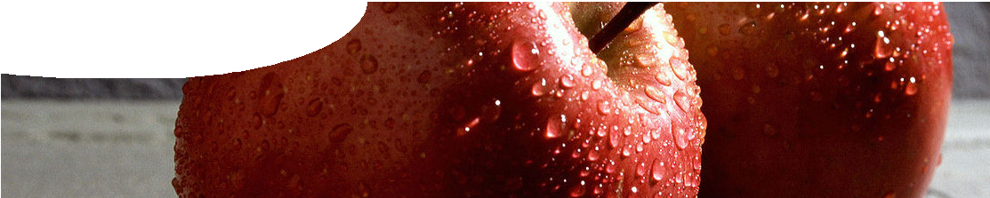

3. A rocket in deep space
In deep space, where there is no air resistance and very little gravitational force, a
rocket would have no external forces acting on it, so it would continue to travel at the same speed and direction without the need to burn fuel.
fact sheet
Newton’s laws of motion

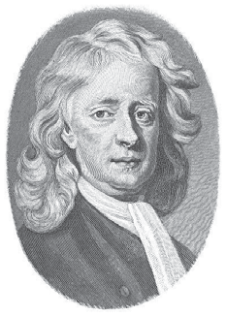Newton’s first law of motion
Objects remain in their state of rest, or uniform motion in a straight line, unless an external unbalanced force acts on them.
This is sometimes called the principle of inertia. Inertia is the tendency of an object to resist a change in its state of motion. In simple terms, it means that an object at rest will tend to remain at rest, or that a body in straight line motion will continue to move in the same direction at the same speed.
Examples:

1. A book rests on a table
When the book rests on the table, the
normal force from the table balances its weight, keeping it in equilibrium. It will remain in equilibrium unless an additional unbalanced force is applied to make it move.

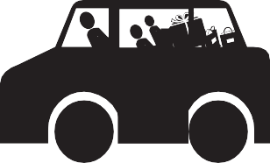
2. A bicycle travels at 20 km h-1 along a level road
When a cyclist is travelling at constant speed, forces opposing his motion balance forces moving him forward. The cyclist is in equilibrium and will continue to travel at the same speed, in the same direction, unless an external unbalanced force acts on him. In practice, external forces of friction and air resistance cause the bicycle to slow down.
UP
5. A car suddenly decelerates
When a car suddenly decelerates, objects inside it continue
moving at the original speed and direction until a force acts on them. Passengers continue to move ‘forwards’ until their safety belts apply a restraining force to limit their movement. Unrestrained objects in the car will move forward until other
forces (if any) act on them to stop their movement.

4. A lift accelerates upwards
When the doors close and a lift begins to accelerate upwards we feel ‘heavier’ than normal. This is because inertia tends to keep us at rest, while the lift gives us an upward force.

fact sheet
Newton’s laws of motion

Newton’s second law of motion
When an unbalanced force acts on an object, the object will accelerate in the direction of the force. Acceleration is directly proportional to the unbalanced force and is indirectly proportional to mass of the object.
ie
a ∝ F and a ∝ 1 m from which F = m a
Newton’s second law helps us to explain why an object may speed up, slow down or change direction when forces act. It also explains why it’s more difficult to accelerate a massive object and also more difficult to bring it to rest.

Newton’s third law of motion
For every action (force) there is an equal and opposite reaction (force). Note:
- Action forces and reaction forces always come in pairs, equal in strength and opposite in direction.
- The action force and reaction force always act on different objects.
- It doesn’t matter which is the action force and which is the reaction force.
So, if action forces and reaction forces are always equal and opposite, how do objects accelerate and move? Don’t the forces cancel each other out?
Well, when you’re deciding if an object is going to accelerate you need to look at all the forces acting on that single object and forget about the reaction force. The reaction force acts on a different object.

Examples:
In the following examples Newton’s third law is used to identify all force pairs acting in a system. Individual objects in the system are then analysed using Newton’s second law (if forces on the object are unbalanced) or Newton’s first law (if forces on the object are balanced).
1. A spacecraft fires its engines to move to higher altitude.
Action: The engines push a jet of hot gases down (ie this force acts on the hot gases).
Reaction: The hot gases push the spacecraft up (ie this force acts on the spacecraft).
Motion: There’s only one force acting on the spacecraft (the reaction force from the hot gases) so this unbalanced force causes the spacecraft to accelerate up.
2. The Earth and Moon
Action: The Earth pulls on the Moon.
Reaction: The Moon pulls on the Earth with an equal and opposite force.
Motion: There’s only one force acting on the Moon, so it ‘falls’ or accelerates towards the Earth in a circular orbit.

Earth’s gravity pulls the Moon
this way Moon wants to go this way
3. I stand on the floor, not moving.
Two action-reaction force pairs act here:
- I push on the ground and the ground pushes me back (first pair of equal and opposite forces); and
- the Earth pulls on me and I pull on the Earth (second pair of equal and opposite forces).
Motion: There are two forces that act only on me (one from each pair): the reaction force from the ground (pushing me up) and the pull of gravity from the Earth (pulling me down).
These happen to be equal and opposite, so I remain stationary and do not accelerate up or down.

