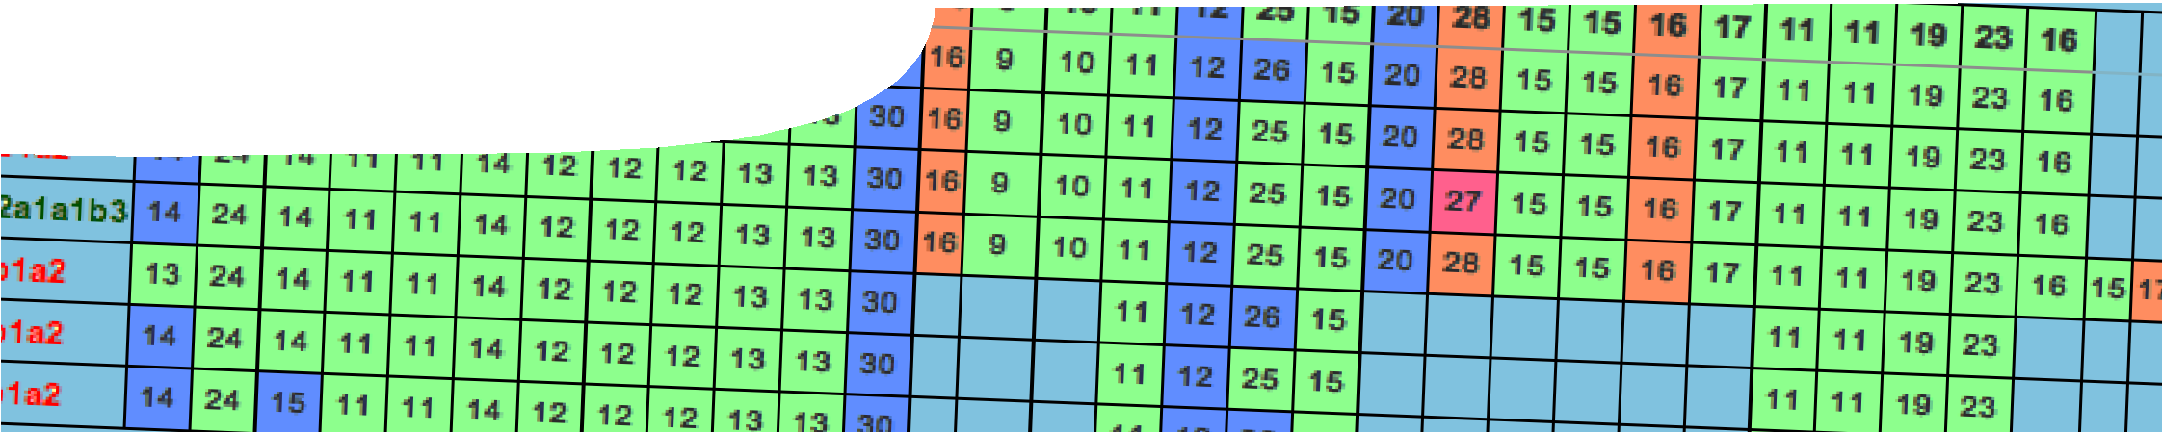
sequence overview
Molecular evidence for evolution

ENGAGE
EXPLORE EXPLAI

Background
N ELABORATE
These SPICE resources may be drawn together into a learning pathway to develop students’ understanding of how molecular biology advances have provided new insight into evolutionary relatedness. The pathway is structured around a constructivist model based on the 5-Es where teachers may:
- Engage students’ interest in evolutionary relatedness between mammals, using traditional evidence, via a card game;
- provide opportunities for students to Explore evolutionary relatedness between primates, based on physical and behavioural adaptations;
- Explain how molecular evidence has provided greater insight into relatedness between organisms and learn how to construct a visual representation of this with phylogenetic trees;
- Elaborate on a different form of evolution (viral) through use of an online research database; and
- Evaluate students’ progress through the pathway and through summative reflection.
The resource is designed for year 12 students, but may also be used with students studying Year 10 Australian Curriculum: Science, at the discretion of the teacher.

Introduction
This sequence relates a more traditional understanding of evolution, based on fossils, anatomical and embryological evidence, to a more current understanding of evolutionary relatedness that also considers molecular evidence from DNA, RNA and protein sequences.

Learning pathway

ENGAGE

EXPLORE EXPLAI
N ELABORATE

Molecular evidence for evolution 1: Mammal evolution
Mammal evolution includes a teachers guide, presentation, card game and teacher background sheets.
A card game engages student interest in evidence used to determine evolutionary relationships between eutherians (placental mammals). See the teachers guide for detailed information on the purpose and use of this resource.

ENGAGE

EXPLORE EXPLAI
N ELABORATE

Molecular evidence for evolution 2: Primates
Primates comprises a teachers guide, two learning objects and worksheet.
Students use interactive learning objects to explore how anatomical evidence may be used to determine relatedness. See the teachers guide for detailed information on the purpose and use of this resource.

ENGAGE

EXPLORE EXPLAI
N ELABORATE

Molecular evidence for evolution 3: Evolutionary trees
Evolutionary trees comprises a teachers guide, video, learning object, fact sheet, student worksheet and teacher background sheet.
The use of molecular evidence to determine relatedness between species is explained. Students draw evolutionary trees to represent relatedness. See the teachers guide for detailed information on the purpose and use of this resource.

ENGAGE

EXPLORE EXPLAI
N ELABORATE

Molecular evidence for evolution 4: Viral evolution
Viral evolution comprises a teachers guide, fact sheet student worksheet and teacher background sheets.
Students use the Influenza Research Database to investigate virus evolution. This bioinformatics database is an authentic research tool used to compare genetic sequences of virus strains, and to construct cladograms to draw conclusions about their relatedness. See the teachers guide for detailed information on the purpose and use of this resource.

Acknowledgements
Thanks to Dr Kevin C Rowe (Senior Curator of Mammals, Museum Victoria); Daniel Scarporolo and Claire Gaskin (Perth Zoo); Ben Gibson and Mark Williams (Taronga Zoo); Judith Henke (Melbourne Zoo); Ruth Hall (Zoos South Australia); Winthrop Professor Linc Schmitt and Celeste Wale (School of Anatomy, Physiology and Human Biology at The University of Western Australia); and Yun Zhang, Burke Squires, Brett Pickett and Jyothi Noronha (Richard Scheuermann Bioinformatics Laboratory at the University of Texas Southwestern Medical Centre at Dallas).
Designed and developed by the Centre for Learning Technology, The University of Western Australia.
Production team: Anton Ball, Pauline Charman, Associate Professor Jan Dook, Alwyn Evans, Dan Hutton, Rebecca McKinney, Paul Ricketts and Dr Michael Wheatley, with thanks to Beate Ferbert- Booth, Bob Fitzpatrick, Jenny Gull and Wendy Sanderson.

SPICE resources and copyright
All SPICE resources are available from the Centre for Learning Technology at The University of Western Australia (“UWA”). Selected SPICE resources are available through the websites of Australian State and Territory Education Authorities.
Copyright of SPICE Resources belongs to The University of Western Australia unless otherwise indicated.
Teachers and students at Australian and New Zealand schools are granted permission to reproduce, edit, recompile and include in derivative works the resources subject to conditions detailed at spice.wa.edu.au/usage.
All questions involving copyright and use should be directed to SPICE at UWA.
Web: spice.wa.edu.au Email: spice@uwa.edu.au Phone: (08) 6488 3917
Centre for Learning Technology (M016) The University of Western Australia
35 Stirling Highway
Crawley WA 6009

