fact sheet
Modelling the future

SRES (Special Report on Emission Scenarios) models are grouped into two families: A and B. Each group shares common characteristics, but models within each family have their own unique features.
SRES

A1 Family A2 Family B1 Family B2 Family

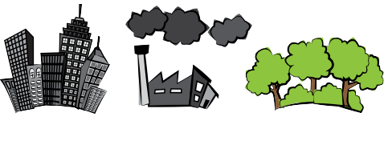
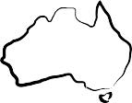
A1T A1B A1F1 A2 B1 B2

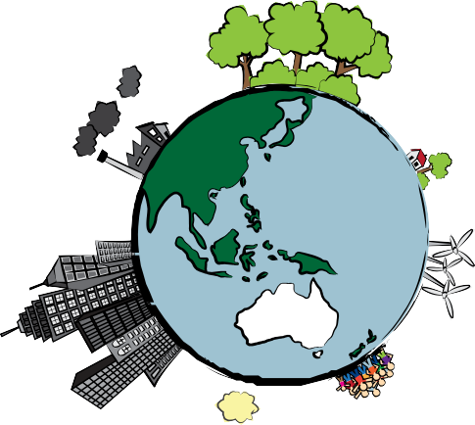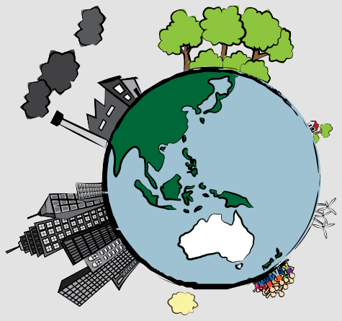

A1B scenario
The world of the future is one of: fast economic growth in traditional industries; overall population decline; increased globalisation; and social and cultural interaction. People are better off financially, however there’s a large gap between rich and poor. Energy sources become more balanced, with a reduction in non-renewable energy, like coal, and an increase in renewable energy. Environmental management is important, as Earth’s resources are consumed in a more efficient way.

+1.5-2˚C
A1F1 scenario
The world of the future is one of: fast economic growth in traditional industries; overall population decline; increased globalisation; and social and cultural interaction. People are better off financially, however there’s a large gap between rich and poor. Non-renewable energy sources are a focus and environmental management is important, as Earth’s resources are consumed in a more efficient way.
+2.5-3˚C
Key:
These icons represent influences in SRES scenarios. Each scenario has the same icons, but size varies. The bigger the icon the more important the role.

+1.5-2˚C
online industry economic growth non-renewable environmental regional focus population size renewable energy projected temperature
and globalisation energy concern rise in Perth
ONLINE

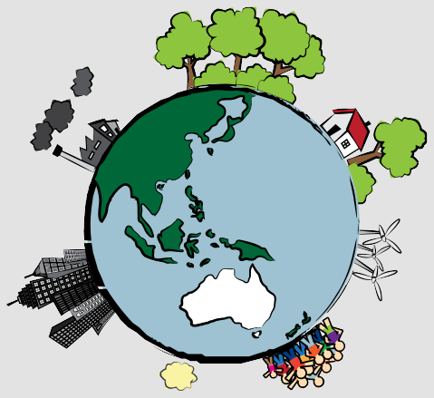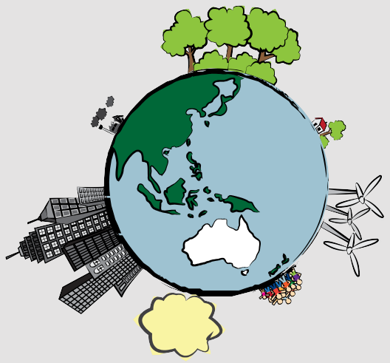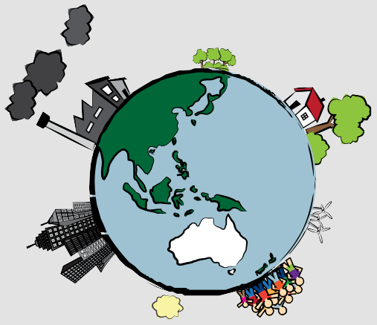B1 scenario
A2 scenario
The world of the future is one of self-reliance and local identity. Economic growth is moderate and population continues to grow, as large families are valued. Per capita income is different between countries as each government makes decisions for its own jurisdiction. Types of energy sources used to generate power are varied but there’s a reliance on fossil fuels, due to mixed availability of technology. Global environmental concerns are mixed, with some local action to reduce damage. Over time, as technology improves, environmental degradation is reduced.
+2-2.5˚C
The world of the future is one of: fast economic growth; overall population decline; and increased globalisation and social and cultural interaction.
A service and information economy is the main focus, with reductions in traditional industry taking place. There’s also a focus on development of renewable technology with a reduction in non-renewable energy sources. Environmental concern is high and there’s a global approach to more sustainable development.

+1-1.5˚C

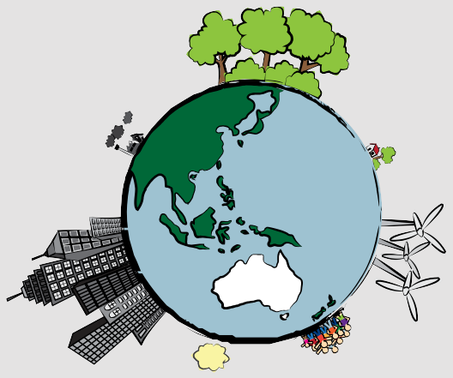
A1T scenario
The world of the future is one of: fast economic growth in traditional industries; overall population decline; increased globalisation; and social and cultural interaction. People are better off financially, however there’s a large gap between rich and poor. Renewable energy sources are a focus and environmental management is important, as Earth’s resources are consumed in a more efficient way.
+1.5-2˚C

B2 scenario
The world of the future is one of self-reliance and local identity. Economic growth is moderate and population continues to grow, but at a reduced rate. Per capita income is different between countries as each government makes decisions for its own jurisdiction. Types of energy sources used to generate power are usually non-renewable but there is a trend towards greater use
of renewable technology. Environmental concern is high and there is some regional co-operation towards solving environmental problems.

+1.5-2˚C

