fact sheet
Mesoporous silica capsules
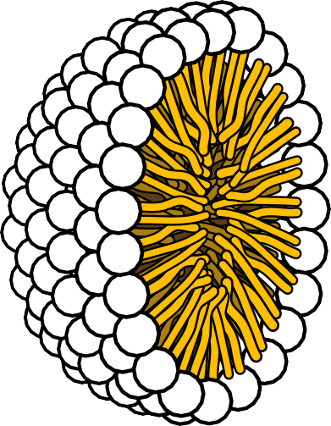
When you next eat a curry you could be helping to protect yourself from cancer.

Curry contains the spice turmeric and a major component of turmeric is curcumin. Curcumin is known to have anti-tumour and anti-cancer capabilities.
Indian people, whose diet includes turmeric, have significantly lower rates of bowel and intestinal cancer than people who eat a western diet. However, curcumin is poorly absorbed from the intestine so to benefit from
these properties a lot has to
be eaten.
Scientists at the Centre for Strategic Nano- Fabrication at The University of Western
Australia have been working on a way to encase curcumin in tiny silica capsules to ensure better uptake by the body through a ‘slow-release’ delivery system.
Mesoporous silica (SiO2) capsules can be used to carry curcumin because they are non-toxic and chemically inert.
Did you know?
‘Mesoporous’ refers to materials with nano- sized pores in them — a nanometer is a million
times smaller than a millimetre!

fact sheet
Mesoporous silica capsules

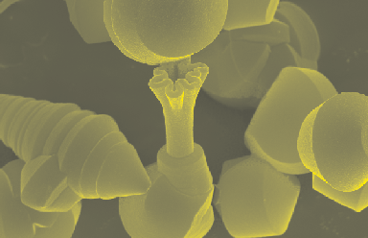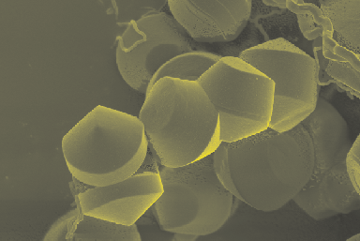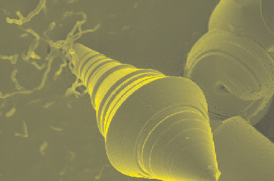H+

Figure 6: Capsules form a wide range of shapes, depending on the reactants used.

Slow release of curcumin from capsules has been measured in test tubes with the same acid concentration (pH) that is found in blood. Controlled release should lead to much better uptake of curcumin, but at this time not enough
is known about the effects of silica capsules on the body for them to be trialled in animals or humans.
In the future this method of drug delivery may be ideal for expensive or poorly absorbed drugs. Curcumin was used in this research as a model for hydrophobic drugs in general. The challenge ahead for the research group is to adapt these methods to a range of drugs and to turn it into a commercial product.
CH3
H2C
O
H3C
O
Si
H2C
CH2
O
CH3
O
CH2
H3C
H
O
O
H
H
Si
O
O
H

Figure 3: Formation of Si(OH)4 by addition of acid to TEOS.

-H2O
Si
O
O
O
Si
Si
Si
Si
Si
O
O
O
Si

Figure 4: Removal of water creates a SiO2 network.

Pores are created as silica wraps around the rods. Pore size, which is important in controlling the rate of release of curcumin, can
be determined by varying the surfactant used. To be classified as mesoporous, pores need to be 2 to 50 nm in diameter.
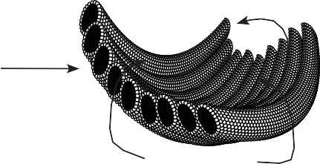
Micellar rods line up in regular structures as they are coated. The silica coating then bends and folds into various ‘origami’ shapes, ranging in size from 5 to 10 μm (about the same size as a red blood cell). About 150 silica capsules would fit across a pinhead!
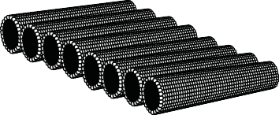

Figure 5. Micellar rods align and fold to create the capsules

Nigel Clifford

Nigel Clifford is a Green Chemistry honours graduate from The University of Western Australia.
The Green Chemistry program offered by The University of Western Australia is focussed upon chemistry that is non-hazardous for both people and the environment.
As part of his honours degree Nigel developed a way of using mesoporous silica capsules as controlled release carriers of curcumin in the human body. Controlled-release medicines mean far fewer side effects and more effective medicinal uptake.
Nigel’s research offers a new approach to the delivery of medicines to the human body, and may well be the drug delivery system of the future.

References
- Clifford, N. W., Iyer, K. S. and Raston, C. L. (2008). Encapsulation and controlled release
of nutraceuticals using mesoporous silica capsules. Journal of Materials Chemistry, 18, 162-165.
- Lee, Y. S., Surjadi, D. and Rathman, J. F. (1996). Effects of Aluminate and Silicate on the Structure of Quaternary Ammonium Surfactant Aggregates. Langmuir, 12, 6202-6210.

