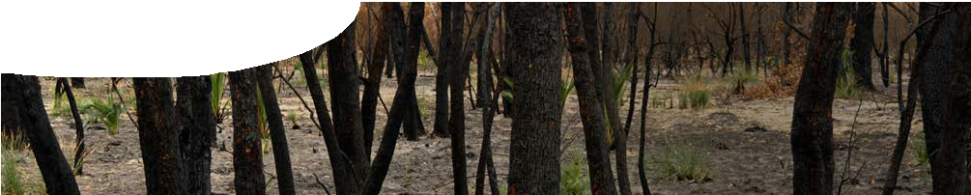
fact sheet
Life from fire

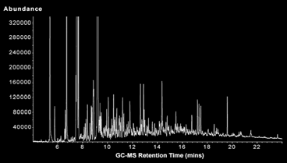Bush fires can be terrible, catastrophic events. They have dictated the evolution of plants over the last 30 million years, resulting in special adaptations for coping with the trauma. Remarkably, some plants have developed to the point where fire is now necessary before seeds will germinate.
Seeds that require fire to germinate tend to be hard with a waxy cuticle that forms a waterproof barrier. They are surrounded by a dense layer of woody material that protects them from heat.
Heat from fire is one factor in promoting seed germination, but smoke is also a key to breaking seed dormancy in a wide variety of Australian plants. It doesn’t matter what form the smoke takes – it is just as effective as an aerosol, liquid or solid. The part of the puzzle that has been difficult to solve is exactly which chemical
in smoke causes germination. This is because smoke is such a complex mixture, made up of thousands of different chemicals.

Gas chromatogram of the compounds present in smoke. Each peak corresponds to a different chemical.
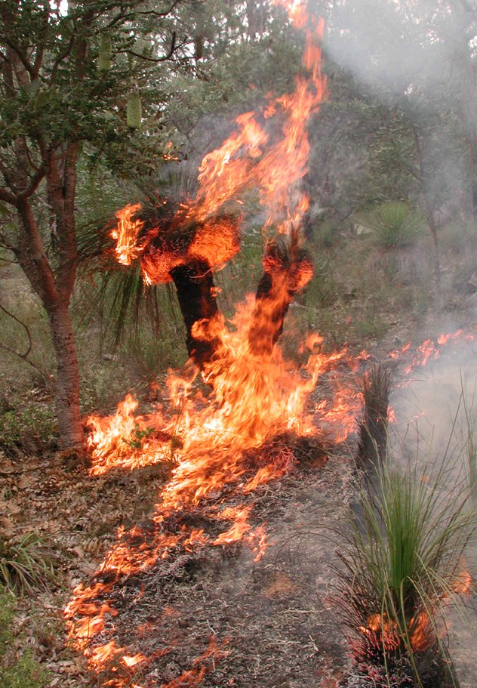
The compound he found is a butenolide, which he nicknamed karrikinolide from the Noongar word for smoke, karrik. It has a melting point of 118 °C, is soluble in water, and is active in promoting germination at concentrations as low as 1 part per billion (1µg/L).

In 2004, PhD student, Gavin Flematti at The University of Western Australia not only found the chemical
responsible, but also worked out its molecular weight, composition and structure.
He used a combination of chromatography, mass spectrometry (MS) and
nuclear magnetic resonance

Structural isomers

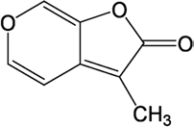
Molecular structure of karrikinolide
The next stage was to work out how to make it. Making an organic compound is a little like building a puzzle. Dr Flematti knew the final shape, the type of elements and where they should go. What he
had to do was work out which chemicals he needed to
react together, building

spectroscope (NMR) to do this.

A molecule with the formula C8H6O3 can have many shapes. It took Dr Flematti four years to isolate and determine the structure of the active ingredient from
and breaking bonds, to achieve the end product.
Further studies revealed that a solution of karrikinolide can regenerate degraded areas
of land, without burning

smoke.
existing vegetation, to induce seed germination.

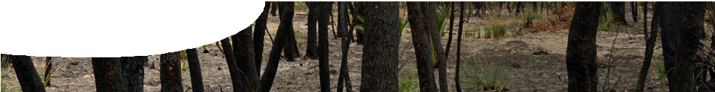
fact sheet
Life from fire

Synthesis of karrikinolide
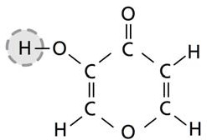
A karrikinolide molecule contains two rings: a pyran ring which has five carbons, one oxygen and two double bonds; and a furan ring that has four carbons, one oxygen and one double bond. To synthesise karrikinolide in the laboratory, chemists started with a molecule that already contained some parts of the required structure.

One of the starting molecules (pyromeconic acid, shown below right) already contains a pyran ring — the
reactions that follow are designed to attach a furan ring to it. Trials confirmed that the synthetic karrikinolide had the same seed-germination properties as the compound previously extracted from smoke.

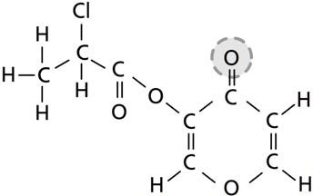
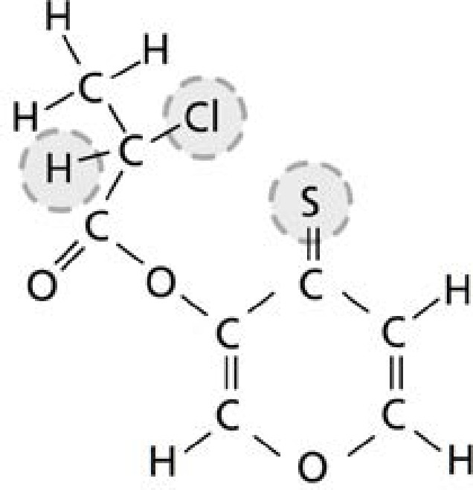
STEP 1  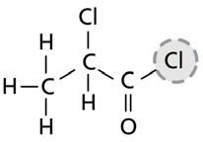  pyromeconic acid (pyran ring) | The first stage is to react these two molecules together.  The highlighted hydrogen and chlorine atoms bond, and are removed as an HCl molecule. The organic molecule produced has a  pyran ring with a side chain.
STEP 2 | Sulfur is substituted for the oxygen atom attached to the pyran ring.
STEP 3 | The highlighted sulfur, chlorine and hydrogen atoms are then removed.
STEP 4  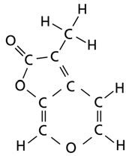 karrikinolide | The two carbon atoms to which the above atoms were bonded then form a double bond. This closes the second (furan) ring to produce  the desired compound, karrikinolide.

Reference
- Flematti, G et al. (2005). Synthesis of the seed germination stimulant 3-methyl-2H-furo[2,3-c]pyran-2-one. Tetrahedron Letters, 46, 5719–5721.

- Flematti, G R et al. (2004). A compound from smoke that promotes seed germination. Science, 305, 977

