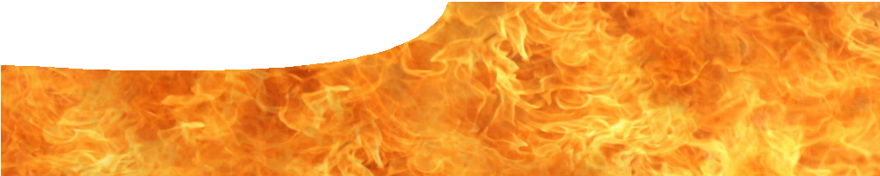
fact sheet
Isotopes

If a hydrogen atom was blown up to the size of the MCG how big would the nucleus be? About 2 mm in diameter. It’s no surprise then that chemical and physical properties of elements depend a lot more on their electron structure than the composition of the nucleus. However there are branches of chemistry and physics – specifically nuclear chemistry and nuclear physics – that are very much concerned with what goes on in atomic nuclei. Isotopes are one example of this.

What are isotopes?
Isotopes of an element have the same number of protons in the nucleus, but differ in the number of neutrons. For example lithium-6 has three protons and three neutrons in the nucleus (giving a mass number of 6) while lithium-7 has three protons and four neutrons (giving a mass number of 7). The standard atomic weight of lithium is 6.94, which reflects the natural abundance of these two isotopes: 7.5% lithium-6 and 92.5% lithium-7.
The existence of isotopes was first suggested by Frederick Soddy in 1913. Together with J J Thompson he had earlier recognized that radioactive decay involved transmutation of elements. In many cases products of radioactive decay are themselves radioactive, leading to a chain of radioactive decay products before a stable element is reached. However when Soddy studied uranium there seemed to be many more products than there were spaces in the periodic table to hold them. Names given to them, such as mesothorium and thorium X, reflected scientists’ bafflement as to how to classify these radioactive products.

A friend of Soddy coined the term ‘isotope’ meaning ‘same place’ to reflect the fact that groups of these radioactive products were apparently located at the same place in the periodic table. Separation of isotopes proved problematic as they shared near identical physical and chemical properties. It wasn’t until 1932 that James Chadwick’s discovery of the neutron provided an explanation for the structure of isotopes.

Stable and unstable isotopes
For each element, only specific numbers of neutrons results in a stable isotope. There are just over 250 stable isotopes in the periodic table. Some elements, such as technetium, promethium and radium have no stable isotopes.
Nuclei with too many or too few neutrons for a given number of protons are unstable. They are radioactive and decay through emission of alpha, beta or gamma radiation.
Isotopes have a wide range of half lives. Lithium-4, with just one neutron and three protons in its nucleus has a half life of 10–22 seconds, whilst tellurium-128 has a half life of more than 1024 years.

2 mm

Figure 1: If a hydrogen atom was the size of the MCG stadium then the nucleus would be a mere 2 mm in diameter.
photo: Donaldytong, PD, commons. wikimedia.org/wiki/File:MCG_(Melbourne_ Cricket_Ground).jpg

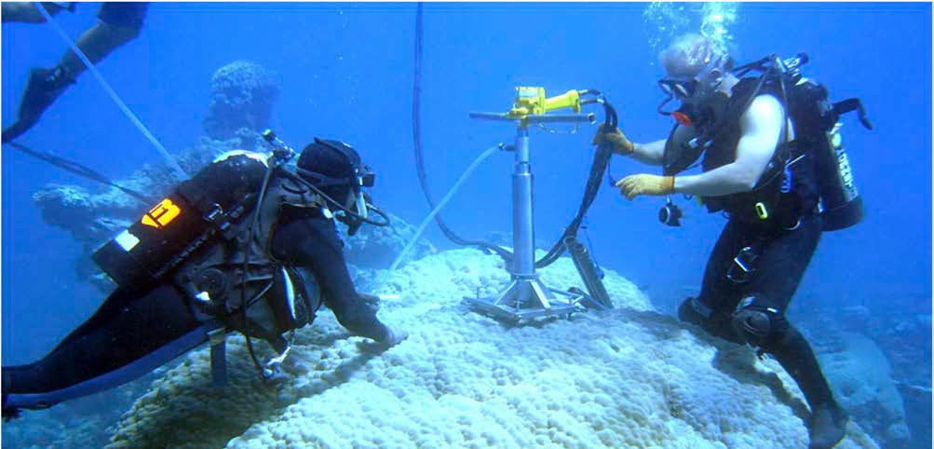
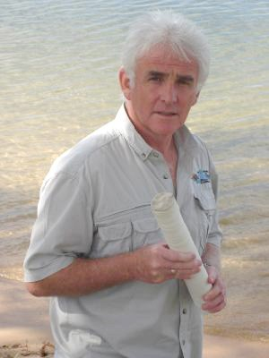Figure 2: Coral sampling. photo: Oceans Institute, The University of Western Australia

Applications of isotopes 1 — environmental isotopes

Although isotopes of a particular element have very similar physical and chemical properties they’re not identical. Differences tend to be greater for elements with smaller mass numbers. These characteristics have been exploited in a wide range of environmental applications.

Boron in corals
Boron is present in seawater in two forms: boric acid B(OH)3 and borate ions B(OH)4–.
B(OH) +H O B(OH)− +H+
3 2 4
The equilibrium reaction between them is pH sensitive. Under more acid conditions (pH < 8.6) the equilibrium is driven to the left and boric acid dominates; and under more basic conditions
(pH > 8.6) it is driven to the right and borate ions dominate.
Seawater contains about 4.5 ppm boron that is present as two isotopes: 20% boron-10 and 80% boron-11. However these isotopes are not distributed evenly between boric acid and borate ions. There is always slightly more boron-11 in boric acid than you would expect.
If seawater pH is much greater than 8.6 then most boron will be present as borate ions, so 11B / 10B in borate ions will be close to seawater average. 11B / 10B in the small amount of boric acid in seawater will be a little higher than average.
If seawater pH is much less than 8.6 then most boron will be present as boric acid, and 11B / 10B in boric acid will be close to seawater average. 11B / 10B in the small amount of borate ions in seawater will be a little lower than average.
Some marine organisms that form calcium carbonate exoskeletons incorporate boron from seawater as they grow, but only from borate ions, not boric acid. Scientists compare the concentration of 10B and 11B in these organisms to determine isotopic concentration of boron in borate ions, and hence seawater pH, when they were growing.
At The University of Western Australia, Professor McCulloch measures the concentration of boron isotopes in the skeletons of corals by testing core samples. Corals can live for hundreds of years, so samples from older corals, or parent corals, are used to build up a picture of ocean chemistry over a long period of time.
Professor McCulloch’s research has shown boron-11 levels in corals are dropping, which indicates decreasing seawater pH (acidification). Research has already shown that ocean pH has decreased over the past 200 years, from 8.12 to approximately 8.06 pH units.

Oxygen in seawater
Oxygen is another isotope that is used in environmental studies of the oceans. Oxygen-16 is the common oxygen isotope with about 2000 times the abundance of stable isotope oxygen-18.
Microorganisms (foraminifera) in seawater incorporate these oxygen isotopes in their shells as they form. The isotope ratio in shells depends on the isotope ratio
in the surrounding water and is also temperature- sensitive. Shells that form in colder water include more oxygen-18 isotope.

Results from these studies can be difficult to interpret, as there are complicating factors. Oxygen-16 evaporates more readily from seawater, whilst
oxygen-18 condenses more readily from water vapour. Precipitation near the Equator has a considerably higher oxygen-18 to oxygen-16 ratio than precipitation near the poles. The ratio is also affected by the amount of ice locked up in polar ice caps. Despite these complications, isotope studies remain an important part of climate research.

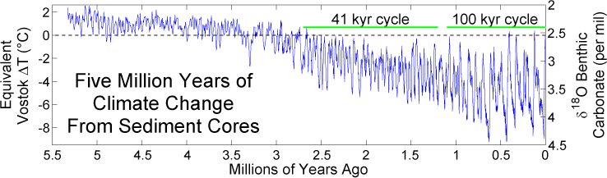
Figure 3: A decreasing value of δ18O in carbonate sediments over the past 5.5 million years suggests seawater is getting warmer. δ18O is a measure that compares the ratio 18O/16O in samples to a standard reference material.
Image created by Robert A. Rohde / Global Warming Art

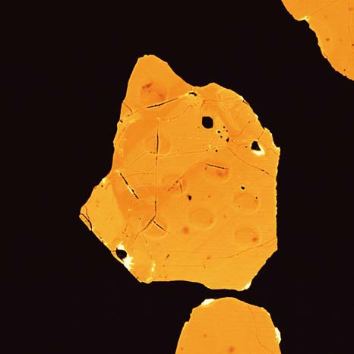Applications of isotopes 2 – radiometric dating

Whilst environmental studies mostly use stable isotopes, radiometric dating depends on unstable isotopes to calculate the age of materials. The principle behind these techniques is quite simple.
Because the decay rate of a radioactive isotope is known, fixed and independent of physical and
chemical conditions, the ratio of a daughter isotope (product of radioactive decay) to parent isotope indicates the time that has elapsed since a material formed.
Difficulties occur in knowing if any of the daughter isotope was present at the start of the process, and whether the system is ‘closed’ – that is, whether material (parent or daughter) has been introduced to or escaped from the system over time.

Zircon dating
Zircon is a tough mineral (ZrSiO4) that is found in small amounts in many igneous rocks such as granite. When it forms it may incorporate tiny amounts of radioactive uranium and thorium, but the crystal structure incorporates very little lead. Any lead found in modern-day zircons is likely to be the product of radioactive decay of uranium and thorium.
Uranium-235 decays through a chain of radioactive isotopes to form the stable isotope lead-207 with a half-life of 704 million years. Uranium-238 decays
through a chain of radioactive isotopes to form the stable isotope lead-206 with a half-life of 4.47 billion years. Measuring both 207Pb/235U and 206Pb/238U provides two estimates of a sample’s age.
Using this technique, zircon samples from the Jack Hills area of Western Australia have been dated to
4.4 billion years, which places them amongst the oldest minerals found on Earth.

Figure 4: micrograph of Jack Hills zircon
photo Professor Simon Wilde, Curtin University

Carbon dating
Carbon-14 is a radioactive isotope of carbon with a half-life of just over 5000 years. It decays by beta- decay into nitrogen-14 with the emission of an electron and antineutrino according to the equation:
14 C → 14 N + e− + ν
Living tissue constantly exchanges carbon dioxide with the atmosphere so they are in equilibrium. Plant and animal material therefore contains a concentration
of carbon-14 that reflects that of the atmosphere. As soon as animal or plant material dies this exchange stops, and the concentration of carbon-14 begins to decrease as it decays. Concentration of cabon-14,

6 7 relative to carbon-12, remaining in a sample can be used to calculate its age.

If carbon-14 has such a short (comparatively) half-
life, why is there roughly one part per trillion of the isotope in the atmosphere? The answer is that it is constantly produced through the action of cosmic rays striking Earth’s upper atmosphere.
These high-energy particles, mostly protons originating from outside the Solar System, produce a shower of fast moving particles as they interact with the atmosphere. Amongst these secondary particles, neutrons are occasionally absorbed by nitrogen nuclei to produce carbon-14 by ejection of a proton.
Refinements to the procedure are required for more accurate measurements.
- Allowance can be made for a gradual change in the rate of production of carbon-14 over time due to changes in Earth’s magnetic field.
- Nuclear testing in the 1950s almost doubled the concentration of carbon-14 in the atmosphere.
- Increased production of carbon dioxide by burning fossil fuels (which contain negligible amounts of carbon-14 due to their age) dilutes atmospheric

14 N +
1 n → 14 C + 1 p
carbon-14.

7 0 6 1
Production and decay of carbon-14 are balanced so that a roughly constant concentration of carbon-14 is found in the atmosphere.
Carbon dating is an important technique in dating archaeological remains such as wood and other organic material. Reliable dates are obtained with material up to 60000 years old.

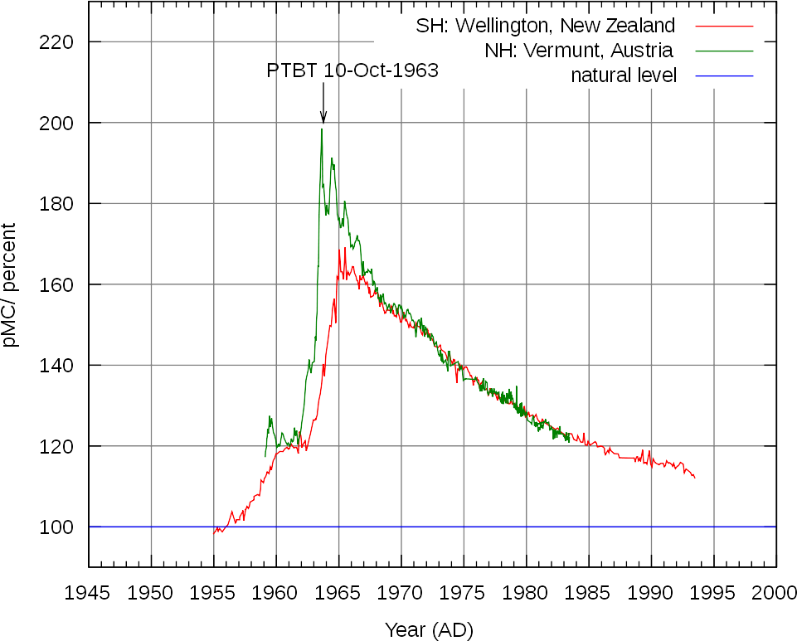
Figure 4: Measurement of atmospheric carbon-14 shows a spike from baseline levels of 100 units before 1955. Levels start to drop from October 1963 when a partial test ban treaty was implemented.
image by Hokanomono. PD. en.wikipedia.org/wiki/File:Radiocarbon_bomb_spike.svg

