Object of the game
Match each animal to the correct clade.
What is a clade?
A clade is a group of organisms that includes a common ancestor and all living and extinct descendants of that ancestor.
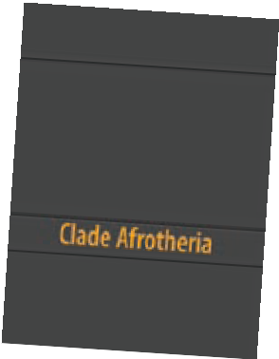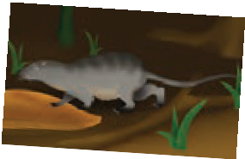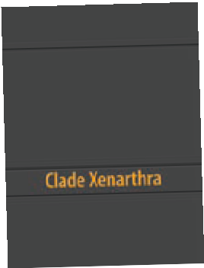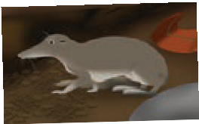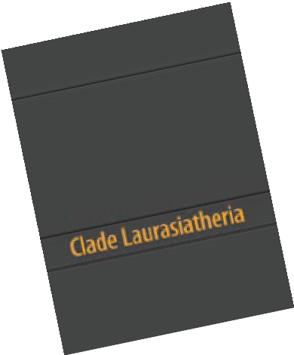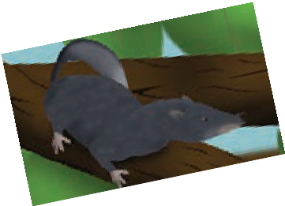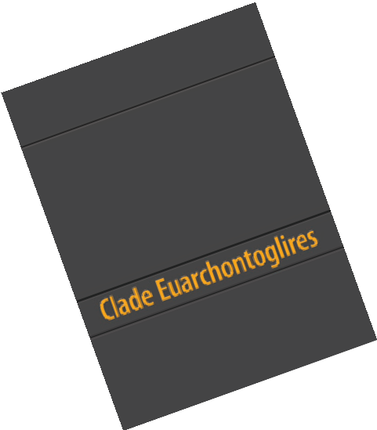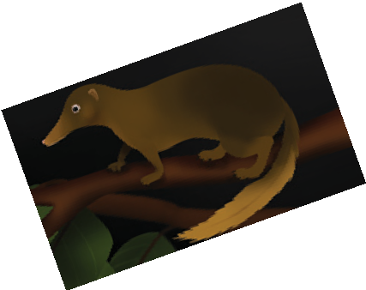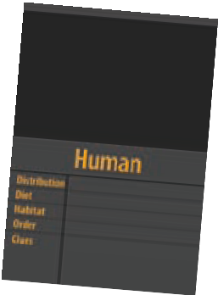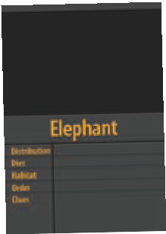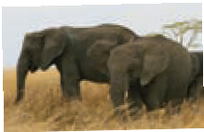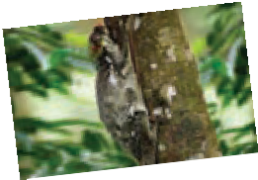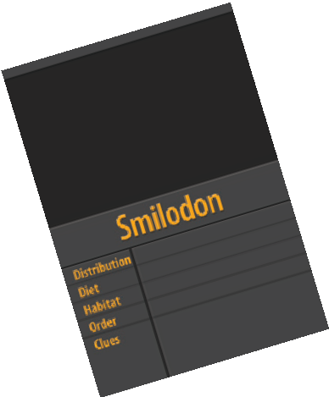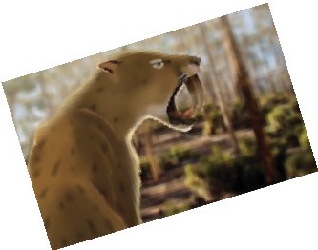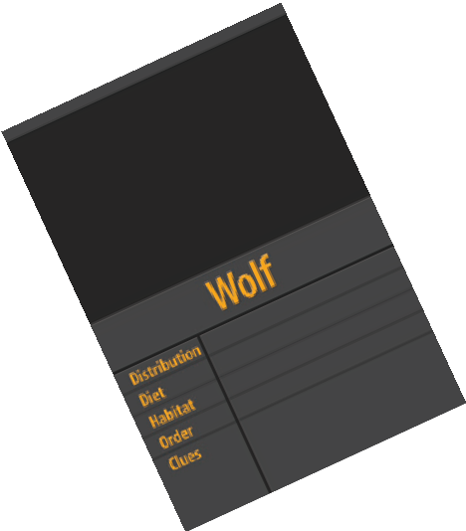What’s in the deck?
clade cards
There are four grouping cards that represent the four eutherian (placental mammal) clades: Afrotheria, Xenarthra, Laurasiatheria and
Euarchontoglires. All existing and extinct eutherians belong to one of these clades.
UTnotall • cheekteeth • low metabolic rate Some of my descendants share the following features:
•
B • cloaca (common urogenital opening)
• abdominal testes (internal testicles)
• incisor tusks
• low body temperature
playing cards
There are forty playing cards that depict various eutherians. Each mammal belongs to a particular clade.
Number of players
for 2 to 6 players
How to play
- Place clade cards face up, in centre of playing area.
- Deal five playing cards to each player.
- Place remaining playing cards face down in centre. This is the draw deck.
- First player uses evidence provided on clade cards and playing cards, and places one of their playing cards with correct clade.
- Player provides a reason for their decision, based on the evidence.
- Other players may challenge this decision, but must provide evidence for their challenge.
- If majority of players challenge, card is withdrawn and placed at base of draw deck. Player whose card is placed under draw deck must take new card from top of draw deck.
- If player’s decision is not challenged they don’t pick up another card.
- Play continues in clockwise direction.
- The first player to match all their playing cards to correct clade wins.
At end of game, work together or individually to match all remaining playing cards to correct clade.

Playing tips
The aim of the game is to group together animals that shared a common ancestor in their evolutionary past. Be aware, common ancestors of each clade existed a long time ago, between 85 to 100 million years.
Think twice, not all animals in a clade will have features listed on the grouping card!

ast0911 | Molecular evidence for evolution: Who’s related? Rules of the game (procedure sheet) developed for the Department of Education WA
© The University of Western Australia 2013 for conditions of use see spice.wa.edu.au/usage version 1.1 revised August 2013 page 1 Licensed for NEALS

