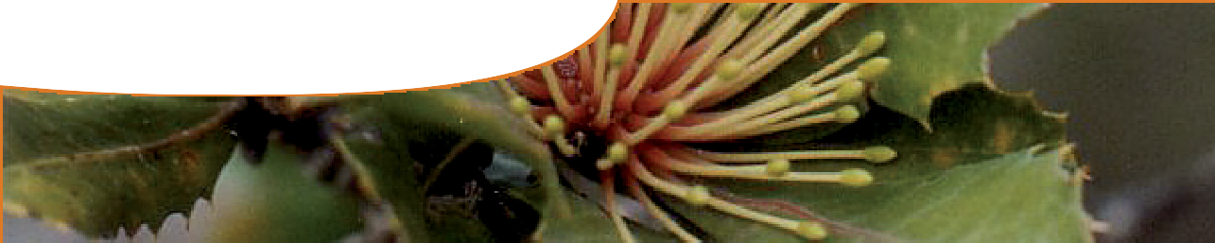
fact sheet
Features of the honey possum

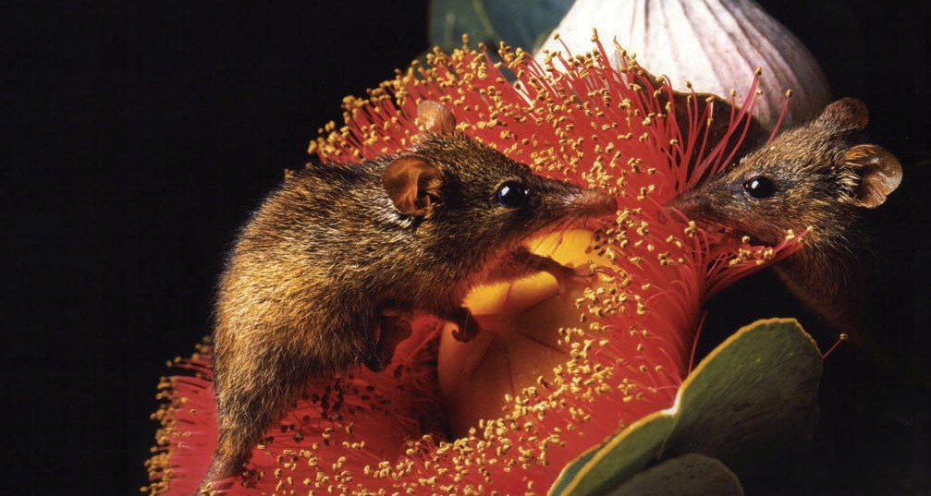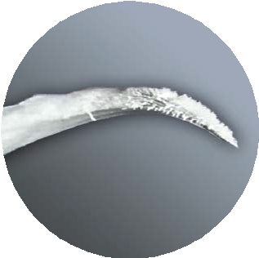common name: honey possum Noongar name: noolbenger scientific name: Tarsipes rostratus

Honey possums are one of the world’s smallest marsupials. With their long snouts, pink prehensile tails and beady black eyes they can easily be mistaken for a mouse. But the honey possum isn’t a mouse: in fact, it’s not even a possum and it doesn’t eat honey!
Johnathan Blair
National Geographic Stock

Feeding

Adaptation

bristles at the end of a honey possum tongue
The honey possum has several adaptations to this fussy diet of

- The honey possum is largely
nocturnal (active at night). It feeds only on nectar and pollen, acquiring all of its dietary water from its food. This diet is especially unusual for a mammal that’s unable to fly from flower to flower.
- Banksias are a favourite food plant.
Banksia flower spikes are made up of clusters of tightly packed
flowers (called an inflorescence) that produce a lot of nectar and pollen.
- Scientists at The University of Western Australia have found that a honey possum’s daily energy requirement is about 34 kJ, or
8 Calories: that’s equivalent to just a third of a teaspoon of sugar.
- If food is scarce, honey possums
can enter short periods of torpor (temporary hibernation) with lowered body temperature and metabolic activity.
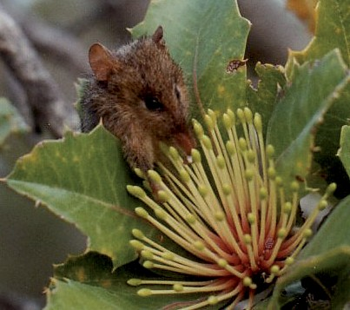
honey possum feeding on flowers of
Banksia ilicifolia
pollen and nectar.
  - Its amazing tongue can stretch out the length of its own head and has bristles at the end to mop up nectar. Pollen grains are scraped off the tongue by a series of combs arranged on the roof of its mouth.
  - A honey possum can flick its tongue in and out three times every second.
  - With no need to chew any food, its teeth have become highly specialised. Most have
disappeared or turned into stumpy pegs, except for two front teeth that help guide the tongue as it shoots for its target.

© 2011 The University of Western Australia,
for conditions of use see spice.wa.edu.au/usage
developed for the Department of Education, Western Australia

ast0073 | version 1.0 Food and energy 1: Features of the honey possum (fact sheet) | page 1

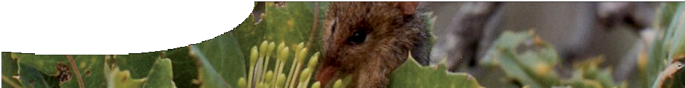
fact sheet
Features of the honey possum

Reproduction
    - Male honey possums have the longest sperm of any mammal:
0.36 mm.
    - They also have the largest testes in relation to body size: approximately 5% of their
bodyweight. For a man to hold the same record, his testes would have to weigh 4 kg!
    - Honey possums only live for one to two years, but a female can have up to three litters of two to four young each year.
    - Honey possums have the smallest newborns of any mammal, weighing 0.003 – 0.005 g. Each is about the size of a grain of rice.
    - The newborn stays in its mother’s pouch for eight or nine weeks.
    - Like kangaroos and wallabies, honey possums have a useful reproductive mechanism known as embryonic diapause, where embryo development can be put ‘on hold’.

Habitat
  - Honey possums need a year-round supply of nectar and pollen to survive, so they’re only found in flower-rich regions of southwest Western Australia.
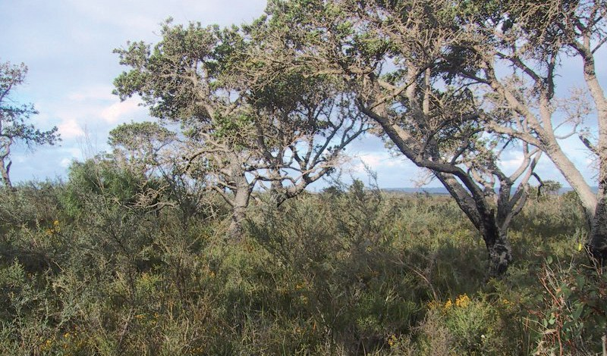
  - Land clearance has drastically reduced prime honey possum habitat, restricting their range to fragments of heathland such as Scott National Park, 260 km south of Perth.

  - Sadly, Australia has the highest rate of mammal extinctions in the world, and with increasing habitat loss, the honey possum’s survival may be under threat.

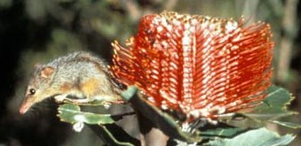

Size
    - 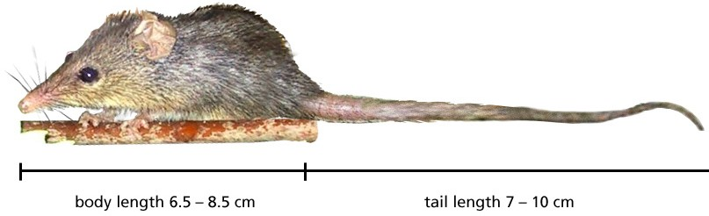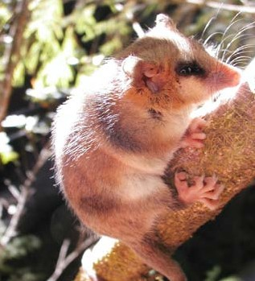Unusually, female honey possums are larger and heavier than male.
typical honey possum habitat, in Scott National Park

Relatives
  - The honey possum is the only species in its family, Tarsipedidae.
 | male | female
weight | 7–11 g | 8–16 g
body length | 6.5–8.5 cm | 7.5–10.5 cm
tail length | 7–10 cm | 7.5–10.5 cm

  - Its close relative, Dromiciops gliroides, lives in South America. Its South American name, Monito del Monte, means ‘monkey of the mountains’.
  - It’s thought the two animals shared a common ancestor that lived on
the super continent of Gondwana over 50 million years ago.

Dromiciops gliroides, perhaps the honey possum’s closest relative

© 2011 The University of Western Australia,
for conditions of use see spice.wa.edu.au/usage
developed for the Department of Education, Western Australia

ast0073 | version 1.0 Food and energy 1: Features of the honey possum (fact sheet) | page 2

