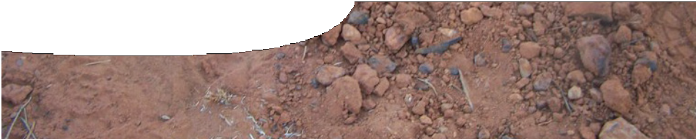
fact sheet
Pitfall trapping

The southwest region of Western Australia is a world biodiversity hotspot with a multitude of different and amazing flora and fauna. It
is also the most populated region of the state, and human impact is increasingly noticeable.
To help maintain a high level of ecological value
to remaining natural areas, research scientists must understand delicate interactions between these unique organisms and their environment.
Professor Don Bradshaw from the University of Western Australia, is one such scientist. He has researched the honey possum, Tarsipes rostratus, in Scott National Park and, after 20 years, has become expert at catching these beautiful animals.
And how does he do that? With pitfall traps — lots of them!
The honey possum
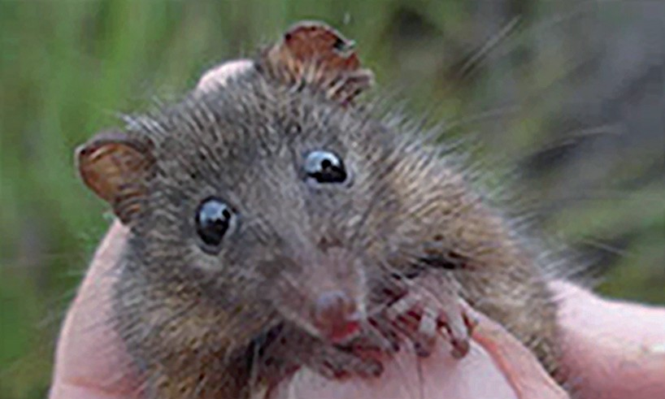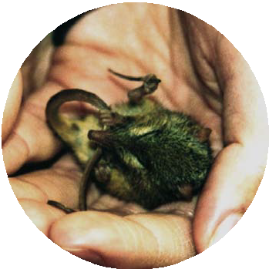is a tiny and elusive animal that can fit snugly into the palm of your hand. It ventures out to feed
between dusk and dawn, running from plant to
plant in search of large, nectar-rich
flowers, such as those from the Banksia genus.
When nectar is abundant, honey possums are able to
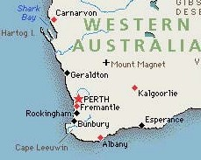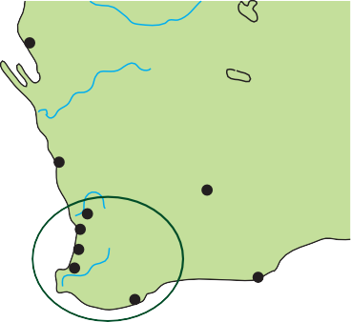produce up to four litters in a year.
Carnarvon
Rockingham
WESTERN AUSTRALIA
Mount Magnet
Geraldton
Kalgoorlie
PERTH
Fremantle
Bunbury
Esperance
Cape Leeuwin
Albany

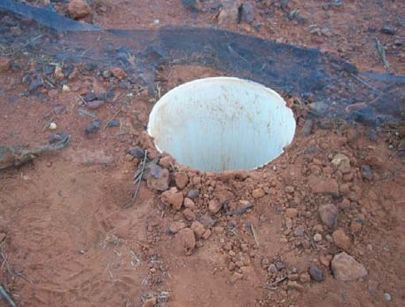
What is a pitfall trap?
Pitfall traps are actually 40 cm lengths of 15 cm diameter PVC pipe dug into the ground so that the rim is level with the soil surface. Traps, arranged in a grid, are spaced five metres apart. Usually, one hundred traps are used per study site grid, but this can vary, depending on the size of the research area. When not in use, traps are fitted with lids to prevent anything from falling in.
At least three different study site grids are set up in a research area. Each trapping period lasts about four days, with every trap checked each morning at dawn. That sounds like a lot of work!

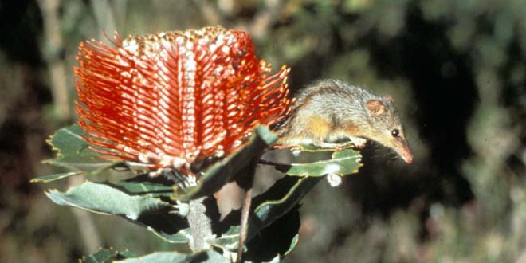

Counting possums!
Research scientists often estimate the relative size of a population of a given species from trapping success rates (%). This is a useful indication in ecological studies, however it may not necessarily directly correlate
with total population size as possums can be more or less likely to fall into traps, depending upon the weather.
Trap success rate (TSR) is the number of animals captured divided by the number of trap nights. One trap night is equal to one trap set for one night.
Example:

300 pitfall traps are set each night for a period of four nights. A total of 54 honey possums is captured.
Number of trap nights = 4 X 300 = 1200 TSR = (54/1200) X 100
TSR = 4.5%

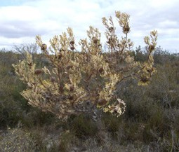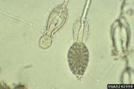So … you may be wondering what the point of all this digging, walking, trapping and getting up before the rooster crows is about? Well, Professor Bradshaw has 20 years worth of data regarding different aspects of honey possum ecology. This has enabled him and his research team to monitor the stability of honey possum populations over time and the possible environmental and human impacts on numbers, health and reproduction. But what could possibly go wrong?

Some facts about dieback
- Dieback is caused by infection of plant roots by the soil-borne
pseudofungus, Phytopthora cinnamomi.
- More than 2000 species of plants in WA’s southwest are at risk of infection.
- Species belonging to the Banksia genus are particularly susceptible.
- The growth, reproduction and spread of P. cinnamomi is favoured by presence of water in the soil and soil surface.

- Zoospores produced by P. cinnamomi are released and ‘swim’ through soil water to the roots of neighbouring plants.
- P. cinnamomi invades and feeds on living roots and stems, reducing a plant’s ability to absorb necessary water and nutrients.
- Symptoms include yellowing of foliage due to root-rot, followed by ‘dieback’ of
the whole plant from tip to trunk.
- Human activities are the main cause of the spread of dieback.
- Rainfall, topography and soil-type can increase the risk of spread.
- P. cinnamomi spreads more slowly up slopes
(1 – 3 metres per year) as it is restricted to growth in plant roots.

An ecological problem
A researcher begins trapping honey possums in 1994 in a 30 000 hectare National Park in southwest Western Australia. Three study site grids (A, B and
C) are established in an homogenous Banksia woodland, unburnt for at least 40 years. Each grid comprises 200 pitfall traps. Trapping sessions are carried out four times a year in summer, autumn, winter and spring. Each trapping session runs over a four night period.
During the last trapping session in 1998, the researcher notices signs of dieback infection within the park. Further investigation reveals that the outbreak has had a significant impact on Banksia species.
The researcher continues trapping for the next seven years. Data regarding rainfall, plant flowering times and topography are also collected to help analyse the population data. The researcher also learns that a mountain bike race was held in spring of 1997
on an ecotourism track that runs through the park.
Grid C

mountain bike track
Grid A
Grid B
The researcher uses the following data to answer the research question:
‘Has the outbreak of dieback had an adverse effect on the honey possum population within the national park?’

dieback infected area
scale: 1 cm = 1 km
topographical map of study site showing grid locations.

Table 1. Flowering times of plants most often visited by honey possums

Plant species | Species in flower
 | Summer |  |  | Autumn |  |  | Winter |  |  | Spring
 | D | J | F | M | A | M | J | J | A | S | O | N
Adenanthos meisneri | • | • | • | • | • |  |  | • | • | • | • | •
Adenanthos obovatus | • |  |  |  |  | • | • | • | • | • | • | •
Banksia grandis | • | • |  |  |  |  |  |  | • |  | • | •
Banksia ilicifolia | • | • | • | • | • | • | • | • | • | • | • | •
Banksia littoralis |  |  | • |  | • | • | • | • | •
Banksia meisneri |  |  |  |  | • | • | • | • | • | •
Banksia occidentalis | • | • | • | • | • | • |  |  | • |  | • | •
Beaufortia sparsa |  | • | • | • | • |  |  |  | • |  | • | •
Corymbia calophylla | • | • | • | • | • | •
Hakea lissocarpha |  |  |  |  |  | • | • | • | • | •
Data from Florabase, florabase.calm.wa.gov.au (images of flowers are available)

Table 2. Monthly rainfall (mm) and mean monthly rainfall (mm) for research area 1994 – 2004

year | Jan | Feb | Mar | Apr | May | Jun | Jul | Aug | Sep | Oct | Nov | Dec | Mean
1994 | 1.2 | 2.2 | 13.5 | 2.6 | 42 | 18.8 | 25.2 | 31.4 | 26.2 | 36.2 | 12.8 | 2 | 17.8
1995 | 38.2 | 44 | 31.6 | 10 | 29.8 | 33.4 | 65.2 | 18.4 | 63.6 | 52.8 | 11.6 | 91 | 43.9
1996 | 0.9 | 9.2 | 13.4 | 22.4 | 23 | 40.6 | 64.6 | 30.2 | 68.4 | 22.2 | 25 | 9.8 | 27.4
1997 | 2.4 | 108 | 77.4 | 25.8 | 57.2 | 31.6 | 44.2 | 67.8 | 105 | 19.8 | 34.8 | 35.2 | 50.8
1998 | 0.8 | 2.2 | 32 | 88.8 | 23 | 56 | 51.2 | 75.4 | 28.2 | 36 | 26.4 | 14.6 | 36.2
1999 | 69.8 | 8.6 | 49.6 | 57 | 35 | 42.3 | 54 | 32.6 | 44.1 | 35.2 | 33.4 | 40 | 41.8
2000 | 210.2 | 42.4 | 58 | 22.4 | 9 | 26.6 | 30.2 | 35.6 | 10.8 | 12.2 | 10.5 | 8.4 | 39.7
2001 |  | 11 | 14.8 | 8 | 34.5 | 29 | 90.1 |  | 38.2 | 38.6 |  | 104 | 40.9
2002 | 16.8 | 3.6 |  | 22.2 | 5 | 18.9 | 31.4 | 24.6 | 22 | 25.4 | 49.6 | 43.4 | 23.9
2003 | 0 | 30.2 | 77.6 | 55.7 |  |  |  | 74.6 | 65.2 |  |  | 8.4 | 44.5
2004 | 41 | 42 | 13.2 | 14 |  |  | 28.6 | 55.6 | 21.8 | 10.6 | 29.4 | 0 | 26.6
Data from Bureau of Meteorology, www.bom.gov.au/weather/wa (blank cells are from months when data is not available)

Table 3. (a-f) Honey possum captures for grids A, B and C, 1994 – 2004

(a) 1994

Season | A | B | C | Total  all grids
Summer | 20 | 28 | 30 | 78
Autumn | 21 | 15 | 30 | 66
Winter | 25 | 36 | 87 | 148
Spring | 16 | 19 | 48 | 83
Annual total | 82 | 98 | 195 | 375

(c) 1998

Season | A | B | C | Total all grids
Summer | 17 | 23 | 26 | 66
Autumn | 15 | 14 | 23 | 52
Winter | 22 | 17 | 33 | 72
Spring | 12 | 22 | 26 | 60
Annual total | 66 | 76 | 108 | 250

(e) 2002
(b) 1996

Season | A | B | C | Total  all grids
Summer | 19 | 23 | 25 | 67
Autumn | 17 | 22 | 26 | 65
Winter | 29 | 20 | 39 | 88
Spring | 16 | 24 | 28 | 68
Annual total | 81 | 89 | 118 | 288

(d) 2000

Season | A | B | C | Total  all grids
Summer | 13 | 15 | 25 | 53
Autumn | 9 | 11 | 29 | 49
Winter | 16 | 14 | 33 | 63
Spring | 10 | 10 | 33 | 53
Annual total | 48 | 50 | 120 | 218

(f) 2004

Season | A | B | C | Total  all grids
Summer | 8 | 12 | 31 | 51
Autumn | 6 | 7 | 22 | 35
Winter | 5 | 9 | 29 | 43
Spring | 7 | 12 | 33 | 52
Annual total | 26 | 40 | 115 | 181

Season | A | B | C | Total  all grids
Summer | 3 | 8 | 25 | 36
Autumn | 5 | 12 | 27 | 44
Winter | 5 | 10 | 29 | 44
Spring | 5 | 6 | 29 | 40
Annual total | 18 | 36 | 110 | 164

