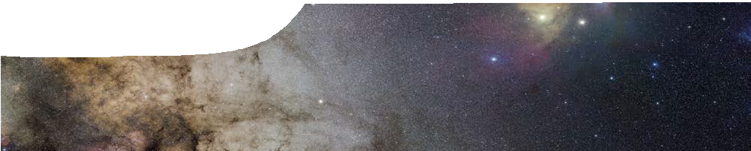
background sheet
Explanation of the cosmic distance ladder

Measuring distance across the Universe is fundamental to astronomy. Without knowledge of distance it’s virtually impossible to study the physical properties of celestial objects. Understanding distance allows astronomers to explain where the Universe came from, and where it might be heading.

Scaling the ladder
Astronomers use various methods to measure relative distances in the Universe, depending upon the object being observed. Collectively these techniques are known as the cosmic distance ladder.
It’s called a ladder for good reason — each rung or measurement technique relies upon the previous step for calibration. The greater the distance measured, the more steps astronomers have used to get there.

Step one: stellar parallax
Stellar parallax is the only ‘direct’ method astronomers have to measure distance outside the Solar System. It relies on principles of trigonometry.
As the Earth orbits the Sun, nearby stars appear to shift slightly in position relative to more distant stars. Distance to a nearby star can be calculated by measuring the amount of this shift (called parallax angle) between two points of the Earth’s orbit that are a known distance apart.
The parallax angle is small — even the Sun’s nearest neighbour, Proxima Centauri, has a parallax angle of only 0.0002° (770 milliarcseconds) — but it allows astronomers to measure distance to stars up to 10 000 light years away. For more remote stars the parallax angle is too small to accurately measure distance.
Earth’s atmosphere makes these small angles very difficult to measure with ground-based telescopes. For this reason the Hipparcos satellite was launched in 1989. Above Earths’ atmosphere, Hipparcos can measure angles as small as 0.3 x 10-6 degree (1 milliarcsecond). Distances to many more stars can be measured, with about 100 000 stars now in the Hipparcos catalogue.

Indirect measurements
The Milky Way galaxy is about 100 000 light years across, so only a small proportion of stars can be measured using parallax. For most astronomical objects astronomers rely on indirect methods of measurement that are based on observable properties of stars. Using knowledge about processes of nuclear fusion in stars, the nature of light and observations of light spectra, astronomers categorise stars with similar properties. This may provide clues as to a star’s absolute brightness and help establish ‘standard candles’.

Step two: standard candle
Stars in the night sky vary in brightness. This is not just because they vary in the amount of light that they emit, but also because they vary in distance from us. ‘Luminosity’ is the term used to describe the amount of light a star emits. The term used to describe its brightness is ‘magnitude’.
For historic reasons, dating back to the ancient Greeks, the brightest stars have the smallest magnitude. That is, magnitude and brightness are inversely related.
distant stars
Earth’s position in July
nearby star
Earth’s orbit
parallax angle
Earth’s position in January
Apparent magnitude refers to the brightness of a star as seen from Earth, whilst absolute magnitude refers to the brightness of a star viewed from a standard distance of 10 parsecs (or 32.6 light years).

Figure 1: stellar parallax

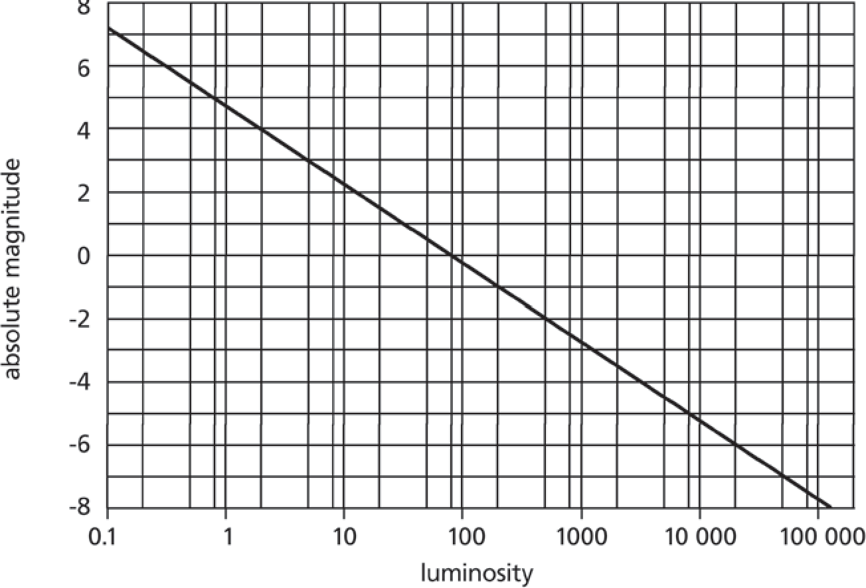
Figure 2: Relationship between absolute magnitude and luminosity – the Sun has a luminosity of one.

The brightest objects in the night sky have negative magnitude, for example Venus has an apparent magnitude of -4.6, which is bright enough to see in daylight. The brightest star, Sirius, has an apparent magnitude of -1.5.
It’s easy to measure an object’s apparent magnitude, but determining its absolute magnitude is a lot harder. There’s not much chance of getting 10 parsecs away from a star and holding up a light meter! Nevertheless, there are some objects for which astronomers do know absolute brightness, and these are called ‘standard candles’.
Type 1a supernovae and Cepheid variable stars both have known absolute magnitude, and are used in astronomy to measure distance. This technique is based on a comparison of apparent and absolute magnitude. If absolute magnitude is known then the apparent magnitude can be used to work out distance from Earth.

Cepheid variables
Cepheid variables are pulsating variable stars that brighten
The relationship shows that the longer the period of a Cepheid, the brighter the star, so astronomers can determine a relationship between absolute magnitude and period. As can be seen in figure 3, there are now known to be two types of Cepheid (population I and II) with slightly different period- magnitude relationships.
A Danish astronomer, Ejnar Herzsprung, took Leavitt’s work a step further. Hertzsprung used properties of the Cepheids’ light curves and statistical parallax to arrive at an estimated distance to the Magellanic clouds. This measurement was further refined by American astronomer Harlow Shapley who observed Cepheids in 86 globular clusters. He then used the apparent magnitude of non-variable stars located in these globular clusters to estimate distances to other stars with the same properties — building each time upon previous knowledge.

and dim at regular intervals. In the early 1900s, Henrietta Leavitt established that there is a simple relationship between the period of a star’s pulsation (the time taken to complete one cycle, bright to dim then bright again) and its average apparent magnitude. The relationship showed that the longer the period of a Cepheid, the brighter the star.
Leavitt compared a group of Cepheids from the Magellanic Clouds. By assuming that all the Cepheids were roughly the same distance from us, she was able to infer that differences in apparent magnitude were related to differences in absolute magnitude.
-8

-7

-6

-5
absolute magnitude

-4

-3

-2

-1

0
1 2 4 6 8 10 20 40 60 80 100
period (days)

Figure 3: This graph shows the relationship between absolute magnitude and period for Cepheid variables. It is based on data from the David Dunlop Observatory, Fernie JD, Beattie B, Evans NR and Seager S (1995), International Bulletin of Variable Stars 4148.

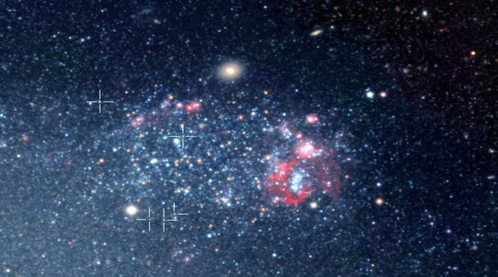
To measure distance to an unknown Cepheid, observations are first made to determine its period. From this, an absolute magnitude can be determined, using the graph in figure 3. Its distance from Earth can then be calculated by comparing absolute and apparent magnitude, even when it lies more than 10 000 light years from Earth.

Figure 4: Cepheid type stars in the spiral galaxy NGC 300. European Southern Observatory, CC-BY-3.0, commons.wikimedia.org/wiki/ File:ESO-Cepheid_stars_NGC_300.jpg

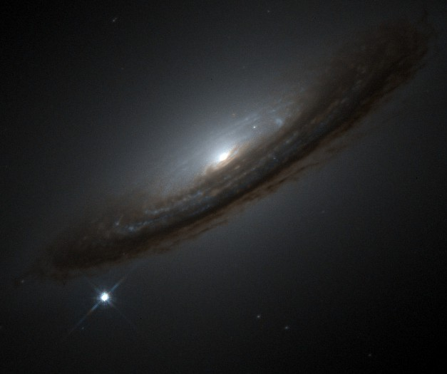
Polaris, the North Star, is the nearest Cepheid to Earth. It lies about 430 light years away. Using ground-based telescopes this technique can measure distances of up to 13 000 000 light years. The Hubble Space Telescope has made the most distant Cepheid measurement so far, of around 100 000 000 light years.

Step three: type 1a supernovae
At greater distances than these, astronomers are unable to observe individual stars, so Cepheid variables are no longer useful. Instead astronomers look to some of the brightest events in the Universe
— supernovae.
Supernovae are extremely luminous stellar explosions. There are various types of supernovae, but only type 1A supernovae are used to establish distance. Type 1a supernovae result when the white dwarf companion in a binary star system accretes matter to the point where it becomes unstable and explodes.
certain point in the accretion process; once this limit is reached the star will explode. The limit is governed by principles of nuclear physics.
Importantly, this event is predictable and does not change. Every type 1a supernovae occurs after the exact same series of events. Type 1a supernovae emit the same amount of light, and produce
the same light curve after explosion. This ‘consistent luminosity’ is very useful for astronomy as it means that type 1a supernovae have known absolute magnitude at various stages of the event.
The shape of the light curve is the same for all type 1a supernovae. The amount of light produced after the explosion (the peak) is the same, and the decrease in brightness follows a constant curve.
Astronomers determine whether they have located a type 1a supernova by examining its light curve. From this they measure the supernova’s maximum apparent magnitude. Because the maximum absolute magnitude achieved by all type 1a supernova is known, distance to the supernova can be determined.
Astronomers use type 1a supernovae to determine distance to galaxies where they occur. Distances of up to an incredible 1 000 000 000 light years have been measured.

Astronomers know that this explosion occurs at a

-20

-19
relative brightness

-18
Figure 6: supernova 1994D, a type 1A supernova on the outskirts of galaxy NGC 426. High-Z Supernova Search Team/HST/NASA

-17
-20 0 20
days after peak brightness

40 60

supernova explosion
Figure 5: light curve for a typical type 1a supernova

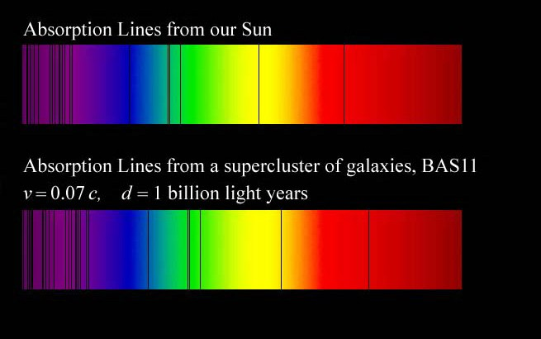
Figure 8: Absorption lines in light from distant galaxies are redshifted when compared with light from the Sun. Image by Harold T Stokes, Brigham Young University.

Step four: redshift
To measure still further out into the Universe, astronomers use the expanding Universe theory, which was developed by Edwin Hubble in 1929.
The light spectra of celestial objects have characteristic lines. Hubble observed a shift in these lines toward the red end of the spectrum. The amount of redshift varies between different galaxies.
Hubble inferred redshift was caused by relative motion of celestial objects (the Doppler effect). Objects travelling toward an observer display a shortening in the wavelength of emitted light, resulting in a shift toward the blue end of the spectrum (blueshift). Objects moving away from an observer display a lengthening of wavelength or a shift toward the red end of the spectrum (redshift).
Based on his observation of ‘redshift’, Hubble established that almost all galaxies are moving away from us, and each other. Hubble also observed that the further away the object, the greater the amount of redshift. This is expressed in Hubble’s law:
The velocity with which galaxies recede from us (recessional velocity) is proportional to their distance from us.
Redshift is expressed by a factor Z that measures the relative difference between emitted and observed wavelengths from an object:
Z = λobserved − λemitted
λemitted
If an object is moving relative to us at a velocity substantially less than the speed of light then the relationship between Z and the object’s recessional velocity v is given by:
v

Z ≈ c , where c is the speed of light (3 x 108 m s-1).
The Doppler effect reveals the recessional velocity of a celestial object (how fast it is moving towards or away from us), but it does not reveal anything about cosmic distance. For example, the Andromeda galaxy,
2.2 million light years from Earth, shows a small blueshift of 0.001 because it is moving towards our galaxy at 0.001 x 3 x 108 = 3 x 105 m s-1 or 300 km s-1.

Cosmological redshift
Scientists now believe that redshift observed for very distant objects is only partly due to the speed of recession of the object from the Earth. Most of it is caused by expansion of the Universe and consequent ‘stretching’ of space. As space itself is stretched, light travelling across it is also stretched, causing wavelengths to increase and the light to be redshifted. Astronomers use the observed shift in wavelength of light from distant celestial objects to calculate how far away objects are. The further away an object is, the longer it has taken for light to reach us, and the more that light has been stretched out due to expansion of the Universe.
Redshifts of less than 0.01 are considered to be primarily due to the Doppler effect. Quasars were the first celestial bodies observed to have anomalously high redshifts (z > 0.1). GRB 090423, observed in April 2009, had a z= 8.2. This makes it not only the most distant object detected (1.3 x 1010 light years away from us), but also the oldest as the Universe was just 630 million years old when light was emitted from it.

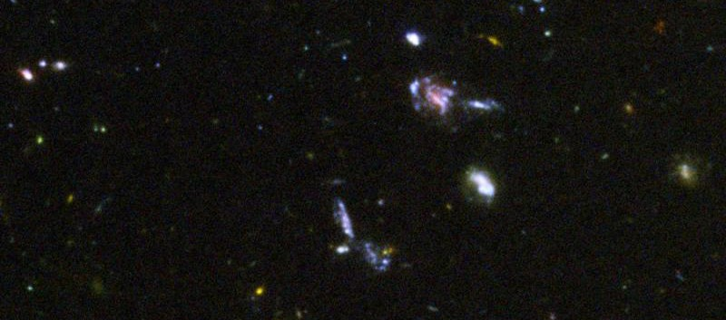
Figure 9: Sample of distant galaxies in the Hubble Ultra Deep Field, NASA/ESA/S. Beckwith (STScI) and the HUDF Team, www.hubblesite.org/gallery/album/the_universe/hubble_ultra_deep_field/pr2004007i/

