fact sheet
Evidence for the Big Bang
What is the Big Bang theory?
The Big Bang theory is an explanation of the early development of the Universe. According to this theory the Universe expanded from an extremely small, extremely hot, and extremely dense state. Since then it has
expanded and become less dense and cooler. The Big Bang is the best model used by astronomers to explain the creation of matter, space and time 13.7 billion years ago.
What evidence is there to support the Big Bang theory?
Two major scientific discoveries provide strong support for the Big Bang theory:
- Hubble’s discovery in the 1920s of a relationship between a galaxy’s distance from Earth and its speed; and
- the discovery in the 1960s of cosmic microwave background radiation.

When scientists talk about the expanding Universe, they mean that it has been increasing in size ever since the Big Bang. But what exactly is getting bigger?
Galaxies, stars, planets and the things on them like buildings, cars and people aren’t getting bigger. Their size is controlled by the strength of the
fundamental forces that hold atoms and sub-atomic particles together, and as far as we know that hasn’t changed. Instead it’s the space between galaxies that’s increasing – they’re getting further apart as space itself expands.
How do we know the Universe is expanding?
Early in the 20th century the Universe was thought to be static: always the same size, neither expanding nor contracting. But in 1924 astronomer Edwin Hubble used a technique pioneered by Henrietta Leavitt to measure
distances to remote objects in the sky. Hubble used spectroscopic red-shift data to measure the speeds these objects were travelling then graphed their distance from Earth against their speed. He discovered that the speed at which astronomical objects move apart is proportional to their distance from each other.
In other words, the farther away objects are from Earth, the faster they are moving away from us. This

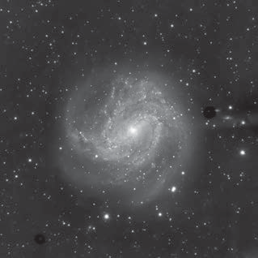
M 83 (NGC 5236, Southern Pinwheel) is a barred spiral galaxy about 15 million light years from Earth. It’s moving away from us at about 513 km s-1.
credit: SPIRIT image by Paul Luckas

became known as Hubble’s law. One explanation might be that the Earth is at the centre of the Universe, and everything else is moving away from us, but that seems pretty unlikely!
1000

500
recessional velocity, km s-1

Right: Simplified graph of Hubble’s data. Hubble plotted the recessional velocity of celestial objects (the speed that they’re moving away from Earth) against their distance from Earth
(1 parsec = 3.26 light years). He found that objects farther away from Earth tended to be travelling faster. Some nearby objects are travelling towards Earth – these have negative recessional velocities.

0

0 106 2 x 106
distance from Earth, parsecs

The relationship Hubble discovered was later used as evidence that the Universe is expanding. It’s a bit like dots on a surface of an expanding balloon: it doesn’t matter what dot you choose, every other dot is moving away from it, and the dots farthest away are moving the fastest.
Of course the surface of a balloon is an expanding two-dimensional shape, whilst the expanding Universe is an expanding three (or more) dimensional shape. Balloons also expand into existing space, while the Universe includes all of space itself, so can’t be expanding into anything.
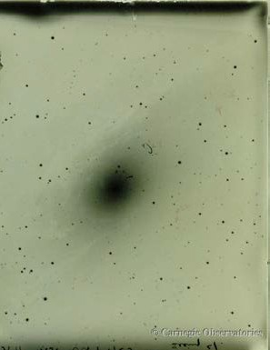
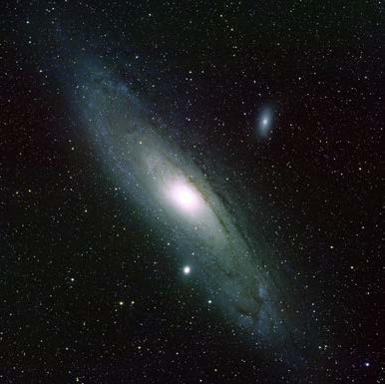
Hubble also realised that distant objects he’d been observing lay far beyond the Milky Way. This was the first time humans discovered that structures existed outside the Milky Way. We now know that the objects that Hubble observed are galaxies, similar to our own Milky Way, and that there are billions of them in the observable Universe.
Hubble’s discovery provided additional evidence for what was to become known as Big

Bang theory, first proposed by Georges Lemaître in 1927. It was a major step forward for astronomy.
Compare Hubble’s image of the Andromeda Galaxy taken in 1923 (left) with a recent image that
shows much more detail for the same galaxy (right). Hubble’s photographic plate is reversed (stars appear black against a bright sky).
credit: Hubble image of M 31 — Carnegie Observatories; M 31 galaxy — Bill Schoening, Vanessa Harvey/REU program/NOAO/AURA/NSF

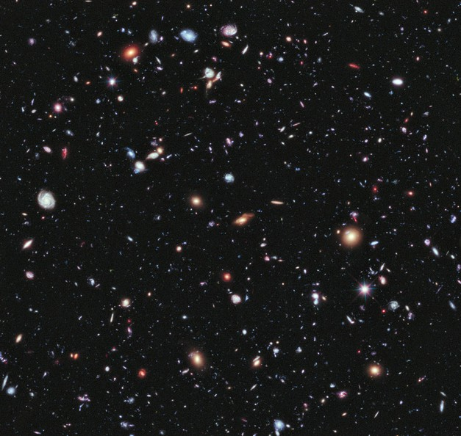
The age of the Universe
Hubble’s law allowed astronomers to calculate how long ago galaxies started moving apart, which provides an estimate of when the Big Bang occurred and how old the Universe is.
Hubble initially underestimated distances to these remote galaxies. He calculated that the Universe was about 2 billion years old. Geologists immediately condemned Hubble’s finding because they had measurements showing the Earth to be somewhere between 3 and 5 billion years old. The Universe couldn’t possibly be younger than the stars and planets in it!
The issue was resolved in the 1950s when new data showed that the Universe was between 10 and 20 billion years old. Today, our best estimate is that it’s 13.7 billion years old.

The Hubble eXtreme Deep Field (XDF) shows galaxies so far away that their light has taken 13.2 billion years to reach us. The image ‘looks back in time’ to when the Universe was 500 million years old.
credit: NASA, ESA, G. Illingworth, D. Magee, and P. Oesch (University of California, Santa Cruz), R. Bouwens (Leiden University), and the HUDF09 Team

Cosmic microwave background radiation (CMBR)
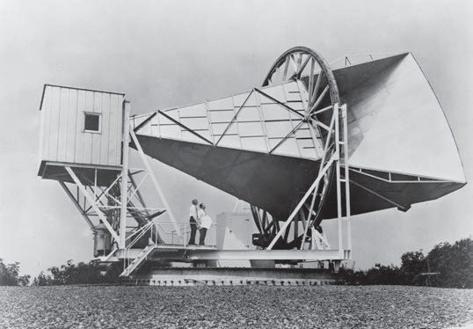
According to the Big Bang theory, the Universe was initially very hot and dense. As it expanded, it cooled (your refrigerator works on the same idea, expanding a liquid into a gas to cool the inside). Cosmologists were able to calculate the theoretical temperature of today’s Universe and began to search for evidence of it.
It was eventually discovered by accident in 1964 by Arno Penzias and Robert Wilson as ‘noise’ in an antenna they had built to research how radio signals could be reflected off orbiting satellites. They first thought it was radio interference from nearby New York City, but eventually recognised it as radiation from beyond the Milky Way.

The cosmic microwave background radiation (CMBR) that Penzias and Wilson observed is
Penzias and Wilson detected cosmic microwave background radiation with
this microwave horn antenna in New Jersey, USA, in 1964. credit: NASA

leftover heat radiation from the Big Bang. Today, CMBR is very cold due to expansion and cooling of the Universe. It’s only 2.725 Kelvin (-270.4 °C), which is only 2.725 °C above absolute zero.
Cosmic microwave background radiation fills the entire Universe and can be detected day and night in every part of the sky.

Studying CMBR
The Cosmic Background Explorer satellite (COBE) was launched in 1992 to look for small variations in CMBR temperature. The Wilkinson Microwave Anisotropy Probe spacecraft (WMAP) was launched in 2001 to measure variations more accurately.
Cosmologists believe that tiny temperature variations in the CMBR are caused by differences in the density of matter in the early Universe.
Areas of different density led to the formation of galaxies and stars.

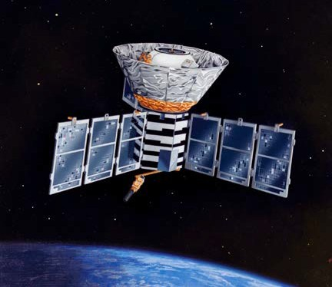
artist’s impression of the COBE satellite in orbit credit: NASA / COBE Science Team

The WMAP survey
After nine years of observation the WMAP survey produced a detailed temperature map of the entire sky. Colours indicate tiny variations in the temperature of background radiation. These correspond to places where galaxies formed.
The WMAP survey shows CMBR is almost the same in all directions. Red spots are slightly warmer and blue spots are slightly cooler, but the difference is only about
±0.0002 of a degree.
The WMAP survey provides strong evidence that supports the Big Bang theory. The pattern of radiation is similar to what astrophysicists predict it would be if the Universe started from a very dense state and expanded to its present size.
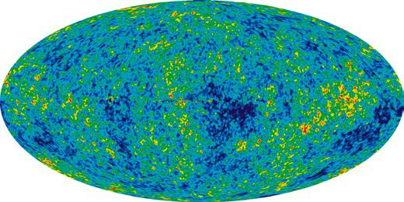

nine-year microwave sky image from WMAP credit: NASA/WMAP Science Team

fact sheet
Evidence for the Big Bang

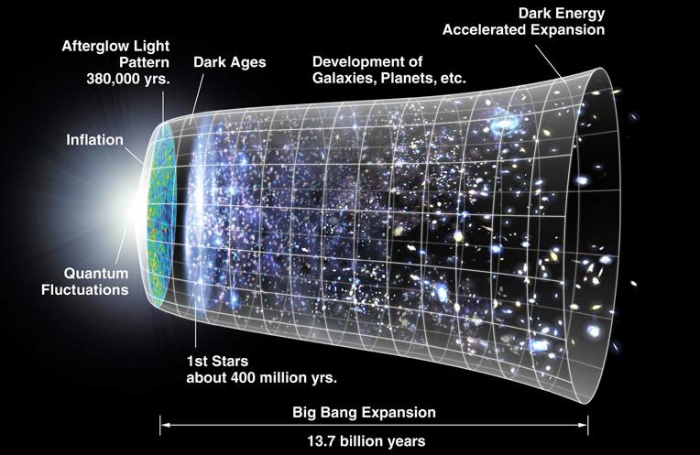Evolution of the Universe

This image represents growth and evolution of the Universe since the Big Bang. Time is shown on the horizontal axis. The size of the Universe is represented by the vertical axis.
credit: NASA / WMAP Science Team

The Big Bang (extreme left of the image) was followed by a period of very rapid expansion and cooling known as ‘inflation’.

In March 2014 scientists from the Harvard-Smithsonian Centre for Astrophysics studying characteristics of cosmic microwave background radiation detected evidence to support inflation theory. Their observations, made at Amundsen-Scott South Pole Station, are believed to reflect the imprint of gravitational waves on the Universe in the first few moments after the Big Bang.

About 380 000 years after the Big Bang the Universe became transparent to light. For the next several billion years, gravity slowed the expansion of the Universe.

About 8 billion years after the Big Bang expansion of the Universe began to accelerate. Cosmologists believe that an effect called ‘dark energy’ is causing the Universe to expand by making matter repel other matter. At present, we still don’t know what dark energy is.

