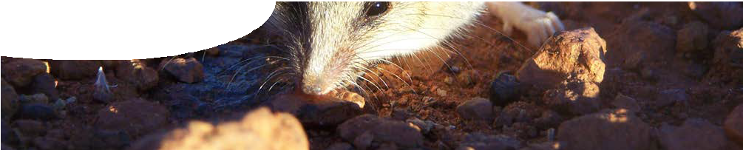
fact sheet
Dynamic dunnarts

In the School of Animal Biology at The University of Western Australia, Sean Tomlinson is studying dunnarts. Sean is examining the energy use and environmental requirements of these small nocturnal marsupials.
Understanding energy requirements of animals, such as dunnarts, is an important aspect of land management and conservation biology. For example, if land is set aside as a national park or wildlife sanctuary it is vital to establish how much land is necessary to support a particular population of animals. It is also important to ensure it is the right type of land, that provides appropriate conditions (i e food and habitat) for a given species.

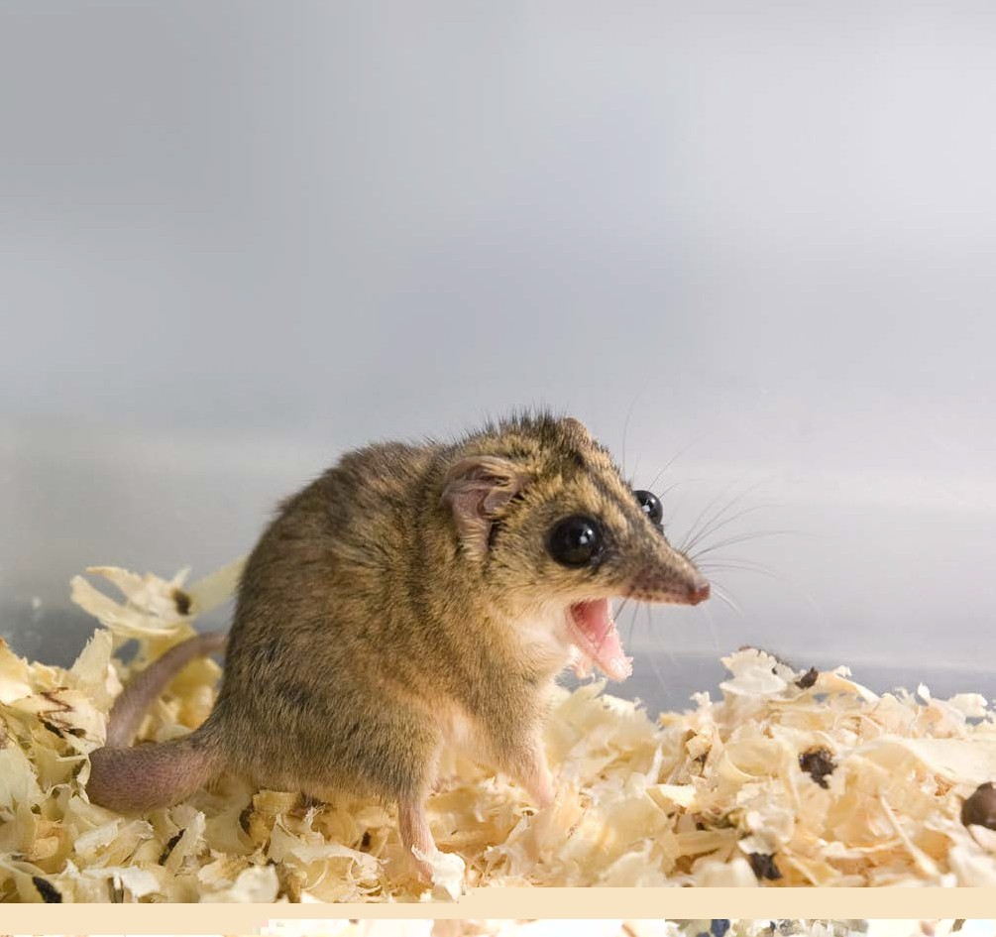Use of radioisotopes

Sean uses the radioactive isotope rubidium-86 (86Rb) in his research with dunnarts. 86Rb is a high- energy beta and gamma emitter with a half-life of 18.66 days. The high-energy properties of the radioisotope mean that only small amounts are required.
86Rb measurements are strongly correlated with carbon dioxide (CO2) production during metabolism. This essentially means that the amount of 86Rb lost from the blood is equal to
the amount of CO2 breathed out. The measure of respiration (CO2 breathed out) is traditionally used to represent the field metabolic rate (FMR). In Sean’s research, this is equivalent to the amount of energy required by the
dunnart for it to live.
There are three main advantages to using 86Rb in these types of studies:
- 86Rb is inexpensive compared to other radiolabels;
- measurements can be taken in the field using a portable gamma counter, eliminating the need to take blood; and
- measurements can be taken over a period of 10 days using 86Rb while other radioisotopes are excreted in 24 to 48 hours.
These physical properties mean that better quality field-data can be collected. Taking measurements
in the field with a gamma counter reduces risks posed to animals during capture.
Animals are not handled much which minimises stress. This,
together with the longer half-life of 86Rb, means that more measurements can
be taken over a longer
time period.

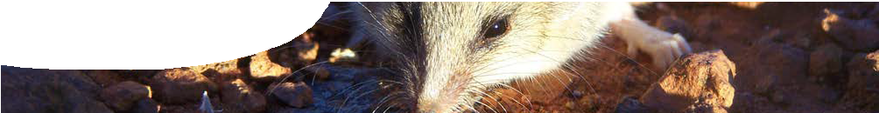
fact sheet
Dynamic dunnarts

How is the radioisotope used?
Dunnarts are captured with a pit-trap. Vital statistics of captured animals, such as weight, sex and identifying features, are recorded before they are injected with a small volume of a solution containing 86Rb. The dunnarts are held for a few hours to allow the 86Rb solution to equilibrate around the body. The amount of 86Rb in the animal is measured by taking average whole-body counts using a gamma counter over a three minute period. Whole-body counting refers to the measurement of radioactivity within the entire body of an animal.
Over the next 10 days the dunnarts are re-captured and gamma ray measurements again taken. 86Rb has a fairly short half-life (days, not years), so decay constants have to be applied to the measurements as a correction factor.
The use of 86Rb in evaluating energy use of animals in the wild is a relatively new application. Because of this, a lot of Sean’s work is about quantifying and validating the technique.

Why is this important?
Research into energy requirements of a species provides essential information linking their long-term survival to land management. For example, Sean is studying two different species of dunnart, Sminthopsis macroura (stripe-faced dunnart) and Sminthopsis crassicaudata (fat-tailed dunnart). The fat-tailed dunnart is quite sociable, while the stripe-faced dunnart is not. Interestingly, the sociable fat-tailed dunnart appears to adjust badly to environmental change, such as variation in temperature and food availability. In contrast, the less sociable stripe-faced dunnart seems to tolerate
altered environmental conditions well. It may be that stress or environmental change is a more important factor in the long- term health of a species than previously understood.
It is important to look at energy requirements of animals using data from field studies, as opposed to laboratory-based research. Laboratory conditions are more likely to cause stress to animals and may result in altered behaviour. This means measurements taken in a laboratory may not give a true picture of how animals behave in the wild and hence their true metabolic rate.

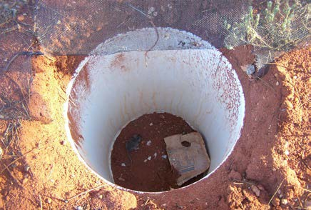
Pit trap used to capture dunnarts
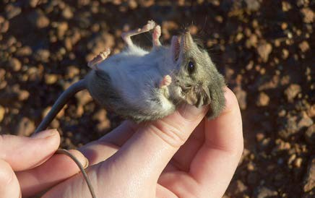
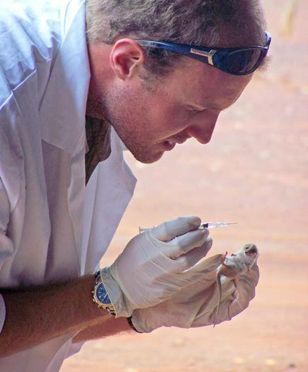

photos on this page: Miriam Sullivan

Reference
1) Bradshaw, S. D. and Bradshaw, F. J. (2007). Isotopic measurement of field metabolic rate (FMR) in the marsupial honey possum (Tarsipes rostratus). Journal of Mammalogy, 88 (2), 401-407.

