Site information:

Student name: |  | Date:
Site sketch:

TEST | RESULT | TEST | RESULT
pH |  | turbidity
nitrate |  | temperature
phosphate |  | salinity
dissolved oxygen |  | E. coli
IMPACTS IN AREA
tourist/recreation | yes / no | weeds | yes / no
farming | yes / no | boats | yes / no
fire | yes / no
cattle | yes / no
rubbish | yes / no
What does the edge of the waterway look like?
Does it look like either of these?
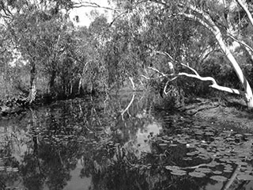  yes / no |  | 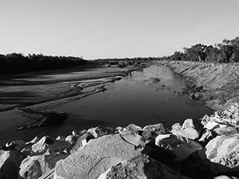  yes / no

Aquatic macroinvertebrates
 | NAME | NUMBER SEEN | YOUR DRAWING

