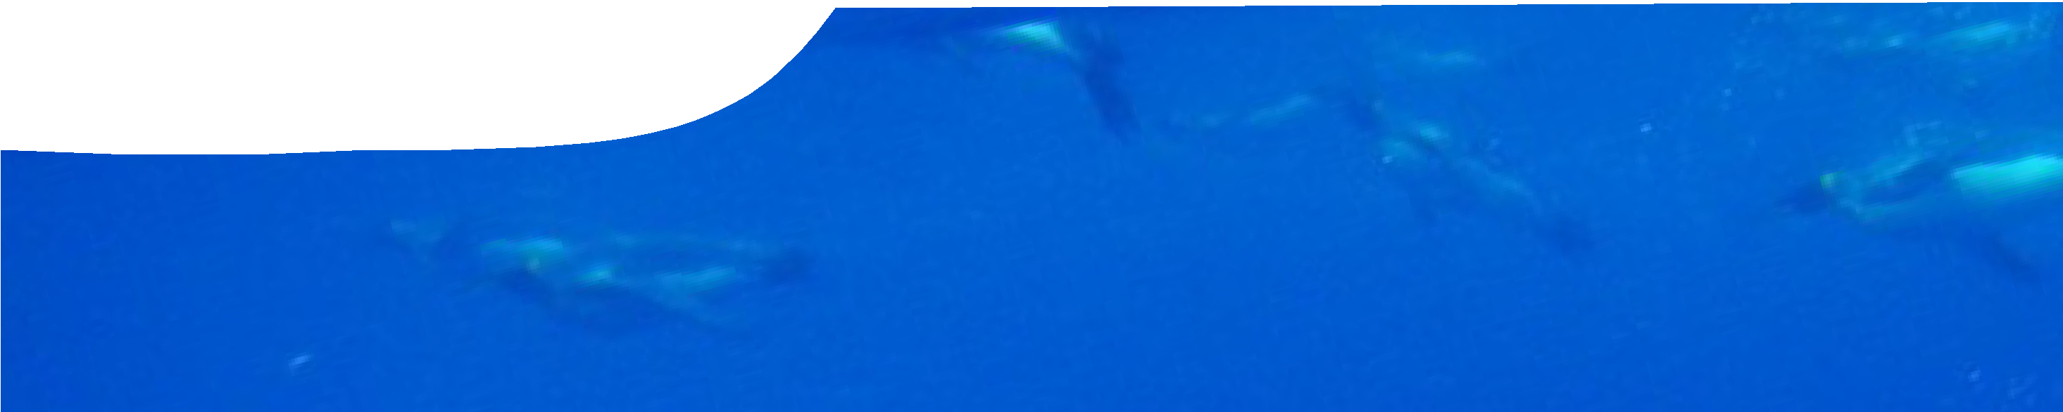
background sheet
Challenges of diving to depth
Photo by Jess © Australian Antarctic Division

To harvest rich food resources of oceans, air- breathing animals not only need to swim, they need to dive. Unlike fish, which have gills, air-breathing animals can’t extract oxygen from water. Instead these animals must regularly come to the surface to breathe.

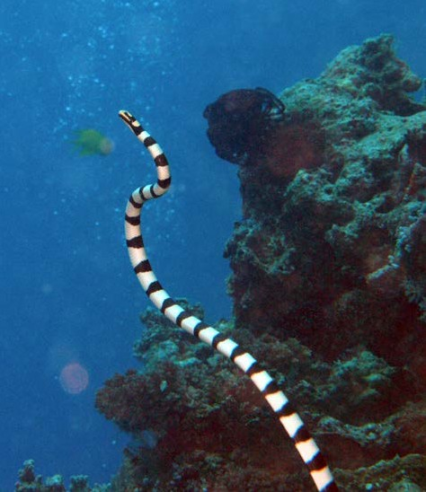
banded sea snake photo by Julie Bedford, NOAA

Diving poses two major challenges for air-breathing animals: hypoxia (a shortage of oxygen) and hyperbaria (high pressure at depth). This background sheet describes adaptations of air-breathing animals that enable them to cope with the hypoxic underwater environment. These adaptations increase oxygen storage and ensure efficient use of oxygen during a dive.

Adaptations for oxygen storage
To compete successfully for underwater prey, an increased body oxygen store is considered essential for air-breathing, diving animals. For many species the larger the oxygen store, the deeper and longer they dive. Generally oxygen storage capacity is greater for air-breathing, diving animals than for terrestrial animals.
In birds and mammals, oxygen is stored in three regions of the body: respiratory system (lungs and air sacs); blood; and skeletal muscles. Research shows that 70-95% of
oxygen is stored in blood and muscle of diving mammals, and 35-60% in diving birds.
Reptiles are ectotherms, with much lower metabolic rates than endotherms. Research into oxygen storage capacities of reptiles is limited, influenced by the fact that some species are capable of cutaneous respiration (respiration through skin), enabling direct uptake of oxygen from water.

Oxygen storage in the respiratory system
Many deep-diving animals have lung capacities similar to terrestrial animals, indicating that their respiratory systems are not the predominant oxygen store. In many species, particularly whales, decreased lung volume correlates with increased dive depth.
Some terrestrial diving animals, including sea otters and diving rodents, have large lungs that provide an important oxygen store. Sea otters store 55% of their oxygen in their lungs. Diving to depth with a large respiratory oxygen store can cause hyperbaric problems such as decompression sickness. However, sea otters are not deep divers, routinely diving to only a few metres.

Oxygen storage in blood
Diving animals store a significant proportion of oxygen in their blood. Oxygen storage in blood depends on an oxygen-binding protein, haemoglobin. Haemoglobin
carries oxygen from the lungs to the rest of the body. The more haemoglobin present in blood, the more oxygen is bound and delivered to the body.
Diving animals have significantly higher haemoglobin counts than terrestrial animals. This increases the oxygen store of these animals. Diving animals also have higher total blood volumes than terrestrial animals, further increasing oxygen stores.

Oxygen storage in muscle
Oxygen storage in muscle is of considerable importance to diving animals. Oxygen is stored in muscles by an oxygen- binding protein, myoglobin. Measurements of myoglobin are generally based on tissue samples from the primary locomotory muscle.
Myoglobin concentrations of diving animals are 10–30 times greater than those of terrestrial animals. Muscle myoglobin concentrations correlate positively with increases in dive duration, and are considered to be one of the most important physiological adaptations in diving animals.
Myoglobin is responsible for the dark red colour of muscle tissue. In many deep-diving mammals it is found in such high concentrations that muscle tissue appears black.

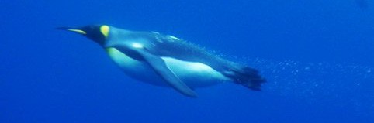

king penguin ‘flying’ underwater photo by Jess © Australian Antarctic Division

Anatomical and behavioural adaptations for diving
Energetic costs of moving through an aquatic medium are higher than those of moving through air due to physical properties of water. Water has a higher density and viscosity than air. Challenges to diving animals underwater include body drag and buoyancy. Anatomical adaptations aid diving animals in overcoming these physical forces.

Overcoming drag
Drag refers to forces that oppose movement through a fluid medium.
Minimising resistance underwater reduces costs of locomotion, which in turn reduces energy and oxygen costs of movement.
A common feature of diving animals is a streamlined body-shape; some of the best divers have a fusiform (torpedo-shaped) body. Emperor penguins display one of the lowest drag coefficients of all diving animals, their shape almost resistance-free. Professional human divers mimic the streamlined body shape of diving animals to minimise locomotory effort and oxygen use.

Overcoming buoyancy
Buoyancy is a force exerted by fluid that opposes an object’s weight.
Diving with large oxygen stores directly impacts on an animal’s buoyancy in water. Greater quantities of stored air increase buoyancy, and propel animals toward the surface. Overcoming buoyancy costs effort, energy and oxygen.
Most animals begin a dive with a period of active stroking in order to overcome positive buoyancy. This is particularly evident in animals that dive with a large respiratory volume, such as sea otters and some penguin species.
Water pressure increases with depth, so air-filled spaces within bodies are compressed, decreasing buoyancy of animals. Humans also experience compression of air-filled spaces, including lungs, during diving.
Deep-diving animals, such as Weddell seals and sperm whales, show progressive collapse of their lungs as water pressure increases, which results in negative buoyancy, allowing animals to sink toward the bottom. Once negative buoyancy is achieved many diving animals glide to depth.

During initial stages of ascent, exertion is required to overcome effects of negative buoyancy. As gases expand during ascent, animals achieve positive buoyancy again, which aids in propelling them toward the surface.

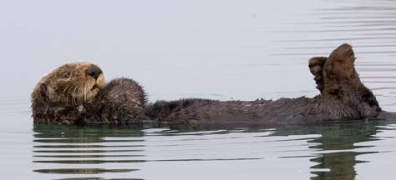
Sea otter at surface photo by Mike Baird

Increasing propulsion
An important structural adaptation seen in diving animals is modification of body structures to increase propulsion. Increasing surface area of the predominant propulsive structure maximises efficiency of locomotion in divers, as a greater volume of water can be moved with each thrust.

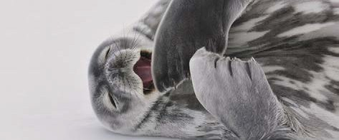
Weddell seal photo by Ruth Wielinga © Australian Antarctic Division
Increased surface area of propulsive surfaces is evident in the large tails of whales, and elongated hind feet of sea otters and diving rodents. All species featured in this activity have increased surface area of propulsive
structures, including the flattened, paddle-shaped tails of sea snakes.

Summary
The major challenge facing air-breathing divers is access to oxygen. All species that exploit rich resources of the oceans rely on adaptations that enhance their available oxygen store, and reduce their use of oxygen during dives. While professional human divers can achieve quite remarkable depths, they do not possess adaptations necessary to store large amounts of oxygen and maximise its efficient use.

