fact sheet
Biodiesel dilemma

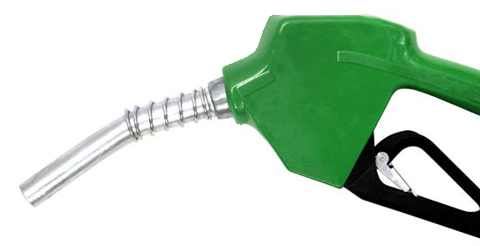The year is 2050 and the world’s oil resources are diminishing at an alarming rate. As resources become scarcer the oil price skyrockets to over US$500 per barrel. At this proce it costs more than $250 to fill your car’s petrol tank.
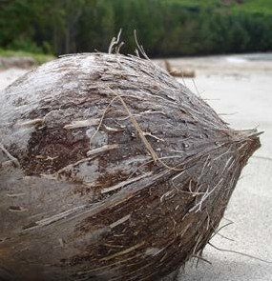
You are Minister for Sustainable Development on a group of Pacific islands that until now has been able to import enough oil to satisfy its energy needs. For over 40 years a small biodiesel production plant has also used palm and coconut oil produced on the islands.
photo: morguefile.com
A large area of the islands has always been reserved in its
natural state and set aside as National Park. It contains several indigenous species of animal and plant that are on a ‘Rare and endangered species list’. It has been World Heritage listed for the last 40 years and supports a tourism industry that forms a significant part of the islands’ economy.
photo: Rarotonga Beach Bungalows, Cook Islands

Unfortunately the economy has a diminishing capacity to import its fuel needs and more and more farm land is being switched from food production to coconut and palm oil production for biodiesel. The islands are no longer self- sufficient in food production and food imports are increasing.
Members of Parliament, pushed by lobbyists and a voting public suffering from rising food costs and thirsty for fuel, are urging you to open National Park land for agriculture. What are you going to do?

Did you know?
It was only in the 1920s that diesel engines were switched
to cheaper petro-diesel. In 1900 the Otto Company of France demonstrated Dr Diesel’s engine at the world exhibition in Paris using peanut oil as a fuel.

What is biodiesel?
Biodiesel is the name of a clean-burning alternative fuel that can be prepared from domestic or agricultural renewable resources. It can be blended with petroleum diesel to create a biodiesel blend (such as B20 or B80, where the number is the percentage of biodiesel in the mix).
Biodiesel can be manufactured from vegetable oil (fresh or waste) or animal fat (tallow).
Imagine the benefits of using waste vegetable oil (WVO) from fryers and animal fat to make fuel for your car. About 360 ML (megalitres) of biodiesel is produced annually in Australia from tallow and used cooking oil.
Biodiesel is biodegradable and non- toxic. It is free of sulfur and aromatic compounds that are toxic products of burning conventional petroleum diesel.
Biodiesel can be used in conventional diesel engines without major modifications.

Biodiesel emissions
Biodiesel emissions produce less pollution than conventional diesel except for nitrogen oxides (NO2, NO, N2O) known as NOX. Results from a study conducted by the US Environmental Protection Agency1 are shown below.
NB: A negative value means less of the material is produced

Quantity of polluting emissions released by burning biodiesel instead of petroleum diesel
total unburned hydrocarbons | - 67%
carbon monoxide | - 48%
particles less than 10 microns | - 47%
NOX | + 10%
SOX | - 100%
benzene compounds | - 80%
CO2 * | - 78%

*The carbon dioxide measurement is a life cycle value. The life cycle of a fuel is a description of all processes, from production through to final use of a fuel to release energy. This includes raw materials and emission products. Remember, it requires energy to farm plants, extract oil and refine fuel before it is burnt. All of these phases produce carbon dioxide. Remember also that plants use atmospheric carbon dioxide to make oil.
A life cycle value is important because of the role of carbon dioxide in global climate change.

On the down side ...
Sustainability of an industry or other enterprise refers to whether the practice is of economic and social benefit to the local community and allows ecosystems to persist unaltered.
To produce oils such as canola, soy and palm oil on a commercial scale, large tracts of land need to be made available that are either currently used for food production or are in their native state.
As petroleum resources diminish there will be greater demand for biodiesel, so this is a growth industry.

What will the outcome be?
A report by the UN Special Rapporteur on the right to food3 drew attention to impacts of use of agrofuels on the international price of staple food commodities, and the need to ensure that agrofuel production respects the full range of human rights.
An OECD report2 criticised governments for encouraging biofuel production because of huge environmental and social costs. It has already led to destruction of large tracts of South-East Asian rainforests. Land clearing leads to hotter, drier conditions.
At current fuel prices it is not economically sustainable to produce biodiesel on a large scale. That is, it costs more to produce than the sale price. However there are some initiatives underway to develop the system and make it environmentally and economically viable.

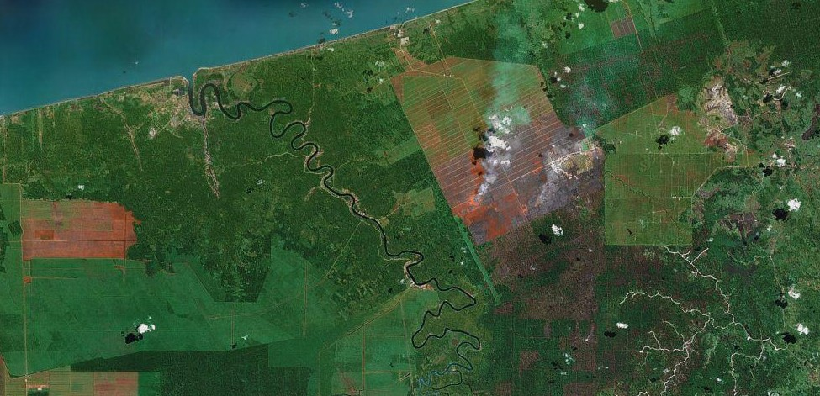
young oilseed palm plantation
land ready for planting (or recently planted)

tropical rainforest
land being cleared for planting (note smoke from fires)

logged rainforest
established oilseed palm plantations
©2008 TerraMetrics
References
- The United States Environmental Protection Agency. (2002). A comprehensive analysis of biodiesel impacts on exhaust emissions: draft technical report. Retrieved February 6, 2008, from http://www.epa.gov/otaq/models/analysis/biodsl/ p02001.pdf
- Organisation for Economic Co-operation and Development. (2007). Biofuels for Transport: Policies and Possibilities. OECD Policy Brief. Retrieved February 6, 2008, from http://www.oecd.org/dataoecd/18/8/39718027.pdf
- De Schutter, O. (2014). The transformative potential of the right to food. Final report to the United Nations General Assembly. Retrieved from http://www.srfood.org/images/stories/pdf/officialreports/20140310_finalreport_en.pdf

