
Aquatic macroinvertebrate identification key

Microscopic
1
Bigger than microscopic
go to
2
green, white or black  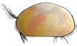  seed shrimp NR | teardrop shape, jerking movement  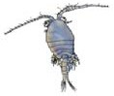  copepod NR | swims with a jerk using antennae  water lea NR

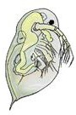

Shell No shell
go to
3
OR
2

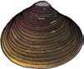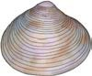Single shell Double shell
little
basket shell 4
small, darker shell with ridges
pea shell 5
small, pale delicate shell
1 very tolerant
tolerant
4
8 very sensitive
6 sensitive
10

7
5
3
not rated
NR
Pollution sensitivity*:
Acknowledgements

This key was designed by Ron Simms and Amy Blaylock, 2002.

Adapted by Steve Walker, 2011.

Assistance was kindly provided by the following staff members of the South Australian Musuem: Dr. Errol Matthews, Dr. Chris Watts and Mr Robert Hamilton- Bruce.
fattened hell with small hump | spiral shell, opening on left | spiral shell, opening on right
freshwater limpet 4 | pouch  snail 1 | gilled snail | 1

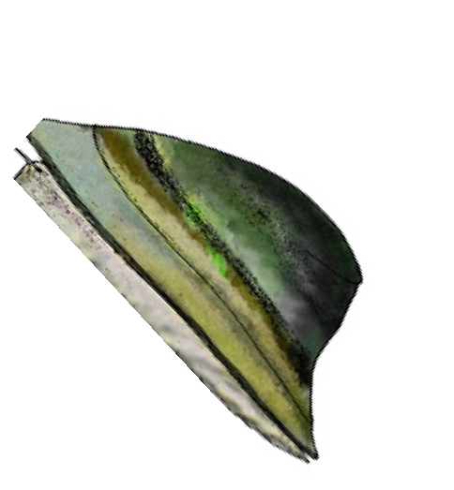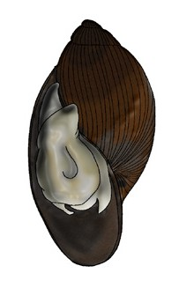

Legs go to
4
3

No legs
over page

Worm-like
OR
OR

Tentacles, brushes or tails

Mat-like

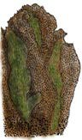
green to red, | segmented, | long, very thin,  swims in ‘S’ shape, can’t coil  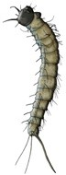  biting midge  larva 4 | suckers, | hair-like, swims | slides along
twisting | no suckers, +/- |  | expands and | in ‘S’ shape | bottom
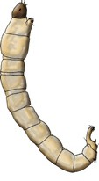  non-biting | bristles  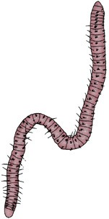 |  | contracts  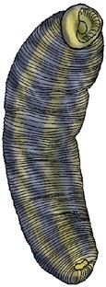 | 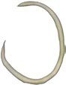 | 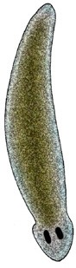
midge  larva 3 | segmented 2  worm |  | leech 1 | round  worm 3 | latworm 2

fe h l e | breathing tube | large head, | grub-like with | sucker on end | slender, with | hangs from
at end of body | at rear | wriggles | no obvious | of body, waves | tentacles, | surface by ring
 |  |  | head | head | attached to | of hairs
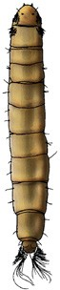  cranely  larva 5 | 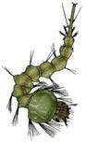  mosquito  larva 1 | 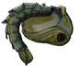  mosquito pupa 1 | 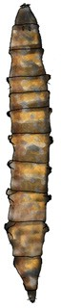  March ly  larva 3 | 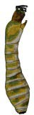  blackly  larva 5 | solid surface  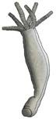  hydra 2 | 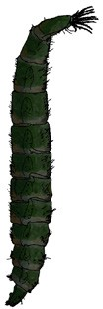  soldier ly  larva 2

4
freshwater sponges
simple, multi-cellular colony
*Sensitivity ratings from SIGNAL2 system in “New sensitivity grades for Australian river macroinvertebrates. Bruce C. Chessman. Marine and Freshwater Research, 2003, 54, 95-103.”

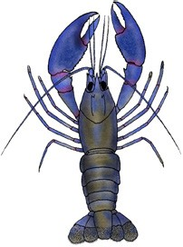more than 3 pairs legs 3 pairs legs
go to
5
4
lobster-like

yabbie 4

more than 4 pairs of legs

OR
4 pairs legs

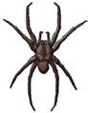

No wings
5
go to 6

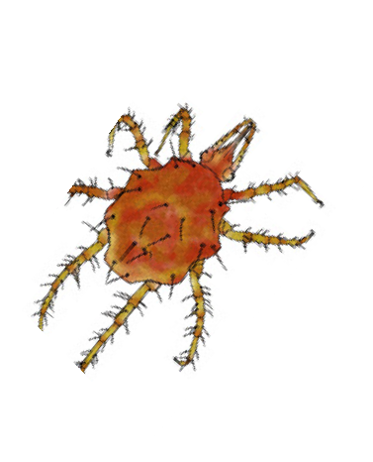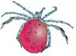Wings OR
tiny, swims in water |  | runs on top of
 |  | water
water mite | 7 | fishing 2  spider

swims with back up | 3 | shrimp-like, swims on side  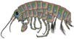 | walks on bottom | 2 | walks on bottom or swims by f ck ng ta l | 4 | rest on bottom of pool or swim with back facing up | can swim sideways very quickly
freshwater shrimp | 3 | scud (side swimmer) 3 | freshwater slater | 2 | freshwater prawn | 4 | shield  shrimp 1 | freshwater spider  crab 3

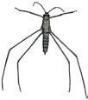
Soft wings, piercing mouth parts (bug) Hard wings, jaws (beetle)
swims moving | back legs move | swims on | crawls through
hind legs | at same time | surface, often | water plants
alternately  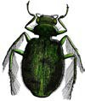 | 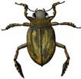 | in fast circles  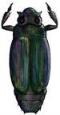 | 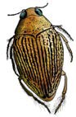
water | predacious |  | crawling
scavenger 2  beetle | diving  beetle 2 | whirligig beetle 4 | water  beetle 3

swims fast, |  | swims on back |  | runs on |  | on water | long, stick-like |  | long breathing
right side up, |  |  |  | surface of |  | surface and | lives on |  | tube, grasping
black back  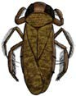 |  | 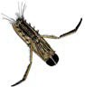 |  | water, black |  | grass edges  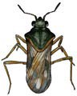 | surface  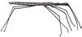 |  | front legs
water boatman | 2 | back swimmer | 1 | water strider | 4 | small water 3  strider | water measurer | 3 | needle bug | 3

long breathing | swims quickly | swims swiftly | climb or crawl
tube, grasping | using two hind | through the | across plants,
front legs | pairs of legs | water | poor swimmers
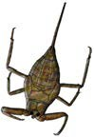 | 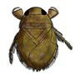 | 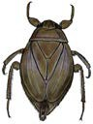 | 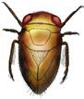
 |  |  | pygmy
water 3  scorpion | creeping 1  water bug | giant water 1  bug | back 2  swimmer

Tails
6
No obvious tail
OR
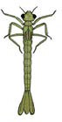
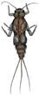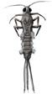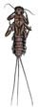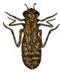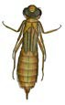2 tails 3 tails
crawls along |  | can’t swim, can | usually brown, | large | spines on |  | large body, hinged | hangs from | small and hops | in tube, case or
rocks |  | only crawl | prefer to crawl | mouthparts, | side, large |  | mouth | surface, large | on surface and | free-living
water  penny | 6 | 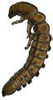  riffle beetle  larva 7 | rather than swim  marsh beetle  larva 6 | may have 7 pairs gills on side  water scavenger beetle larva 2 | mouthparts,  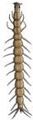  whirligig beetle larva | 4 | dragonly nymph 3 | mouthparts  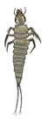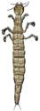  predacious diving beetle larva 2 | in edge plants  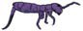  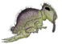  springtail 1 | 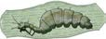  caddisly larva | 8

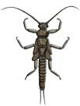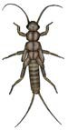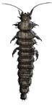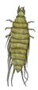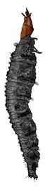
10
stonely nymph
fast water and stream edges
plate-like tails, | long tails, gills
no gills on | on abdomen
abdomen
damselly nymph 3 | mayly nymph | 9

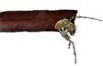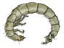(c) NRM Education 2011
All images on this ID Key are adapted by Steve Walker (2006) from the B&W images in ‘Critter Catalogue: a guide to the aquatic invertebrates of South Australian inland waters (2004 EPA)’ except for the crawling water beetle (Steve Walker 2006).

