What are acid sulfate soils?

ACID SULFATE SOILS
FACT SHEET

Acid sulfate soils (ASS) are naturally occurring soils and sediments containing iron sulfides, most commonly pyrite. When ASS are exposed to air the iron sulfides in the soil react with oxygen and water to produce a variety of iron compounds and sulfuric acid.

Initially a chemical reaction, the process is accelerated by soil bacteria. The resulting acid can release other substances, including heavy metals, from the soil into groundwater and the surrounding environment.

How are acid sulfate soils formed?
Although some ASS were formed millions of years ago and occur in ancient marine rocks, those of most concern were formed after the last major sea level rise—within the past 10,000 years (Holocene period).

When the sea level rose and flooded the land, sulfate in the seawater mixed with land sediments containing iron oxides and organic matter.

Potential acid sulfate soils
ASS which have not been oxidised by exposure to air are known as potential acid sulfate soils (PASS). While contained in a layer of waterlogged soil, the iron sulfides in the soil are stable and the surrounding soil pH is often weakly acid to weakly alkaline.

Potential acid sulfate soils:

- often have a pH close to neutral (6.5–7.5);
- contain unoxidised iron sulfides;
- are usually soft, sticky and saturated with water;
- are usually gel-like muds but can include wet sands and gravels; and
- have the potential to produce acid if exposed to oxygen.

Actual acid sulfate soils
When PASS are disturbed or exposed to oxygen, the iron sulfides are oxidised to produce sulfuric acid and the soil becomes strongly acidic (usually below pH 4). These soils are then called actual acid sulfate soils (AASS)—that is, they are already acidic.

Actual acid sulfate soils:

- have a pH of less than 4;
- contain oxidised iron sulfides;
- vary in texture; and
- often contain jarosite (a yellow mottle produced as a by-product of the oxidation process).
If at all possible, DO NOT DISTURB acid sulfate soils (ASS).
They are benign when left in a waterlogged, undisturbed environment. Avoiding disturbance is often the most environmentally sustainable and economic option.

July 2015 DER2015001427

Where are acid sulfate soils found?
ASS commonly occur in coastal wetlands as layers of marine muds and sands which are deposited in protected, low-energy environments such as barrier estuaries and coastal lakes. In similar environments, they are still being formed.
ASS are a natural component of the landscape and may be found in a variety of waterlogged soil types.
These include:
- dark, organic rich soils and muds;
- peaty wetland soils;
- some pale grey sands (Bassendean sands and Spearwood sands); and
- ‘coffee rock’ (cemented iron and/or organic rich sands) found below the watertable.
ASS in Western Australia frequently occur in low-lying wetlands, backswamps, estuaries, salt marshes and tidal flats, although they are not limited to coastal regions.
ASS may be found in:
- low-lying land adjacent to estuaries— typically grey silty or sandy sediments of alluvial origin;
- groundwater dependent wetlands— typically peaty and sandy sediments associated with some wetlands on the Swan Coastal Plain. Pyrite in the sediments can acidify the wetland if the watertable falls well below the base of the wetland due to dry weather or excessive groundwater pumping;
- former seashores—pyrite often occurs with heavy-mineral accumulations associated with former seashores. These seashores may occur several kilometres inland from the current seashore;
- sandy soils—leached sandy soils (Bassendean and Spearwood sands) in

What are acid sulfate soils?
areas of high groundwater table along the Swan and Scott coastal plains; or
- inland ASS—there are inland forms of ASS occurring in agricultural areas well away from the coast. These soils appear to be forming in response to rising watertable and land salinisation in southern WA.

The impact of disturbing acid sulfate soils
Without proper management, disturbing ASS can have serious environmental, economic, engineering and health impacts and can constrain development, construction and other activities in affected areas. Detrimental effects can include:
- ecological damage to aquatic and wetland ecosystems;
- effects on estuarine fisheries and aquaculture projects;
- contamination of groundwater with arsenic, aluminium and heavy metals;
- reduction in agricultural productivity due to soil degradation;
- damage to infrastructure through the corrosion of concrete and steel pipes, bridges and other sub-surface assets; and
- potential threat to human and animal health.

Activities that may generate acid in certain areas:
- major earthworks—large scale excavations for canal developments and estates;
- infrastructure earthworks—digging for clearways, roads, tunnels and railways;
- excavating for sewerage pipes, pump stations, basements and installation of underground services;

2

- construction and maintenance of drainage channels (including digging channels to manage waterlogging in agricultural areas);
- maintenance dredging—boating channels and canal estates; and
- lowering of the groundwater table from low rainfall, groundwater abstraction and dewatering activities.

Indicators of acid sulfate soil disturbance—what to look for in soil:
- stunted, dead vegetation;
- acid scalds—bare patches appear where the topsoil is salty or acid;
- iron monosulfides—‘sulfurous smelling’ black sediments and muds found in low oxygen environments; and
- jarosite—yellow mineral indicative of iron sulfides in ASS oxidising and forming sulfuric acid.

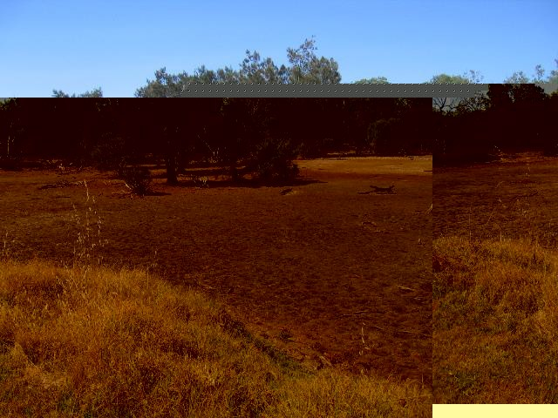
Acid scald—bare patches appear where the top soil is salty or acid.

What are acid sulfate soils?

Indicators of acid sulfate soil disturbance—what to look for in water:
- crystal clear water—high levels of aluminium can cause soil particles to drop to the bottom of a waterway leaving the water clear;
- yellow-brown water—indicates iron;
- iron flocs—usually a red-brown or brown- yellow colour present throughout the water;
- blue-green water—indicates soluble aluminium and iron; and
- milky-white water—also an indication of aluminium particles.

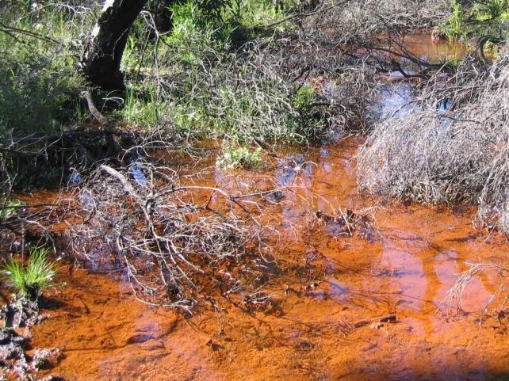
Iron flocs—ususally a red-brown or yellow-brown colour present throughout the water.

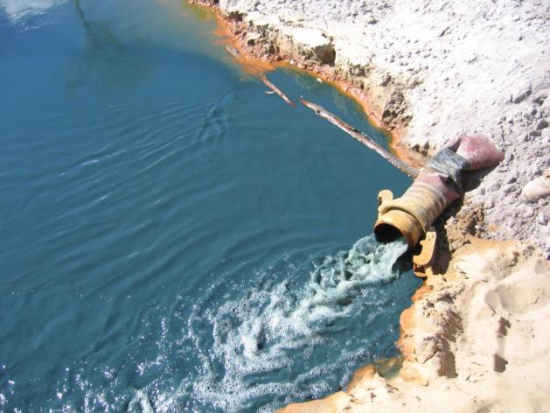
Blue green water—indicates soluble aluminium and iron.

3

Other possible indicators of acid sulfate soils
- fish kills—acid water and metals can kill fish and increase their susceptibility to disease;
- damage to infrastructure—sulfuric acid can degrade concrete and steel;
- iron staining—rust-coloured iron stains on foot paths, fences and walls; and
- oily looking water—iron bacteria floating on affected water.

Management options for acid sulfate soils
Where ASS disturbance is unavoidable, successful management can be derived from a suitable investigation of the nature of soils and groundwater. Mitigation management measures may include:
- minimising radial drawdown of groundwater associated with dewatering;
- treatment of soils—mixing adequate qualities of lime into exposed ASS to neutralise any produced acidity; and
- building wide, shallow drains—shallow drains allow removal of surface water while maintaining water-table height.

What are acid sulfate soils?

4

Disclaimer
More information
For advice on ASS, or related matters, please contact DER Contaminated Sites on 1300 762 982.
This document is available in alternative formats and other languages on request.
Document file number: DER2015001427
Effective July 2015

Related documents
Additional publications about ASS are available online from www.der.wa.gov.au/ass
or can be requested by phoning 1300 762 982.

Legislation
This document is provided for guidance only. It should not be relied upon to address every aspect of the relevant legislation. Please refer to the State Law Publisher (SLP) for copies of the relevant legislation, available electronically from the SLP website at www.slp.wa.gov.au
The information contained in this document is provided by DER in good faith as a public service. However, DER does not guarantee the accuracy of the information contained in this document and it is the responsibility of recipients to make their own enquiries as to its accuracy, currency and relevance. The State of Western Australia, DER and their servants and agents expressly disclaim liability, in negligence or otherwise, for any act or omission occurring in reliance on the information contained in this document or for any consequence of such act or omission.

Limitation
The Western Australian Government is committed to providing quality information to the community and makes every attempt to ensure accuracy, currency and reliability of the data contained in this document. However, changes in circumstances after the time of publication may impact on the quality of information. Confirmation of the information may be sought from the relevant originating bodies or the department providing the information. DER and the State of Western Australia reserve the right to amend the content of this document at any time without notice.

Legal advice
The information provided to you by DER in relation to this matter does not constitute legal advice. Due to the range of legal issues potentially involved in this matter, DER recommends that you obtain independent legal advice.

What are acid sulfate soils?
5

