Other Employees

Misconduct
  - Procedure

Approval Date 05 March 2024
Assessment Date 05 March 2025
Administrator Associate Director Employee Relations

Important Information
      - This Procedure has 2 processes —

Process 1 — Establishing Potential Employee Misconduct

Process 2 — Determining Misconduct

Process 1: Establishing Potential Employee Misconduct

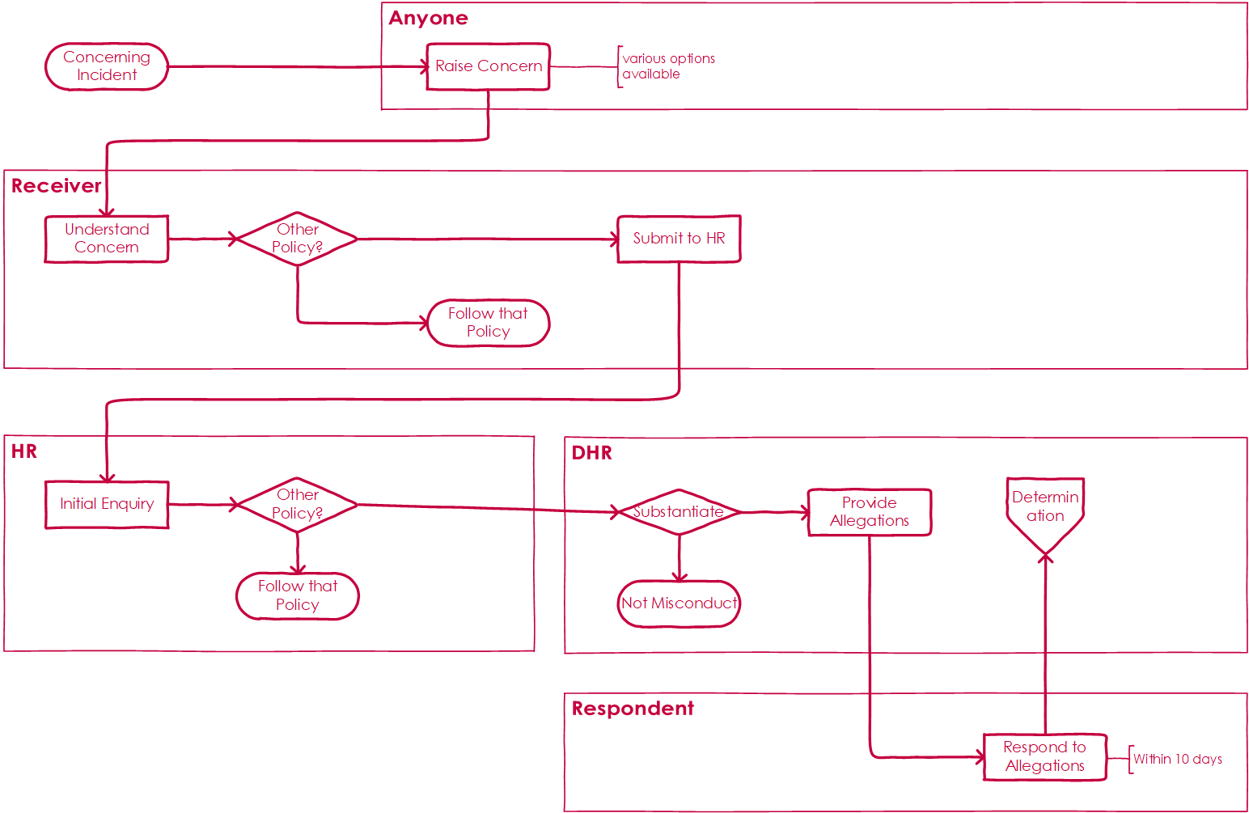

Raising a Concern

Step 1 — Raising a Concern (Anyone)
- If you believe that a FAR, Child Care, Probationary or Casual Employee has engaged in Misconduct raise your concerns with —
        - anyone in your line management structure; or
        - Human Resources.
- Include as far as possible the following information —
        - name of individual who engaged in Misconduct;
        - date and time of incident;
        - location of incident;
        - details of the incident; and/or
        - any other information you think might be important.

Note — the individual you raise your concerns to becomes the Receiver

Understanding the Concern

Step 2.1 — Receiving a Concern (Receiver)
- If you receive a concern, you will need to make sure that you understand enough about what happened so that you can make a decision about what to do next.

Step 2.2 — Confirm Potential Misconduct (Receiver)
- Using the information you have available, determine to the best of your ability if the incident might qualify as —
        - Misconduct or Serious Misconduct in accordance with Managing Employee Misconduct Policy; and/or
        - Misconduct in accordance with the —

Sexual Misconduct Policy;

Diversity, Equity and Inclusion Policy;

University Behaviour Policy;

Research Integrity Policy;

Fraud and Corruption Policy;

Conflicts of Interest Policy; and/or

Gifts, Benefits and Hospitality Policy.
- If you believe that the incident qualifies as Misconduct under another Policy, follow the requirements of that Policy.

Step 2.3 — Submit Concern to Human Resources (Receiver)
- If the concern qualifies as Misconduct or Serious Misconduct under the Managing Employee Misconduct Policy, submit the concern to any member of Human Resources.

Initial Enquiry

Confirm Potential Misconduct (HR)
      - Using the information provided, determine whether the incident qualifies as —
        - Misconduct or Serious Misconduct in accordance with Managing Employee Misconduct Policy; and/or
        - Misconduct in accordance with the —

Sexual Misconduct Policy;

Diversity, Equity and Inclusion Policy;

University Behaviour Policy;

Research Integrity Policy;

Fraud and Corruption Policy;

Conflicts of Interest Policy; and/or

Gifts, Benefits and Hospitality Policy.
- If you believe that the incident qualifies as Misconduct under another policy, follow the requirements of that policy.

Step 3.2 — Submit Concern to Director Human Resources
- If the concern qualifies as Misconduct or Serious Misconduct under the Managing Employee Misconduct Policy, submit the concern to Director Human Resources.

Substantiate Misconduct

Step 4.1 — Substantiate Misconduct (DHR)
- If, following the initial enquiry you determine that —
        - no Misconduct has occurred inform the Receiver in writing and confirm that no further action is to be taken; or
        - Misconduct has occurred in accordance with the Managing Employee Misconduct Policy, produce a letter of allegations to the respondent.

Step 4.2 — Provide Allegation (DHR)
      - Provide a letter of allegations to the individual about the concern that has been raised.

Note — the individual about which the concern has been raised becomes the Respondent. The Respondent has 10 Business Days to respond.

Respond to Allegations

Step 5.1 — Respond to Allegations (Respondent)
      - If you receive a letter of allegations, respond within 10 Business Days.
- If you need assistance in understanding the allegation, or in how to respond, contact Human Resources.

Process 2: Determining Misconduct
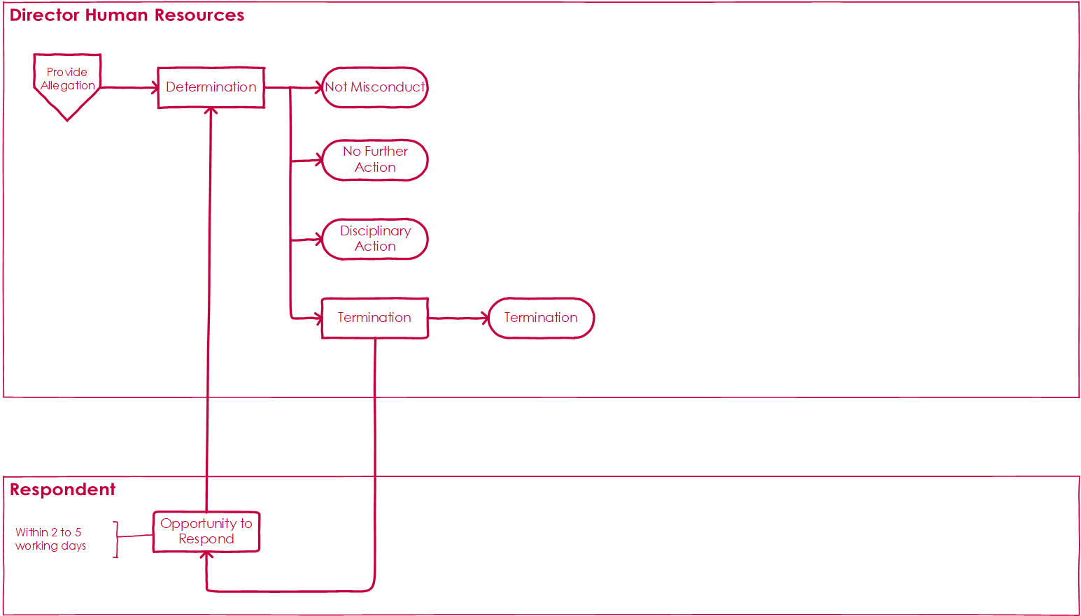

Determination

Step 6.1 — Determining Misconduct (DHR)
- Decide what, if any action is to be taken depending on the Employee’s response to the allegations.

Step 6.2a — Not Misconduct (DHR)
- If you determine that the Respondent did not engage in Misconduct, write to the Respondent with your findings and inform them that no further action is to be taken.

Step 6.2b — No Further Action (DHR)
- If you determine that the Respondent did engage in Misconduct, but the best course of action is not to pursue any disciplinary action, write to the Respondent with your findings and inform them that no further action is to be taken.

Step 6.2c — Disciplinary Action (DHR)
- If you determine that the Respondent did engage in Misconduct, and as a consequence disciplinary action is to be taken, write to the Respondent with your findings and inform them of the disciplinary action to be taken, in accordance with the Managing Employee Misconduct Policy.

Step 6.2d — Termination (DHR)
- If you determine that the Respondent did engage in Misconduct, and as a consequence their employment is to be terminated, provide the Respondent with —
        - an opportunity to show cause as to why their employment should not be terminated; and
        - a timeframe of between 2 and 5 days to respond.
- After either —
        - the Respondent has responded; or
        - the timeframe for a response has elapsed and the Respondent has not responded

make a decision as to whether the Respondent’s employment will be terminated, and then —
        - confirm with the Respondent the decision to terminate their employment;
        - take alternative disciplinary action that is not termination; or
        - take no disciplinary action despite the finding of Misconduct or Serious Misconduct;

noting that no further opportunity to respond is permitted.

End

