Child Protection,

Risk Context
  - Procedure

Approval Date 26 April 2022
Assessment Date 26 April 2025
Administrator AD Research Operations
AD Student Success and Wellbeing
AD Talent Acquisition, Organisaitonal Development and Workforce Diversity

Important Information

This Procedure has one process —

Process 1 – Establish Child Protection Risk Context Process.

Process 1 Establish Child Protection Risk Context

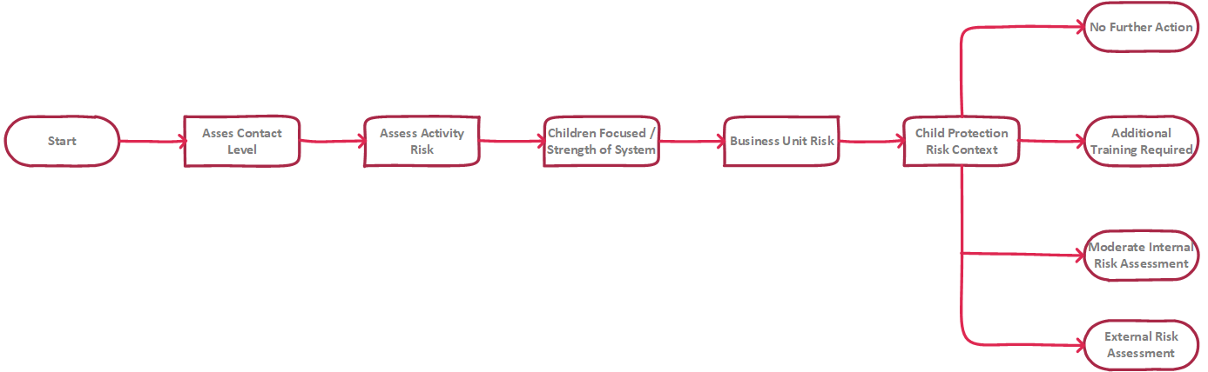

Establish Child Protection Risk Context Procedure

Step 1 — Assess Contact Level (Individual)

What is the level of Child-related Work you are engaged in?

Complete worksheets 1 and 2 by adding Y or N in the response column —

Table 1: Worksheet 1
 |  | Response
Contact with Children
Inherent Risk | Individual(s) will be deployed internationally (outside of Australia)
 | Individual(s) will be working in a remote and/or rural location
Degree of Isolation | Involves being alone with Children
 | Involves activities that are away from organisation location
 | Involves meeting one-on-one with Children
 | Involves unpredictable or remote setting
Online Contact or Access to Personal Details | Involves direct one-on-one group access to Children online
 | Involves supervising child-to-child online contact
 | Involves online access to Personal Information/Sensitive Information
 | Inadequate/missing safe options for Children to report unwanted attention or inappropriate behavior by others
 | Involves educating children and supporting adults on cyber safety

Table 2: Worksheet 2
 |  | Response
Working with Children
Vulnerability of Children | Engages with Children whose true or cognitive age impacts on their ability to protect themselves
 | Engages with Children who have challenges that contribute to their vulnerability e.g. psychological
 | Engages with Children who do not have many support systems
Degree of Physical Contact | Involves demonstrating a skill to Children
 | Position involves need for physical contact/touching Children
 | Involves providing a personal service e.g. washing, dressing, toileting
Degree of Monopoly | Monopoly on provision of goods and/or services e.g. medical, food, career training
Degree of Supervision | Involves individual(s) having unsupervised contact with Children
 | Activities/engagement with Children is not observed or monitored
 | Insufficient number of trained staff to supervise activities/engagement with Children
Degree of Trust | Involves developing close, personal, long-term relationships with Children
 | Involves transporting Children
Involves one or more of the following —
- one-on-one supervision, overnight supervision, out of town activities, advising or offering guidance to Children or spending extended periods of time with Children e.g. camps
 | Contributes to important decision regarding the future of Children
Access to Property | Has access to Personal Information/Sensitive Information
 | Adult has a perceived or actual level of authority (from the perspective of the Child)
Skills and Knowledge Required | Requires specific skills, knowledge, qualifications or service eligibility requirements to undertake Child-related Work.
Child Labour | Possibility that activity will lead to the employment of Children
 | Possibility that activity will lead to the removal of Children from School
 | Possibility that activity will lead to Children being employed in hazardous work
Vulnerability of Parent/Carer | Engages with Parents whose true or cognitive age impacts on their ability to protect their Children
 | Engages with Parents who have challenges that contribute to their ability to provide care e.g. psychological
 | Engages with Parents who do not have many support system
Vulnerability can include | Physical and mental disabilities, homelessness, child sex workers or Parents who are sex workers, Children and families impacted by disasters, displaced, migrants, refuges and asylum seekers Children in contact with the law, Children that have been subjects to trafficking, orphans, unaccompanied minors and the very young.

Step 2 — Assess Activity Risk (Individual)

Based on your answers in step 1, identify the inherent risk of the activity using the table below.

Note — activity risk is the level of potential risks to Children due to the nature of the activity or the design of the activity.

Inherent Risk | Risk Context | Tick | Advice
Low | Nil Contact | □ | The activity does not involve any individuals working in-country (you answered NO to ALL questions in step 1.1)
Moderate | Contact with Children | □ | The activity involves or may involve contact with children – this includes and work in-country, remote or rural area (you answered YES to ANY questions in Contact with Children but NO to ALL questions in Working with Children)
High | Working with Children | □ | The activity involves working with Children (you answered YES to ANY questions in Working with Children)

If the activity is determined to be Contact with Children then you are required to sign the Child Protection Code of Conduct and submit this to you Supervisor or Manager.

If the activity is determined to be Working with Children then an assessment of Child Protection Risk is required and you must —

hold a current Working With Children Card; and

sign the Child Protection Code of Conduct;

and submit these to you Supervisor or Manager.

Step 3 — Child-focused Business Unit with Child Protection Controls (Individual)

Complete worksheets 3 and 4 by adding Y or N in the response column —

Table 3: Worksheet 3
 |  | Response
Child-focused Business
Types of Activities | The Business Unit across all of its operations provides direct activities/service to Children
Business Services | Business Unit provides residential services to Children
 | Business Unit provides care/medical/health related service to Children
 | Business Unit provides technical expertise to implement any Child-related Work
 | Business Unit uses Children and/or images of Children in fundraising activities
 | Business Unit undertakes Research involving Children
 | Business Unit provides community engagement activities to Children

Table 4: Worksheet 4
 |  | Response
Systems and Controls
Child Protection Policy, Code of Conduct and Procedures | All members of the Business Unit have read and understood the Child Protection Policy
 | All members of the Business Unit have read, understood and signed the Child Protection Code of Conduct
 | All members of the Business Unit have read and understood the Child Protection Reporting Procedure
 | All members of the Business Unit have received Child Protection Training
 | The Business Unit keeps accurate records of meetings, activities, incidents, reports logs, complaints and performance involving Children

Step 4 — Business Unit Risk (Individual)

Based on your answers in step 3, identify the inherent risk of the activity using the table below.

Note — activity risk is the level of potential risks to Children due to the nature of the activity or the design of the activity.

Inherent Risk | Risk Context | Tick | Advice
Low | No Focus | □ | The Business Unit is not a Child-focused Business Unit (you answered NO to ALL questions in step 1.3)
Moderate | Child-focused with Strong Systems | □ | The Business Unit is a Child-focused Business Unit and has good Child Protection systems in place (you answered YES to ANY question in Child-focused Business and a majority of YES to questions in Systems and Controls)
High | Child-focused with Poor Systems | □ | The Business Units is a Child-focused Business Unit and has poor Child Protection systems in place (you answered YES to ANY question in Child-focused Business and a majority of NO to questions in Systems and Controls)

If the activity is determined to be Working with Children then an assessment of Child Protection Risk is required and you must sign the Child Protection Code of Conduct.

Step 5 — Child Protection Risk Context (Individual)

Based on the results in step 2 and 4 establish the overall risk context using table 5 —

Table 5: Overall Risk Context
Business Unit | Contact with Children
 | Nil Contact | Contact with Children | Working with Children
No Focus | No further action required | Additional training required | UWA Child Protection risk assessment required
Child-focused with Strong Systems | Additional training required | Additional training required | Internal Child Protection risk assessment required
Child-focused with Poor Systems | Internal Child Protection risk assessment required | Internal Child Protection risk assessment required | UWA Child Protection risk assessment required

If Table 5 indicates the need for additional training, please —

re-read the Child Protection Policy; and

read and sign the Child Protection Code of Conduct and submit a copy to your Supervisor or Manager.

If Table 5 indicates the need for a Child Protection risk assessment, you must inform your Supervisor or Manager.

Step 6 — Child Protection Risk Assessment (Business Unit)

If Table 5 indicates an assessment of Child Protection risk is required —

you must conduct an assessment of the Child Protection risk for your Business Unit;

record evidence (including who completed which steps above) that an assessment has been completed; and

consider whether you should get someone with Child Protection expertise to assist with the risk assessment.

Submit completed assessments of Child Protection Risk to your Head of School.

End

